Eddie Hazeldine // Rawlins // Student
Rawlins Academy
Productivity Tracker

Contents
Analysis 4
Problem Identification 4
Computational Methods 4
Stakeholders 5
Potential Features to Include: 5
Questionnaire: 6
Questionnaire Results: 7
Research 12
Existing Solutions: 12
Features 16
Essential Features: 16
Optional Features: 16
Limitations 17
Pygame Limitations: 17
Other Limitations: 17
Solution Requirements/Success Criteria 19
Hardware Requirements: 19
Software Requirements: 19
Success Criteria: 20
Design 22
Decompose the problem 23
Define the structure 25
Database Design 26
Algorithms 27
Flowchart for the Main Program 27
Sign Up 28
Log in 28
Log Habit Session 29
Add Habit 30
Delete Habit 30
Edit Habit 30
Leaderboard Checker 31
Reset for New Day 31
Failure 32
Running Time 32
How Failure Messages would be implemented 32
Usability Features 33
General Features 33
UI Design 34
Variables, Data Structures and Validation 37
Variables and Data Structures 37
Validation 39
Iterative Development Test Data 40
Post Development Test Data 44
Development 49
Initialise Database Prototype 1: 49
Sign Up Prototype 1: 52
Log in prototype 1: 54
Start Page Prototype 1: 55
Rectangle Button Prototype 1: 58
Log in prototype 2: 61
Input Box class Prototype 1 (Done between the login 2nd prototype): 63
Returning to Log In Prototype 2 (after input box class development): 63
CheckLogIn prototype 1: 64
Main Program Prototype 1(between login prototype 2): 66
Returning Log In prototype 2 again (after making the main program): 67
Sign Up Prototype 2: 69
CheckSignUp Prototype 1: 70
Home Page Prototype 1: 72
ImageRectButton Class Prototype 1 (midway through home page): 81
Add Habit: 82
Delete Habit: 82
Edit Habit: 83
Log Habit Session 83
Reset New Day 84
Leaderboard Page 84
Customise Page 87
Failure Message 89
Adding in Failure Messages to Home, Log In and Sign Up pages 89
Initialise Databse Prototype 2 90
Main Program Prototype 2 90
Testing: Evaluative 92
Final Testing Evidence 92
Usability Testing 105
Evaluation 113
Evaluate Success Criteria 113
Evaluate Usability Features 118
Limitations & Maintenance 119
Limitations 119
Maintenance 120
Appendix 120
References 120
Code Appendix 120
Check User Data: 120
Customise Page 122
Failure Message 124
Habit Operations 125
Initialise Database 127
Leaderboard 128
Log In Function 132
Main Page 136
Main Program 147
Rectangle Button Class 149
resetDay 152
Sign Up Function 153
Start Page 155

Analysis

Problem Identification

Consistency can be difficult without a way to track progress and hold yourself accountable. Without this, it can be easy to lose motivation, especially with no tangible results, I decided to create a productivity tracker, which will allow the user to make a habit, which they will complete every day for a given amount of time, it will track how consistently they have been completing these over the last week, data will be recorded by logging this into an input space. Users will also have the option to edit the title or time taken of the given habit, this will most likely be done via a class, as each habit will have the same attributes, but with different values.
When users log a habit session it will add XP or Currency to the users account, this will then be added to a global leaderboard, showing the top 10 best users, this will give user’s motivation to improve and gamifies their productivity. With the objective of getting to the top of the leaderboard.
The majority of this will be stored in a database, storing users name, password and any habits made by their account, the habits database will be a separate table, searched via the username which will be unique.
The program will start on the start page, featuring the title and options to log in or sign up, then the user decides which, either sign up a new account or log into an existing account, once their inputted username and password is validated, they will be sent to the main program.

Computational Methods
Method | Explanation | Justification | Why computational approach?
Abstraction | When the user creates a habit, there are many values and features that are unnecessary for its implementation, e.g. to make a habit they need the title of it and the time taken, it will then be given a unique ID to ensure for less errors, this gives the primary key that the habits table will be searched on. Certain parts are not needed for searching or saving it. | Abstraction will improve the efficiency of the program, removing any unimportant inputs from the user decreases the processing time and leads to savings in storage. Making it an efficient method for solving this problem | This approach requires inputs processing and outputs, processing done in databases for example require complex processes that aren’t suited to other approaches.
Iteration | This project will use pygame, and in order to keep images on the screen, an infinite game loop must be set up in order to repeatedly refresh the display, elements of iteration will also be seen in the habits list, the habits will be on a list on the screen, the length of the list will need to change with the number of habits a user has, incrementing through the list one-by-one. | Iteration will improve the efficiency of the program, rather than writing the code in sequence many times. For the infinite game loop it would be impossible by a sequenced approach, therefore repetition of code via iteration is essential | There is no other method for creating and refreshing a UI other than a computational method, so it is essential for these kinds of repetitive processes
Decomposition | The program, for example, has the same features as above: creation, editing and deletion of elements of a back-end database, creating a table for the leaderboard to display the data in, outputting data from the database and entering it into the leaderboard table. Once this is done, it will only need to be edited when the data changes. | Decomposition will allow for a more simplistic problem, it allows the project to be broken down logically into modules, improving debugging, maintenance and allowing for more sophisticated programs that are simpler to read for others | A computational approach further allows for more efficiency, as decomposition breaks a problem into modules that are more logical computationally speaking, in the way they are broken up
Recursion | When logging in, the user will either have credentials matching the external database or they won’t. Should the user’s information not match any database records, they will have to return to the login page. Recursion seems the most efficient way to handle this operation. | Recursion allows for repetition of functions. In addition to modular programming, I intend on using some functional programming, and for some use-cases, recursion is necessary for repeated calls of a function | Methods that aren’t computational would fail to properly understand the logic and purpose of recursion. Meaning computational methods are essential.

Stakeholders

After researching potential end users of other existing habit trackers, I saw the largest group of people in need of tracking productivity is Students. This is because students are often expected to balance many responsibilities.
This tracking software will allow the students to build consistent habits, reduce procrastination, and gives them the ability to hold themselves accountable. Students are also more familiar with the use of similar software, so the integration and set-up will be much simpler, e.g. Calendar, Reminders.
Students will use this to keep track of habits or events they are preparing for, e.g. exams and deadlines. It will allow them to look at how consistently they have been performing and will add optional elements of competition via leaderboard and gamification. It would give them a measurable way of tracking their goals with actual results. Students would also be the people most likely to have an incentive or end goal, as opposed to older users; this will mean more engagement in many features.
This project would be appropriate for the needs of students, because it allows greater organisation and productivity, which are things that students often struggle to achieve. It means they can keep track of deadlines and prepare themselves in advance.

Potential Features to Include:

Feature | Explanation
Leaderboards with friends | This feature could motivate students to stay consistent by seeing what their friends are achieving
Calendar showing missed/achieved days | This feature could show students any patterns or inconsistencies in their habits, and therefore allow them to correct these
Daily streak with increasing rewards | This feature could act as a form of gamification, motivating students by giving incentives more regularly than passing a test
In-game currency to decorate rooms/change avatar | This feature also acts as a form of gamification, allowing smaller, more regular rewards as a form of motivation
Stakes if not completed | This feature could give the student consequences for a lack of completion, motivating them to avoid losing something

I also wanted to see their preferences on the following features that were essential, as they were fundamental:
Account Creation

Ability to log habits

Create/Edit/Delete Habits with a given frequency

Questionnaire:
I wanted the opinions of potential users as to how the app could be most motivating and engaging. I wanted to survey potential end users, students who would use this to track time spent on homework or revising. This would provide me with the features that would be found most/least useful, allowing me to optimise my success criteria accordingly. It will also give me insights into which methods of displaying data would be most useful

Would you use the Habit Tracker individually or with a group?
- Individually
- With a group, e.g. classmates, for a joint project
- Both

Do you currently use an app to track your habits?
- Yes
- No

If you use a Habit Tracker, are there any challenges faced when maintaining habits?
- Forgetting to complete habits
- Loss of motivation
- No way of tracking/visualising progress
- No rewards or incentives
- I don’t use a Habit Tracker currently
- Other

Which extra features would you find MOST useful in a habit tracker?
- Calendar view, showing days that were completed or missed
- Daily Streak tracking
- Visualising your data via a graph or diagram
- Leaderboard with friends
- In-game currencies
- Avatar or Room Customisation
- Stakes for missing a habit, e.g. losing in-game currency
- Other

Which extra features would you find LEAST useful in a habit tracker?
- Calendar view, showing days that were completed or missed
- Daily Streak tracking
- Visualising your data via a graph or diagram
- Leaderboard with friends
- In-game currencies
- Avatar or Room Customisation
- Stakes for missing a habit, e.g. losing in-game currency
- Other

Would you prefer a simpler or gamified experience?
Scale from 1 ----> 5
1: Very simple
5: Very engaging and gamified

Which features do you feel would help you stay consistent with your habits
- Badges for a milestone, e.g. 100 days
- Streak-based rewards: get a reward every time you stay consistent
- In-game currency
- Customisation options
- Competing with friends
- Other

Would you ever want stakes if you missed a habit? E.g. losing in-game currency
- Yes
- No
- Maybe

Questionnaire Results:

Would you use the Habit Tracker individually or with a group?
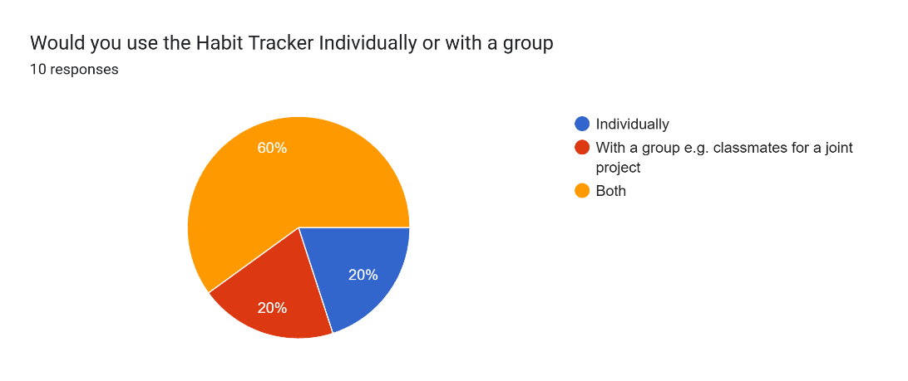
This prompted me to include a multi-user function as a feature. As this seemed to be the largest group, this will, of course, be optional, appealing to the largest group of people. As 8/10 people would use a multi-user option. However, this can increase the complexity of development, as there would need to be communication between user accounts, in order to have updated results.

Do you currently use an app to track your habits?
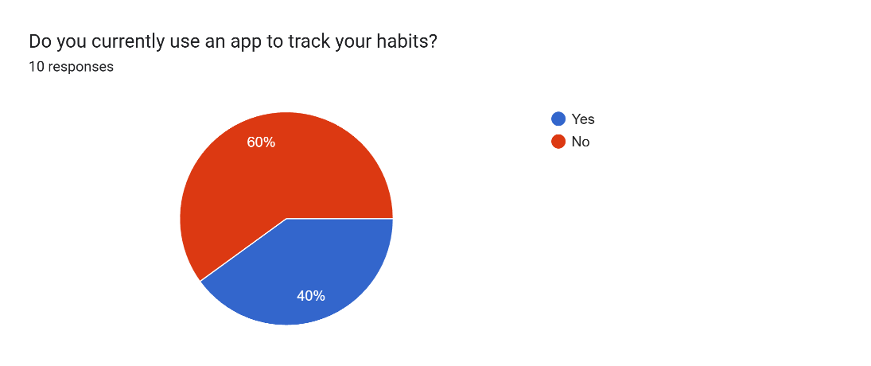
This reinforced the opinion that this was a viable project that many people would have an interest in, meaning I had a large group of people to appeal to. This also made the survey more mixed, as I would be receiving opinions from a large spread of people, further allowing me to have a diverse project, appealing to the majority of people.

If you use a Habit Tracker, are there any challenges faced when maintaining habits?
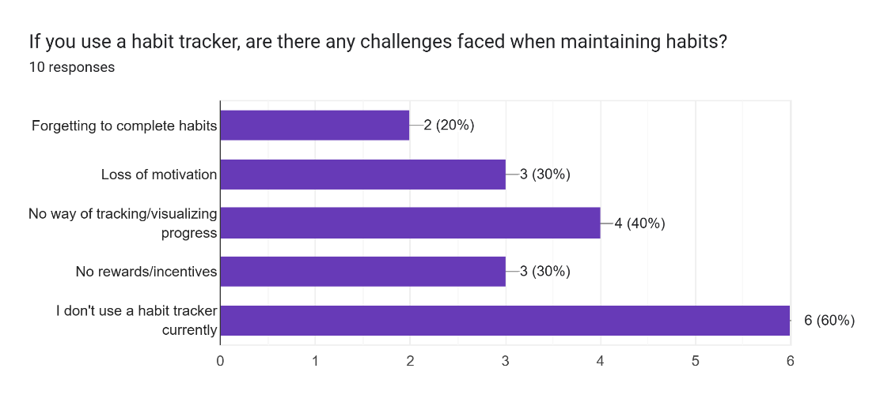
I chose to include a method of visualising progress via a graph or diagram as this seemed to be the most requested feature. This would allow for tracking which habits are completed most consistently and on which days. In addition to this, I chose to include elements of gamification, solving the issues of loss of motivation and no rewards or incentives. This would be solved by adding a daily streak, with increasing rewards for each, which would allow for motivation and incentives.

Which extra features would you find MOST useful in a habit tracker?
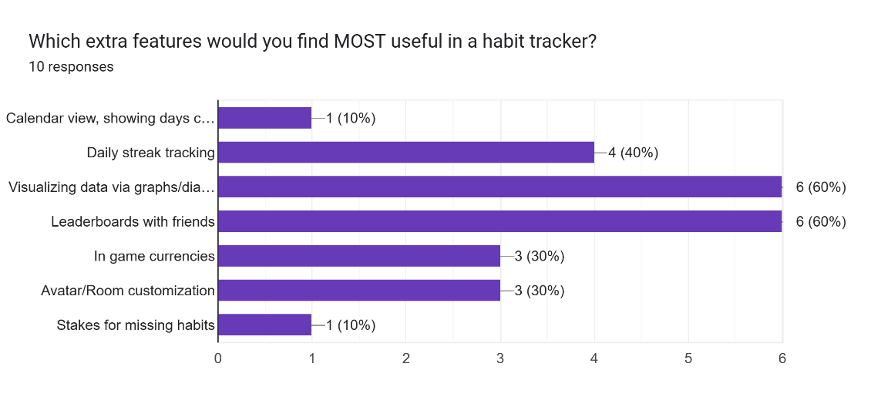
This further reinforces the idea of graphs and diagrams, in addition to the idea of rewards. These rewards would be in the form of in-game currencies, which could be used to purchase customisations for a room or avatars. This allows for the majority of the features to be included in a way that keeps a cohesive tool, because the majority of the features are somewhat reliant on each other. Also, I would include a leaderboard, showing which of the friends has completed the most habits

Which extra features would you find LEAST useful in a habit tracker?
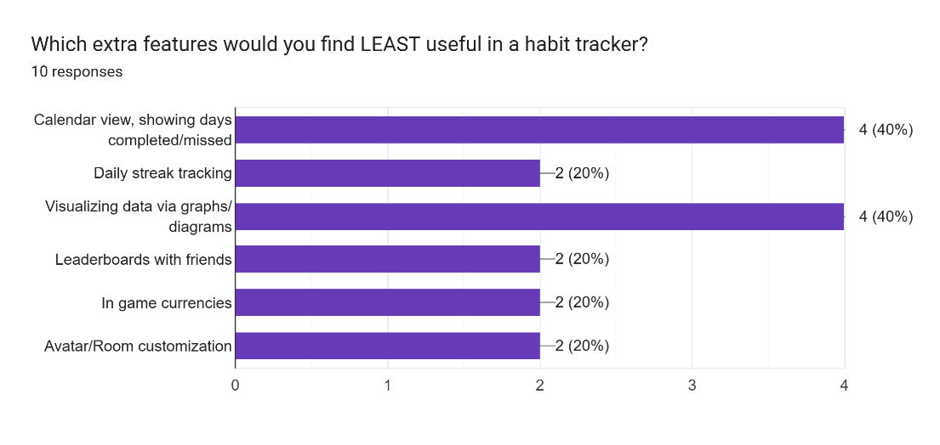
I chose not to include the idea of a calendar view due to the limited development time. This also further reinforces the idea of visualising the data via a graph, as the majority of people appeared to want this.

Would you prefer a simpler or gamified experience?
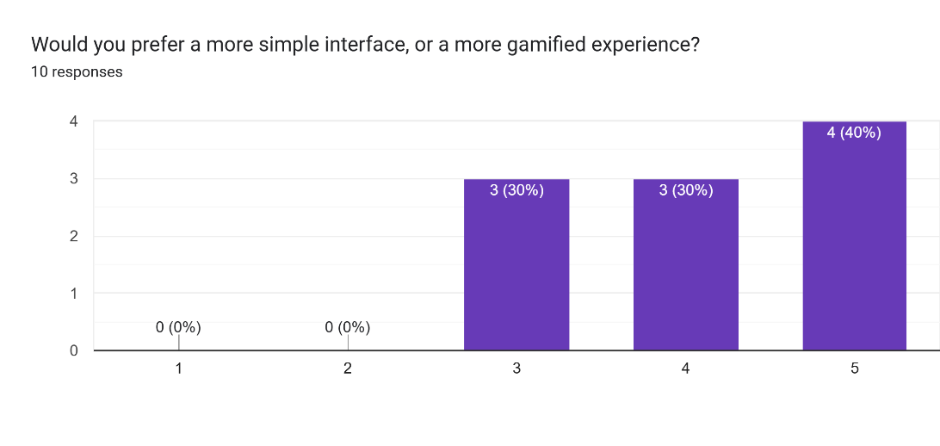
This proves that all the previous features would combine to create a more engaging, gamified experience that would ultimately motivate the user to achieve their goals and stay on track

Which features do you feel would help you stay consistent with your habits?
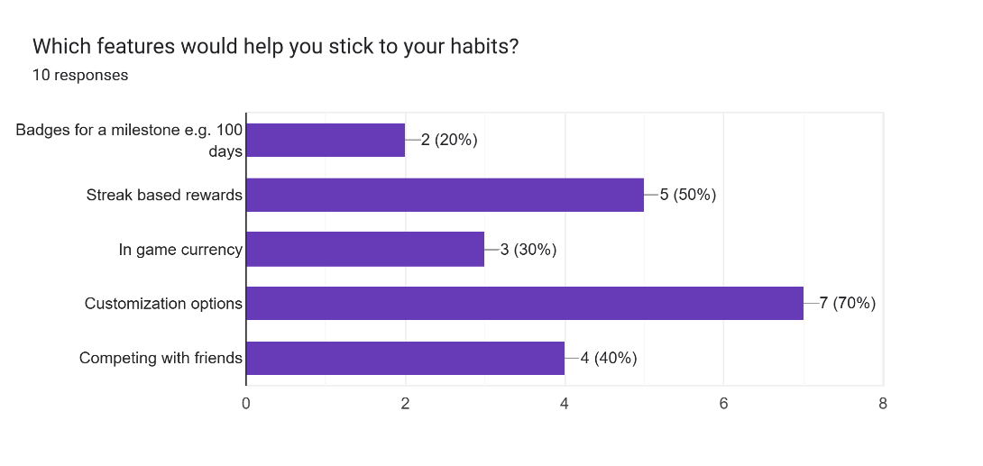
I have chosen to include the top 3 ideas here: Streak rewards in the form of in-game currency, which can be exchanged for elements of customisation. These ideas feel cohesive, and all work together

Would you ever want stakes if you missed a habit? E.g. losing in-game currency
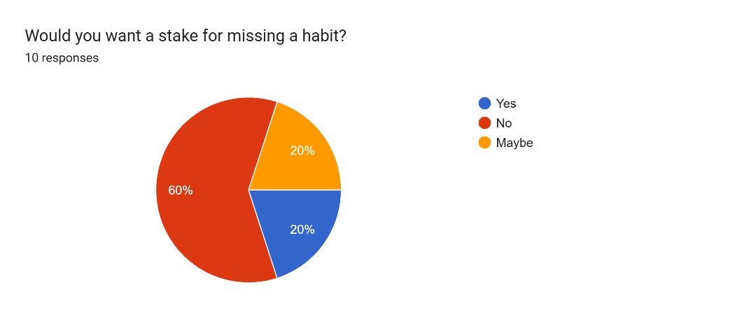
As this feature was never crucial for the project, it was rejected, as it may not incentivise users

E.g. Which chart would be most appropriate for displaying your data?
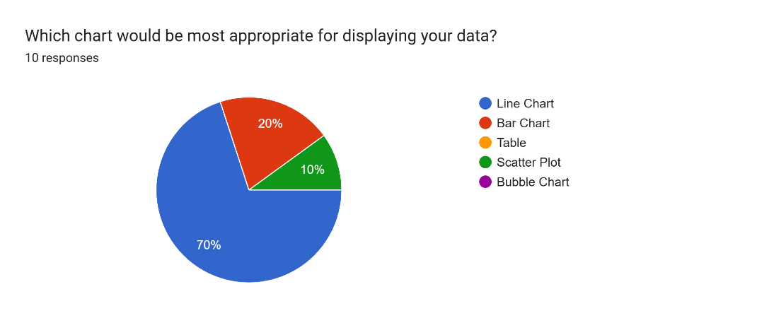
I chose to show the data via a line chart, as this can show the data more clearly, and the user can interpret it more simply

Research

Habit trackers are a tool that helps a user to monitor their habits and routines. The goal is consistency in the users’ habits, allowing them to be more productive. This goal is achieved by making the data, provided by the user, into a rewarding, measurable visual aid. As my target user is students, these habits could be studying more, monitoring progress on assignments, or building revision habits.
Habit trackers work by allowing the user to create a habit, and logging every instance when it was completed, over time it will build up a visual representation of their progress, which turns their more abstract goals into visualised progress.

Existing Solutions:
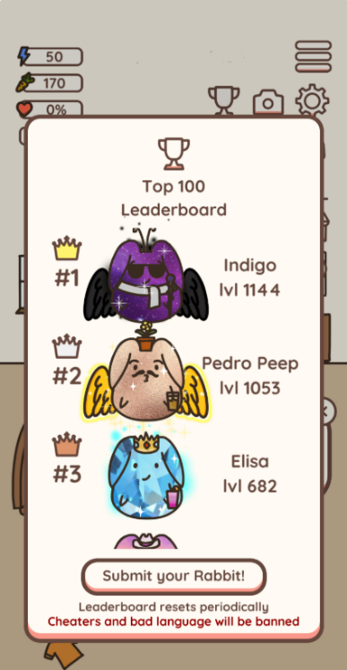
Name | Habit rabbit
Brief explanation of solution | A Habit tracking System where users can create a habit with a given frequency, their consistency is tracked, and they get rewards for their productivity
Features I intend on implementing | The feature I intend to include is a Leaderboard with the Top 10 most consistent users who are the most productive. I feel this would act as a form of motivation, showing the user what they can achieve with consistency and dedication
How I will approach this | I will implement this by having the Top 10 most consistent users will be stored in a back end database, they will be ranked by their total in-game currency they have ever collected, users lifetime currency will be compared to the 10th place, if it is larger it will be compared to 9th place and so on, until they find a user with a greater currency, once this is found the users place will be before this higher user, every other user below this will be pushed down a position
How my approach will differ from the existing solution | The Habit Rabbit metric is done by creating their own metric, the users’ ‘level’, which is increased when they complete a habit. This adds a level of complexity that, given the limited development time, may be too complex. This is why I chose a metric that I already planned on including, reducing the workload, but getting a similar result
Justification for my approach | Other metrics and methods for checking positions could have been used, e.g. making my own metric which focuses more on consistency than quantity, this would be better if I had the time to, as it could better track which player is ‘best’. However, this would add complications to creating a function to make a metric
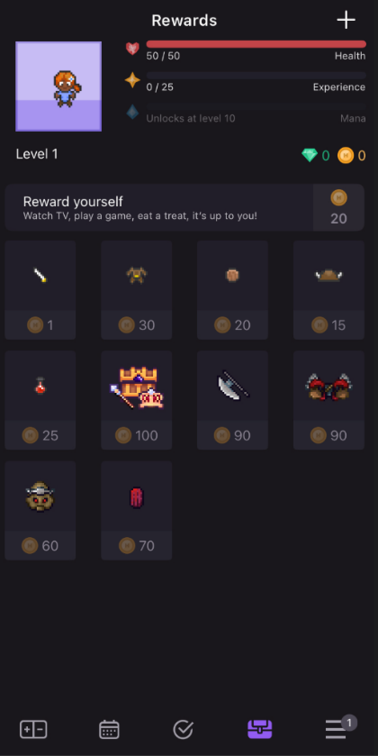
Name | Habitica
Brief explanation of solution | Habit Tracker with elements of gamification, users get in-game currency for consistency, which can be used to buy rewards in the form of customising an avatar
Features I intend on implementing | The Feature I will include is the in-game Currency and customisation rewards offered. I feel this would gamify the system, further motivating the user to be consistent
How I will approach this | I will implement this by having increasing rewards for consistency, First day could be 5, Second day 10, Third day 20, there would be a variable storing the current amount, for every day they are consistent it would increase by a certain amount, should they intend on buying a customisation, the current amount of currency stored would decrease, these items may be stored in a back-end database, avoiding the need to have a separate function for each item.
How my approach will differ from the existing solution | In the Existing Solution, the customisations are applied to an avatar of the user, rewarding their consistency. I intend to decorate a room. In terms of the rewards system, it will remain largely similar, possibly with a change in currency between each streak, e.g. exponentially larger rewards as opposed to the system they use in the existing solution
Justification for my approach | Other methods of increasing rewards can also be used. Should people find it more motivating to have a different change in rewards for each day increased, it could possibly be tiered, e.g. Days 1-3 will be a given amount, Days 4-7 would be more. This would make long-term goals and improved consistency, making a longer streak more rewarding. Should there be sufficient development time, a more adaptive rewards system could be created, taking into account other metrics, e.g. total time per day, or rate of consistency

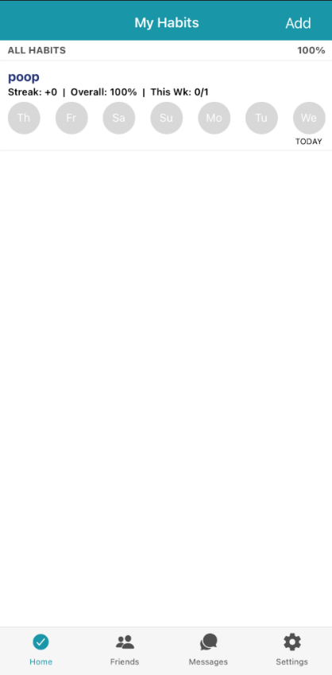
Name | HabitShare
Brief explanation of solution | A Habit tracker focusing on streak-based rewards and competition with friends, encouraging users to maintain consistency by adding an element of competitiveness, the aspect of trying to ‘win’ against someone else can be very motivating
Features I intend on implementing | The feature I will include is a daily streak. This will track the number of days the user has been consistent for. Rewards would be given for keeping the streak; the longer the streaks the higher the rewards
How I will approach this | I will implement this by storing a variable, the current streak. It will start at zero and increment if the goal is achieved that day; if the goal is not achieved that day, it will reset to zero. I intend on creating two separate functions: increase streak and reset streak. These will also have a reward in the form of in-game currency, and possibly, if I have sufficient development time, a temporary change to the UI, where there will be an animation or other celebration feature, should time permit
How my approach will differ from the existing solution | The game only seems to track the streak across the week, with a diagram showing if they have achieved this or not. I will simply have a number storing the number of days the user has been consistent. This will allow for simpler development, while still including the feature in a user-friendly way.
Justification for my approach | Another method could be to take a more visual approach to representing the streak. There is also an option to include a maximum achieved streak, where if the current streak is larger than the maximum streak, it will be replaced, also including more visual elements if I have time. The amount of rewards given for this consistency will be determined later, as this will have to be tweaked to ensure it is not made too easy or difficult to progress.
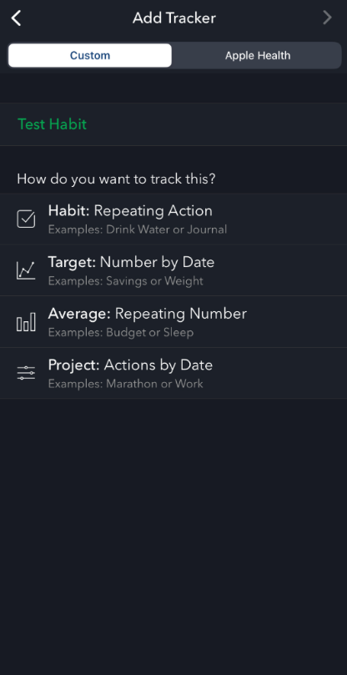
Name | Strides
Brief explanation of solution | A simple and Minimal habit tracker, focusing on a user-friendly interface, with the options to view progress and see trends in your productivity, in addition to rankings and leaderboards, their variety of options in the type of habit you can log makes it a useful tool.
Features I intend on implementing | I plan on taking inspiration from their features in adding, modifying and deleting habits. You can also add it into many different categories, e.g. Productivity, Hobbies, Chores
How I will approach this | I will have a separate function for each habit, the data about the habit will be stored in another back-end database, this will include Title, Category and Frequency, when the Add Habit function is called, the database will use the INSERT INTO function a new habit will all the respective data, when the Delete Habit function is called, the database will use the DELETE FROM function to remove a record from a database, if the modify habit function is called, the database will use the UPDATE function to change the data about a record.
How my approach will differ from the existing solution | The existing solution has the option to link it to health apps, allowing improved productivity from this data. Mine will not implement this as it will be based on a desktop, meaning this is not accessible, and there will be unnecessary complications that will significantly eat into development time. This is an unreasonable feature to be included.
Justification for my approach | Another option is to use a JSON file instead of a database to store the data; this means there is no need for an external database, and it will be easier to implement. This, it is very portable and readable, it is ideal for smaller-scale projects such as this one.

Features

Essential Features:

My final solution will be a computer application, with a mouse and keyboard. Using buttons and input boxes to get the users inputs, and displaying these for the user to see and track.
Feature | Description | Why its essential
Sign Up | Creating an account with a username and password, all stats are set to zero, or their initial value, it will be empty and the username must be unique | Without this feature the log in feature couldn’t exist, it is foundational as without this the accounts couldn’t exist in the first place in order to interact with the database etc
Log in | Ability to log into an account that has already been created, I would use Abstraction to simplify this into a simple database query, which only has two possible outputs. Selection would also be used, as access cannot be granted until it is known that the account exists | This is essential because users will want to come back to their account after logging out, e.g. the next day. Without this they would lose their account the next time they logged in, rendering it pointless as you cant measure consistency over just one day
Create a habit | Creates a habit with a title and frequency; this can then be tracked by the user. I would use object-oriented programming for this feature, creating an object from the class blueprint of a habit. This would make generating many habits simpler, as they would all have the same attributes and methods, but would leverage polymorphism to redefine the frequency that the habit needs to be completed in | Without this users would not be able to log habits at all, it would mean they couldn’t do anything other than sign up and log in, as all other features build off this
Delete a habit | Removes an existing habit, so that it won't be tracked anymore, meaning there won't be consequences for not completing it. This would be decomposed into a simple deletion of the object from the habit class | This is essential because users may not need to do this habit anymore, they may have stopped needing to, without it affecting their streak etc, this is why its needed
Log habit completion | User can report if they have completed a habit; this will increase the streak and reward them for their consistency. Selection must be used here, as the streak rewards cannot be given unless the habit has been completed | This is needed so users can actually track when they have completed something, its fine to be able to make and delete habits, but without the ability to actually track them it would be rendered useless

Optional Features:
Feature | Explanation
Edit a Habit | Will allow the user to change the name or the time they will spend on the habit, its not essential to the program, but it would be very useful, if you don’t need to do as much maths work for example, or if you want to carry over the records under a new name, this will enhance the usability while not being absolutely essential
Leaderboard with friends | A table showing the most productive people and what they have achieved, acting as a form of motivation and gamifying the experience. I would use decomposition to split this into its different parts, e.g. the UI and back-end database. This would allow for a simpler problem
Daily Streak | Keeping track of how many successive days a certain habit has been achieved, there could be increasing rewards for each milestone. I would use Iteration for this task, in order to increment the streak every day the habit is completed.
In-game currency | Reward for completing habits and consistency. This would increase as each habit is achieved for longer, further incentivising the user to complete tasks. I would use Abstraction to simplify this problem into simply adding a given amount of currency to the existing amount, depending on the streak
Customisation | Using the currency to buy customisations, e.g. an avatar or decorating a room, this would give the user more frequent goals, giving a motivation to complete. I would use concurrence in this, as many different customisations will need to be loaded and included simultaneously

Limitations

Pygame Limitations:
Limitation | Why this limitation exists | Alternatives
Must be an application | As Pygame is only built for desktop, it cannot be used on a browser, meaning I am limited in how the software can be accessed. Because of this, I decided to have an application | Alternatively, I could have built a web-based application, using HTML, CSS and JavaScript, however I felt I was more comfortable using python, and it allowed for greater customisation and involvement in the development
Cannot be used on a Mobile app | This meant it could not be accessed via a mobile device. Further limiting how it can be accessed, this meant I was limited to a Desktop computer application | I could have used C# or a language compatible with app development, however due to my very limited experience with these, it was unreasonable to learn it in addition to studying for A levels and EPQ, and completing a coursework writeup alongside.
Pygame is not designed for computation, only a UI | It would be difficult to include some training or machine learning features, in addition to being very time-consuming in development; these cannot be applied to a habit tracker that is built on Pygame. | If I did want to include training or machine learning, this would have to be abstracted away from pygame, it would be very time consuming and involve new libraries I am unfamiliar with.
Pygame doesn’t have an integrated database | This makes it more difficult to track and store this information. It is possible to manually integrate a file-based database, which, however, limits the scalability of the platform | I would have to use an external database, e.g. Pysqlite, or others to allow for actually tracking and storing the data
Pygame doesn’t have any built-in networking support | This means multi-user platforms can be difficult to achieve, especially with constrained time and resources | I could have built this across a network, using a cloud database allowing multi-user support, however time constraints and reduced efficiency mean this is not feasible.

Other Limitations:
Limitation | Why this limitation exists | Alternatives
Too gamified | If the platform is too gamified, any included animations or avatars will greatly limit performance, especially on lower-end devices. | Reducing the gamification and making a more minimal display, however it was clear my stakeholders were against this idea so I had to include it somewhat
Wider applications | If usernames or passwords are stored without any form of hashing, there will be many security risks for the project, meaning that if it were to be distributed, it would be very insecure | Including a form of hashing can be complex and isn’t necessary for now as this project won’t be distributed for people to use.
Privacy and data leaks/losses | Privacy is a big issue, as if users’ data is not handled correctly, there is a risk of lost or leaked data | N/A
Time limits | Can cause not all planned features to be implemented, the timeline may be unrealistic, leading to prioritisation of the more core features, which may lead to a more basic and less interesting application | N/A
Mock Exams | Doing A levels and an EPQ means there are times when I have to prioritise mock exams over my coursework, meaning it would receive less attention | N/A
Deadlines | Doing my EPQ means a lot of deadlines are very close together, the deadline for my first draft is the same as the development deadline, and the final hand in date is also the same for both, meaning my attention will be divided | N/A
In-school development | Not all school machines have pygame and other libraries installed, meaning in-school development is difficult to achieve | I can bring in my laptop from home and develop exclusively on this, as I know all libraries will be installed with no risk of changing anything unintentionally

Solution Requirements/Success Criteria

Hardware Requirements:
Requirement | Description | Justification
Processor with a clock speed of at least 1GHz | This will allow the program to run smoothly and efficiently while still being accessible to the majority of people. If this standard is not met, it will mean the program cannot run at a fast enough speed for it to be usable. However, I wanted to keep the requirements quite basic, as many stakeholders (students) may not have access to powerful machines capable of running certain programs, meaning that to appeal to the largest group of people, certain standards need to be made | Without this, the program would either run very slowly or not at all, however most modern processors can achieve this, so it should not be difficult for students to access this
At least 2GB RAM | This will mean the program can be held fully without relying on virtual memory, as many of the features need each other to function; this can lead to lots of swapping between virtual memory and RAM, leading to disk thrashing and degraded performance. This decision was also made to make the program accessible to the largest number of students, allowing for larger groups of people to use it | There has to be enough RAM to store the program, so it can be accessed efficiently. Again most devices now have at least 8GB so this is achievable
2GB of Storage Capacity | This means that the program can actually be stored on the device. I wanted to keep requirements as low as possible, due to students not necessarily having the largest budget for additional storage, but it still needs sufficient storage for the program itself | Must be enough to actually store the program and database, but not too much so it isn’t accessible for majority of people
A Display/Monitor | The program will have a GUI, meaning graphics and images will need to be displayed. This means a sufficient output device will be needed; no strict requirements have been set due to the limited resources of the students | No outputs can be seen if there is no monitor
Standard Keyboard | The program will require users to input certain data about their productivity; this means that they will need access to some kind of text-based input. This allows most people to access the program, but it still has certain requirements | Nothing can be inputted without a keyboard; usernames, passwords and habit names
Standard Mouse or Pointing device | The program requires users to click on buttons and enter certain inputs. This means a mouse will be needed for users to access this; standards were kept quite low due to the limited resources accessible to students | Nothing can be clicked in order to be accessed, buttons and such

Software Requirements:
Requirement | Description | Justification
A Python IDE | This is required for the development of the program, but also to run the code, meaning some form of development software is needed. There are many free and accessible IDEs usable for students, so this requirement didn’t seem too unreasonable | Program cannot be run without this, therefore cannot be accessed. Also for development
Microsoft Access | There is a need for a back-end database to store the user’s data and information. This means using the free Microsoft database ‘Acess’ would be needed for processing of data | Database cannot be accessed without this
Windows 11 | Due to the use of a Microsoft database, a Microsoft operating system is needed to use the latest version of this | Applications must be up-to-date for its execution

Success Criteria:
Primary:
Criteria | Measurement of success
Start Page | This is needed so users can navigate to the log in and sign up pages, It needs to be clear which page is which, and also be purpose of the page. The start page will be relatively simple, it is likely it will only contain 2 buttons, so the bare functionality will revolve around this, however I need to ensure that it is clear what this page is for, and that users instantly recognise what they need to do. Beyond my testing of its functionality, I will include a question in my survey, asking whether people found the function of this page instantly obvious, and also if they found it simple to navigate, this will likely be a linear scale, if it scores 8/10 or above on average, I have achieved this. Its fine to just test the functionality but I found its just as important that users can understand the functionality, hence the question in the survey.
Log In | This is essential, because users need an account in order to interact with the database and use the software.  I will measure this success by whether the user can log in to an existing account, but also whether it accounts for invalid inputs: If there is no record of the account, these must be handled accordingly, and the user must be informed that their action was successful or unsuccessful. I will send out a survey to my post development test users, asking how efficient they found the process of navigating the log in page. If they give an 8/10 or above, this was successful. A survey is the only real method for measuring the success of the usability, as it is not a simple binary: ‘it does work or it doesn’t work’. As long as this works as intended, considers invalid inputs and informs users of any failures, this has been successful
Sign Up | This feature is also essential, as users need to create accounts in order to use the log in function, but also to complete any other actions, an account is necessary. I will measure this by ensuring users can enter a new username and password and checking that its not taken, and handling accordingly, also the user must be told why it hasn’t worked, e.g. the username was taken or password length was out of range. This will also have its own question in the survey, asking how usable they felt the sign up page was, if this was 8/10 or above for the majority of stakeholders then this was successful. Again as with the log in page, there is no measure of success outside of ‘does it update in the database and send you to the home page?’
Create a Habit | Again this is essential as the project wouldn’t be functional without this feature, success is more of a binary yes or no, the only measurable way of looking at its successes would be to whether it is functional and whether it is usable. For the functionality this will be achieved through testing, however for the usability the only way of assessing this is through a survey, this will contain a question along the lines of ‘On a scale 1-10 how easy did you find it to make the habit?’, if the average rating is 9 or above then this is successful, but there is no way of measuring success purely from testing, so a survey was the best option to test its usability..
Delete a Habit | This is not absolutely essential, however it would not be very usable without it so I included it in primary success criteria. Success would be measured by whether the habit is successfully removed, but also whether the method for finding the delete button is easy enough to access, this will also be mentioned in the final survey, asking, ‘how easy was it to delete a habit you had made?’ if the score was greater than 8/10 on average then this was successful.
Log Habit Completion | Other secondary features cannot exist without this to track the users data, so its essential for the program, success is measured by whether the user is able to figure out how to log the data, and also that the logged data is stored in the external database. This project must also feature this, as data cannot be tracked without the user logging their data. Validation is also a crucial part of this, users must be unable to have their invalid inputs rejected. This will also have a question on the survey, asking whether they found it simple to complete this. If it scored 8/10 or above on average then it was successful.

Secondary:
Criteria | Measurement of success
Leaderboard with Friends | The project doesn’t need to feature this, as it is not essential for the use of the software. Success would be measured by how effectively it represents the leaderboard and how often it updates  Not essential, as no other features build off it and the program would function without it. However, I think it would have enhanced usability and would motivate people to stay consistent. I will test this to ensure it displays in the correct order and the correct users, usability is less important as this wont have any interactive features, but there will still be a question in the survey to ensure its readable
Daily Streak | Also non-essential, no other features build off it, however it gives the user a reason to be consistent beyond completing tasks, enhancing the motivation to actually complete their habits. I would track success by its functionality, by testing that it does increase if the user is consistent for a day, and also that it resets when the user stops their consistency. Usability isn’t completely necessary as there is no user interaction beyond reading it, but its important they understand what it means and can read it clearly.
In-game currency | Again unnecessary for the bare functionality of the project, but it would be nice to include if time permits. It allows for greater elements of gamification, motivating the user to be more consistent and productive. This will be increased by the user's logging habit sessions. This will be tested by looking to see if it changes when they log a habit session, and its usability will also be tested in the survey, ensuring users knew what it meant. If they say it is over 8/10 usable then this has been achieved.
Customisation | Non-essential feature that builds off the currency, where users can use currency to customise an avatar or their page. This will allow them to have more tangible goals, which will be tested by ensuring that the users can access this and that when they buy things, they are equipped and the users currency decreases. In the survey, if they say it is over 8/10 usability-wise, this was successful in its usability. And also its functionality

Design

Decompose the problem

When the program is run, the start page is displayed, using pygame, this is a library in python that allows for the creation of windows, shapes and event handling, it allows for a GUI to be made in python with no other languages or libraries, its optimal for lightweight tasks with short timeframes.
Large parts of the program will be interacted with through buttons and input boxes, When a button is clicked, the coordinates will be checked against each button on the screen to check which was clicked. And when a character is typed, the type of character will be added to whatever input box is currently being accessed by the user.
The Design will also feature a back-end database using pysqlite3, my intended design for this is shown below, made up of 2 tables, one containing the users and the other containing the habits belonging to said users. This database will allow for large amount of data, i.e. account and habits to be stored, due to the large volume of accounts and habits, this favours a computational approach, also the calculations and comparisons that are carried out on the values stored here mean computers are a more efficient method for solving this problem. Also the large amount of event handling in button presses and text inputs. A computational approach will also enhance the scalability of the project
I intend on using modular programming for this project, which involves decomposition of a large problem into smaller problems that can be simplified and solved.
Also I will use icons around the pages to allow for usability without actually writing the function of each program, for example the home page represented by a home and the leaderboard page having an abstracted icon of a leaderboard, and the same for the customisation page. These will allow for users to navigate efficiently without reading lots of text on screens. I will need to use the pygame.Transform.Scale() function, as I had found these icons online, some are different sizes, so to ensure consistency, I will need to make sure they are all the same size.
When the user carries out an operation on a habit, e.g. logging a session, it is necessary to inform them of this via a message on the screen, however I need the window to be accessible while the message is on the screen. So I will need to use threading to allow for concurrent activities. This will involve using the threading library, using threading.Thread() to allow this to happen.
Upon creating an account, the user will have an empty list of habits that they can add to or remove as they see fit. Once they have made a habit, they will have the option to log a session of completing this habit, this will involve logging the time spent and comparing this with the value stored in the database.
I will also have to use the datetime library so that I can find the date the user is logging in and the last time they logged in. This involves use of functions such as datetime.Datetime.now() and other formats of the current date. Without this I would not be able to verify the daily streak or reset the status of habits on a new day.
These all make this problem ideal for a computational solution, as they rely on concurrency, iteration and recursion. These large amount of data and event handling make it viable for a computationally-solvable problem.

Define the structure

The program will start on the opening page, it will feature an option to log in or sign up, should the user press log in button they will enter their information and it will check the back-end database to ensure the users data is there, if it isn’t present on the file then it will return to the initial log in page with a message, if it is then it will go to the main page, should the user press the sign up button they will be prompted to enter a username and password, it will amend the back-end database with the data entered by the user, this will also take the user to the main page.
The main page will feature a window at the top showing some of their stats, amount of currency and their current streak,
Just below this it will show 7 boxes representing each day in the week, it will show which days the streak has increased and which days it has not, also showing what percentage of their habits were completed on that day.
Nearer the bottom of the page, it will show a list of all the users’ habits and associated data, it will also show options to add, delete and edit the habits
At the bottom of the page, it will show options to have more detailed views of the streak data, avatar and currency, leaderboard and the main page, there will be icons that the user can click on to change the page

- Start Page
  - Sign Up
    - Input boxes to enter username and password
      - If user enters then do validation
    - Ensure information is valid
      - Add this information to the database along with last logged in date (current date)
    - If password is out of the range, or if the username is taken then prompt the user to re-enter this information with a message informing them why
    - If password is valid then take them to the main page
  - Log In
    - Input boxes to enter username and password
      - If enter is pressed then validate
    - Ensure information is valid
      - Check that the username exists
      - If the username exists, then check the password is correct for this user
      - Change the last logged in date to the current date
    - If invalid prompt them to re-enter details with a message
    - If valid info then take them to the main page
- Main Page
  - Buttons to access other pages
    - Main Page Button
    - Leaderboard Page Button
    - Customisation Page Button
  - Streak Length + Currency at the top
    - Fetch this info from the database
  - Account Button
    - If its pressed give them the option to log out
  - Habits List
    - Habit Name
    - Log Habit Session
    - Add Habit
    - Edit Habit
    - Delete Habit
- Leaderboard
  - Buttons to access other pages
    - Main Page Button
    - Leaderboard Page Button
    - Customisation Page Button
  - Streak Length + Currency at the top
    - Fetch this info from the database
  - Account Button
    - If its pressed give them the option to log out
  - List of 10 users with most currency
    - Usernames
    - Currencies
- Customisation Page
  - Buttons to access other pages
    - Main Page Button
    - Leaderboard Page Button
    - Customisation Page Button
  - Streak Length + Currency at the top
    - Fetch this info from the database
  - Account Button
    - If its pressed give them the option to log out
  - Current Avatar in Window
    - Shows the current avatar with equipped items
  - List of All items
    - Purchased items can be equipped and dequipped
    - If equipped it shows on the users avatar

Database Design

Below is an example of what the database would look like, visualised with example data, I find this helpful to visualise any SQL queries I will be making in the main solution
Users Table:
Username | password | Currency | lastLoggedIn
testAccount | Abc123 | 1 | 31/03/2025
Admin | Password | 50 | 28/07/2024
firstAccount | Password2 | 600 | 01/01/2001
account2 | 987654321 | 12 | 29/09/1999

Habit Table:
habitName | habitID | username | dailyTime | timeLeft | streakLength | LastCompleted | Completed
homework | 0000001 | Admin | 20 | 10 | 1 | 02/12/23 | True
CompSci NEA | 0000002 | firstAccount | 30 | 4 | 5 | 04/08/25 | False
Brush teeth | 0000003 | Account2 | 5 | 3 | 500 | 05/03/26 | False

Algorithms

Flowchart for the Main Program
Start

Goes to page where they customise their avatar
Goes to the page showing the leaderboard
Goes back to the main page
Removes a habit from the list
Edits an existing habit from the list
Adds a new habit to the list
Doing an operation to the habit list
Going to a new page
The user will now either choose one of the pages or the operations that can be done to a habit
Both pages will direct the user to the main page
If user chooses to log in to an existing account
If user chooses to sign up for a new account
Delete Habit
Edit Habit
Add new Habit
Habit operations
Main Page
Customis-ation Page
Leaderboard Page
Which Page?
Main Page
Login
Sign up
Start, Login or Sign up
The purpose of this is to show the main structure of the program, how it is intended to operate, I did this showing each subroutine that will be done and when

Sign Up

The Sign Up algorithm is for users to create a new account. It takes the users name and password and checks that the username is unique and not already in the database, if its unique and the length of the password is in the allowed range (7-20 characters) then insert this new record into the users table. If the username is taken then it will inform the user of this issue and prompt them to re-enter it.
Procedure signUp():
#Enters the username and password into a space and stores these in a variable
usernameInput = input(Space to enter username)
passwordInput = input(Space to enter password)
conn = sqlite3.connect(‘habit_tracker.db’)
cursor.execute(SELECT * FROM users WHERE username = ?, (usernameInput))
if cursor.fetchone() then
output(Username taken, please enter a new one)
usernameInput = input(Space to re-enter username)
else then
if 7 >= length(password) => 20 then
#Opens the database
conn = sqlite3.connect(‘habit_tracker.db’)

#Adds the new username and password into the database
INSERT INTO users (username, password) VALUES (?, ?)’, (usernameInput, passwordInput))
#
else then
output(Password length invalid, change to a password between 7 and 20)
passwordInput(Space to enter password)

Log in
The Log In algorithm is for users that want to log in to an existing account, takes the username and password as an input and connects to the database, it then checks that these details exist in the in the database and if they do then send the user to the main page, if it doesn’t exist then handle this recursively and inform the user of this, allowing them to try again.
Procedure logIn():
#Enters the username and password into a space and stores these in a variable
usernameInput = input(Space to enter username)
passwordInput = input(Space to enter password)

#Opens the database
conn = sqlite3.connect(‘habit_tracker.db’)

#Searches the users attributes username and password, attempting to find the username and password entered by the user
cursor.execute(‘SELECT * FROM users WHERE username = ? AND password = ?’ (usernameInput, passwordInput))

#Stores boolean variable, whether the user details were successfully fetched or not
result = cursor.fetchone()
if result then

#if user info is found then it will go to the main page
Mainpage()

#recursively handles the function by allowing the user to re-enter data
Else then
logIn()

Log Habit Session
The Log Habit session takes a habit and allows users to log a session they have spent on the habit. It will take the habit name and the time spent, and if the time logged by the user is a positive integer then add to the database, updating the time left to the old time left minus the time just spent, if the habit still remain incomplete then do nothing, if it is now complete then register this in the database.
Procedure logSession():
#Takes inputs for the habit name and time spent
habitInput = input(desired habit is selected from menu)
timeSpentHabit = input(time spent is entered into a space)
cursor = conn.cursor()

if timeSpentHabit < 0 or timeSpentHabit MOD 1 != 0 then
print(“invalid time spent”)
logSession()
if isinstance(timeSpentHabit, int) then
#Checking if the Habit is completed today or not

#Updates the table by completing the habit, changing the last time it was logged to today and targets the row where the habit ID matches the input
conn = sqlite.connect(‘habit_tracker.db’)
cursor.execute(UPDATE habits SET completed = 1, last_logged = CURRENT_DATEWHERE habit_id - ?, habitInput)

#Increments the Streak, Adds currency, finds the correct user by matching habit ID to username
cursor.execute(UPDATE users SET streak = streak + 1, currency = currency + 10 WHERE user_id = (SELECT user_id FROM habits WHERE habit_id = ?), habitInput)
conn.commit()
conn.close()

#If the habit is not yet completed
else then

#Calculates remaining time for the habit
conn = sqlite3.connect(‘habit_tracker.db’)
cursor = conn.cursor()
cursor.execute(SELECT dailTime – timeSpent FROM habits WHERE habit_id = ?, habitInput

#Fetches the result of this calculation from the Database
timeLeftHabit = cursor.fetchone()
conn.commit()
conn.close()
else then
timeSpentHabit = input(re-enter time spent as it was invalid)

Add Habit
This algorithm allows the user to adda a new habit to their current list of habits. It will take the new name and time spent daily as inputs and if the time spent is a positive integer then adds this record to the habits database, before closing and saving the database. If the time is invalid then handle recursively.
Procedure addHabit():
#enters necessary info from space and stores in a variable
newHabitName = input(name of new habit entered from a space on screen)
timeDaily = input(expected time entered from a space on screen)

#connects to the database
conn = sqlite3.connect(habit_tracker.db)
cursor = conn.cursor()

#Ensures the inputted time is a positive integer
if timeDaily % 1 = 0 AND timeDaily > 1 then
#inserts the habit into the database, along with all its
cursor.execute(INSERT INTO habit(habit_name, time_daily, completed, last_logged, user_id) VALUES (?, ?, ?, NULL, ?), (newHabitName, timeDaily, currentUserID))
conn.close()
conn.commit()
#save and close the database
conn.commit()
conn.close()
#recursively handles any incorrect inputs
else then
addhabit()

Delete Habit
This algorithm simply removes the desired habit from the database and saves this in the database.
procedure deleteHabit():
#habit name is entered from a space
habitDelete = input(name of habit selected from a menu on the screen)

#connects to the database
conn = sqlite3.connect(habit_tracker.db)
cursor = conn.cursor()

#deletes the habit with the entered name from the database
cursor.execute(DELETE FROM habit WHERE habit_id = ?, habitDelete)

#save and close the database
conn.commit()
conn.close()

Edit Habit
This algorithm takes the old habit name, new habit name and new time spent, checks the time spent is a positive integer in the allowed range, then updates the name and the time where the name is the old habit name and saves this, if not then it will be handled recursively
procedure editHabit():
#enters the new info for the existing habit, along with identifiable old info
oldHabitName = input(existing name for habit selected from space on screen)
newHabitName = input(new name for habit is entered into a space on screen)
newtimeSpent = input(new time spent daily entered into a space on screen)

#Validation
if (newTimeSpent < 1 OR newTimeSpent > 600) AND newTimeSpent % 1 = 0 then
if
#opens and connects to the database
conn = sqlite3.connect(habit_tracker.db)
cursor = conn.cursor

#edits the habit on the condition that it is between the set parameters
cursor.execute(UPDATE habits SET habit_name = ?, time_daily = ? WHERE habit_name = ?, (newHabitName, newTimeSpent, oldHabitName

#saves and closes the database
conn.commit()
conn.close()

#recursively handles any incorrect inputs
else then
editHabit()

Leaderboard Checker
Fetches a list of the top 10 highest scoring users in descending order of their currency, then saves this to a variable and closes the database.
Procedure checkLeaderboard():
#creates a new empty list of the top 10 users

#opens and connects to the database
sqlite3.connect(‘habit_tracker.db’)
cursor = conn.cursor()
#fetches top 10 usernames and currencies from the users table, descending from most to least
cursor.execute(SELECT username, currency FROM users ORDER BY currency DESC LIMIT 10)

#adds all the data into a list
leaderboardData = cursor.fetchall()

#saves and closes the database
conn.commit()
conn.close()

Reset for New Day
This algorithm resets for a new day, if all habits were completed yesterday then it will increment the streak, if not then It will set it to zero, then it will reset all the completed values because its only executed for a new day
Procedure checkNewDay(username):
#connects to database
sqlite3.connect(‘habit_tracker.db’)
cursor = conn.cursor()
#selects all completed values from all habits under the username and saves in array
cursor.execute(SELECT completed FROM habits WHERE username = ?, (username))
completedList = cursor.fetchall()
allCompleted = True
#if any completed values aren’t true then all completed = False
for index = 1 to len(completedList)
if completedList[index] then
pass
else then
allCompleted = False
endfor
#if their all completed increment streak
if allCompleted then
streak += streak
#if not then reset
else then
streak = 0
#set all completed values to false for a new day
for index = 1 to len(completedList)
cursor.execute(UPDATE habits SET completed = False WHERE username = ?, (username))

Failure
This is used to draw the failure message whenever it is necessary, it works by making a rect object and drawing two rectangles, to make one with a coloured border, it is repeatedly called until the timer is up
Procedure failure(window)
#draws rectangles at the top of the screen
rect = pygame.Rect(xStart, yStart, length, height)
pygame.draw.rect(window, (colour), rect)
pygame.draw.rect(window, (colour2), rect, 2)
textPrevious = 0
#sets the font
#each new line is 10 pixels down
y = 10
#renders text on the screen
text_surface = font.render(line, True, (colour2))
window.blit(text_surface, (xCoordinate, y))

Running Time
This algorithm is used to track how to long the failure message has been running for, by comparing the change in time to the length of time it can run for. After that the message will disappear.
Procedure runningTime()
#sets start time
Start = time.monotonic()
#while the length of time its been on the screen is less than the time length
While time.monotonic – start < timeLength:
#reduces load on CPU, for effciency
Time.sleep(0.1)
endwhile

How Failure Messages would be implemented
This is how the code is meant to be implemented, starting the timer and completes the function until the target condition is met, using an infinite loop with the quoted text
#starts the time
start = time.monotonic()
#completes target is positive
t = threading.Thread(target=runningTime, args=(failure, 3, Window))
#starts threading
t.start()
#sets infinite loop
running = True
while running
#executes function until the time is up
if failed and t.is_alive()
failure(Window, f”test failure message”)

Usability Features

General Features

Feature | Explanation | Justification
Colour | I will use a dark theme, the main background will be a dark grey, my intention is for any other colours to be a pale, dark green. This contrast draws attention to any buttons or icons. I wanted to keep a minimal design that was simple yet effective.  Alternatively, I could have used many different colours depending on the page being used, in my opinion this would have made programming unnecessarily complex, it would, in addition to taking longer, also be more difficult to learn to use, as people would find the changes in colours too confusing. | Using a Higher contrast UI will make my project easier to navigate, highlighting the main features will simplify the User Interface, users will find it simpler. Additionally using similar colours and shapes through different pages will make a more consistent experience for the user.
Layout | I intend on including a menu bar down the side of the screen, this will feature buttons that will send the user to the designated page.  Alternatively, I could have used a menu that would vary depending on the page. The way I have designed this takes advantage of reusable program components, making testing and development easier. This menu design would have taken longer with real improvement in the quality of the program. | Regardless of the page the user is on this will be consistent, this will make the project layout easier to learn as it is going to be consistent, also in addition to using the same colours and icons, this consistency will make it simpler to navigate for users.
Icons | On the menu bar, and other buttons, I intend on using icons to represent each page in the menu bar, which will be consistent throughout the program, it makes the UI simpler and more minimal, this will also be the same for altering habit lists: to add, remove or edit the habit list. Icons will show the user the function of the button, without describing it.  Alternatively, I could have used a hotkey, e.g. if the user presses Shift+H then go to the home page, or if user presses Shift+L then go to the leaderboard page. This would allow for easier programming but will be less user-friendly. | Use of icons means that users can easily access all elements of the program clearly and simply. I found it to be more user-friendly than most other solutions, while not being as simple to program, Users will find it simpler to navigate and access features.

UI Design

Opening Page
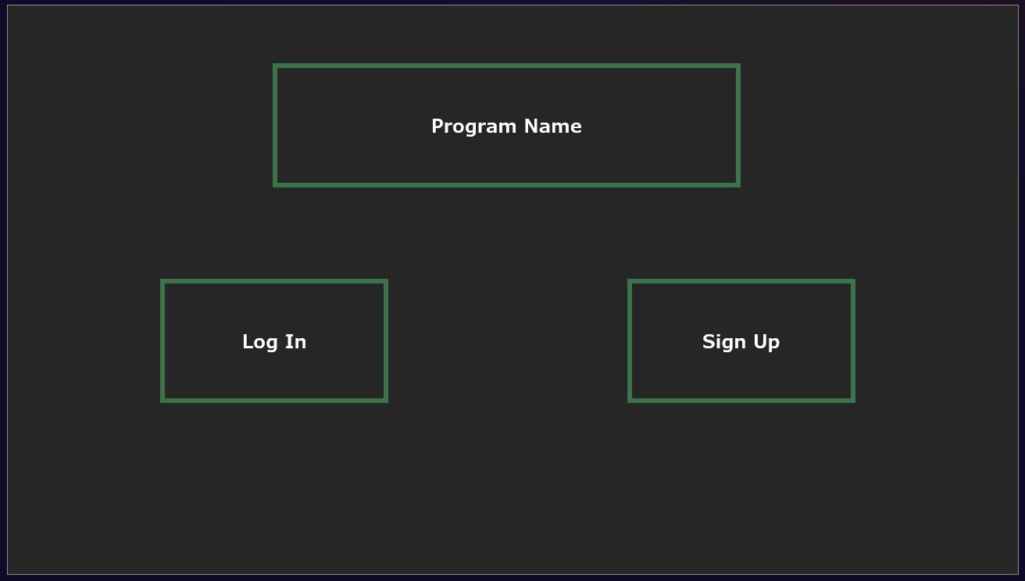
Explanation:  This is a rough design for the opening page  It contains the log in and sign-up options, one using an existing account, another using a new account, in addition to the name of the program (Work in progress)  I wanted to make this page as simple as possible; its only purpose is to guide the user as to which account option they need to use.  One side has the log in option, I used a button for this as it is the most simple method, if the user clicks this, it will take them to the log in page, Alternatively I could have used a hotkey or an icon, rather than text, however I found there was no clear way of showing the difference between logging in and signing up. This led to me making this choice  The other side features a sign-up option, I also used a button due to its simplicity, as to not overcomplicate this, this will take them to the sign-up page to make a new account. Alternatively, Icons could have been used to simplify the experience, I also felt this would overcomplicate development unnecessarily, in addition to having a less clear purpose. | Justification:  I have made the UI for this as simple as possible while still keeping it functional, I had the option to use icons however I was unsure how to clearly show the difference visually between signing up and logging in, I used a button with text on  If I manage my time effectively, I may implement a more detailed page for this, however as it is not an essential feature, I needed to prioritise other essential functions.

Home Screen:
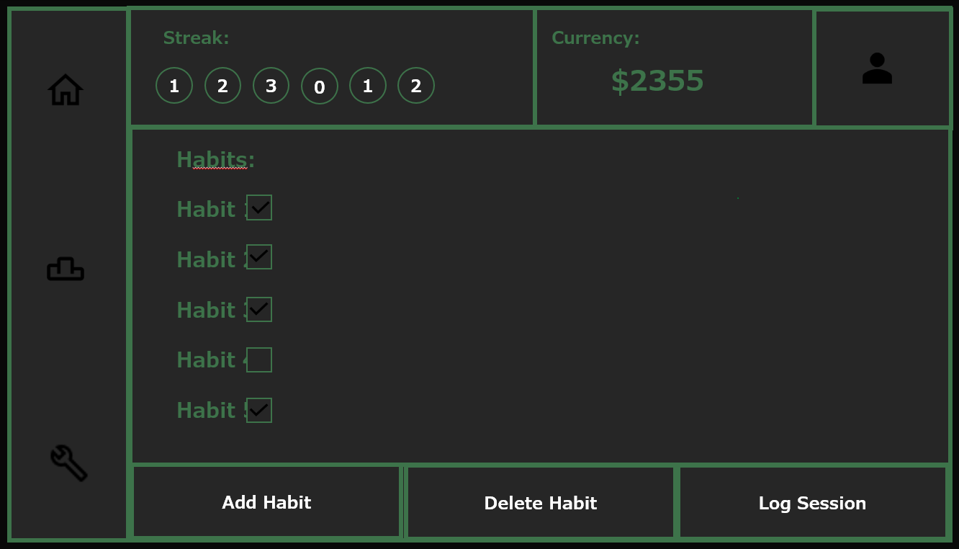
Explanation:  I decided to have a bar running down the side, containing the option to visit each page, to simplify this and improve usability I used icons for this, making the pages simpler to navigate. Additionally, throughout the program, regardless of which page is being accessed, alternatively, using a hotkey or having the menu elsewhere on each page, this may be less obvious to users and would make this more difficult for navigating.  In the top left there is a diagram showing how consistent the user has been, their daily streak, this will show across the week how consistent the user has been.  At the top, it will show how much currency the user currently has, this will change when it is spent or when a session is logged. In the top right it will show the avatar the user currently has, this may change and it will need to check whether it has changed as its loading. This is optional, but I think it makes the program much more effective  The centre of the main page contains a list of the current habits the user is currently doing. When the user logs a habit session it will tick off the habit for that day, that is the purpose of the checkboxes, this in my opinion is the most user-friendly way of showing how much the user has done.  At the bottom of the page there is the options to add a new habit, edit an existing habit, and delete a current habit. This seems the most user-friendly option, if this were anywhere else it would be in the way of other components, it also seems the most obvious choice | Justifications:  The bar running down the side means the user can navigate the pages very easily as this will be a consistency, this would be the most obvious method for the user to figure out, use of hotkeys may be difficult to learn.  The Streak Diagram will be effective because it is very visual and allows users to see how consistent they have been over the last few days.  The currency info is in the corner, as it will need to be accessed, but it will still need to be out of the way enough for the user to do other actions.  I added a button in the top right corner that gives the user the option to log out of the account, this is out of the way so it can’t be accidentally clicked but, on the page, so it can be accessed.  I put the habit information in the centre of the page, I did this because it is the main purpose of this page; to have an overview of everything, further use of buttons will also make it more user-friendly and accessible.

Leaderboard Screen:
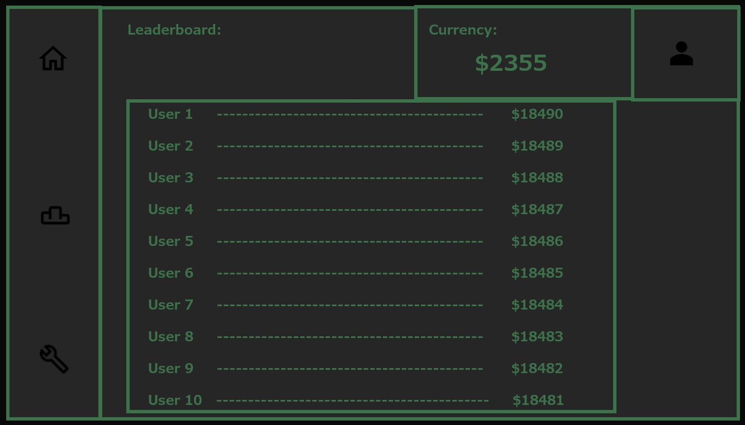
Explanation:  I kept the same bar running down the side, ensuring that it remains easy to navigate, in addition to the UI at the top, it also has a title showing what the page means, if I didn’t include this it may be difficult to understand and navigate.  I have also kept the same UI in the top right, I wanted this to remain consistent for the sake of usability, this will ensure the user will understand the layout much more efficiently, it takes less time to learn how the program works.  Below this is the main part of the leaderboard page, it will show the name of the top 10 users and the amount of currency they have, I aimed to have this executed in a clear way, using a line of dashes to show which user has which score more clearly, this shows the user how the best user are scoring, I made this the main feature of this page, as it is its main purpose. Alternatively, I could have included this in the main page, in my opinion this would have made the main page look too busy and crowded, this seemed the most sensible option as it would make pages more readable and usable, having each page have its own function allowed for a cleaner design. | Justifications:  I left the same bar down the side to enhance the usability, having this bar in the same place for all pages makes navigation easier, as its more consistent across the program.  Also keeping the same UI in the top right means the user becomes more familiar with the log out process, and where they can check their currency, keeping this consistent was crucial to keeping it usable.  Below this is the actual leaderboard, this will be accessed by a quick sort algorithm that will find the top 10 users and their currency, and display this on a table on the screen. I made this a separate page to avoid the main page becoming too cluttered, aiding the readability and having a more usable design.

Customisation Page:
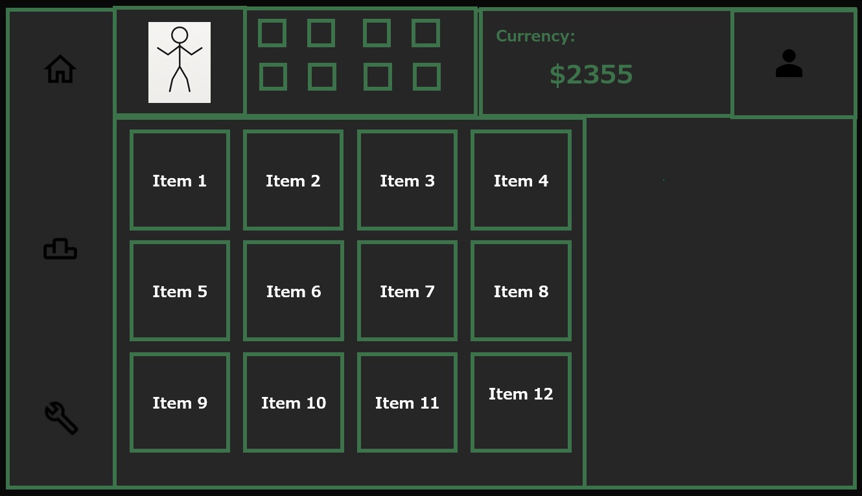
Explanation:  This page’s purpose is to allow the user to customise their avatar.  Keeping the same bar of pages down the side and the currency and avatar icon in the top right, for consistency  It will show the users avatar at the top of the screen, along with the currently equipped customisations. Alternatively, this could have been a list, however I feel this would have been unclear as to which item is which, using images will simplify this so the user can more easily navigate this  Below I will have all available items that can be purchased, these will also use images for a simpler display, in addition to their respective costs. This felt like the simplest way to execute this, alternatively I could have used just plain text, this while being more efficient and simpler to develop, may have reduced the effectiveness of the UI | Justifications:  I left the same bar down the side to enhance the usability, having this bar in the same place for all pages makes navigation easier, as its more consistent across the program.  Also keeping the same UI in the top right means the user becomes more familiar with the log out process, and where they can check their currency, keeping this consistent was crucial to keeping it usable.  I gave a list of the available items for purchase, if the user has purchased any then it will be indicated on this screen, also with the option to equip and buy it.  I have done this as it feels most accessible and usable, showing it visually rather than less visual.

Variables, Data Structures and Validation

Variables and Data Structures

Name | Data Type and justification | Use Case
usernameInput | String, usernames are alphanumeric, but there will never be any arithmetic operations done to this, this also makes it most efficient to store and search for. | Captures the input of the username when login or signup, and to be added or compared to the database, we don’t need separate variables for logging in and signing up because it doesn’t matter if this is overwritten.
passwordInput | String, passwords are also alphanumeric, again no arithmetic operations are done so numbers can be stored as text, also making validation more efficient. | Captures the input of the password at login or signup, must also be added or compared to the database, overwriting is irrelevant so we can keep the same variable for login and signup.
Result | Boolean, most simple and efficient method for checking whether the instance of an account, there are only two possible outputs from this, info found from database or not. | Determines whether the login data matches any records in the database, True if it matches, False if not found, this will also determine program flow, if True then the user will be sent to the main page, false they will be prompted to re-enter recursively.
habitInput | String, these are text-based only, strings are most efficient and simple for database queries and searching. | Identifies the habit that the user has spent time on, this will subtract the time spent from the total daily time until the minimum amount is met.
timeSpentHabit | Integer, arithmetic operations will need to carried out on this variable, an integer will allow for this most efficiently, it will ever be a number due to validation carried out. | Stores the time that is spent on the selected habit, this stores the time spent so far on the habit, this will be subtracted from the daily minimum, and will be inputted by the user.
timeLeftHabit | Integer, another example where arithmetic operations will need to be carried out, exclusively numeric values will be stored in this due to other validation. | Stores initially the total time that needs to be spent on the habit, this will decrease as the user logs time spent until its less than zero, once it is less than zero it is completed.
newHabitName | String, will purely be text, this will be most suitable for efficiently searching for the names. | Stores the input of the new habit to be added to the database and list of current habits.
timeDaily | Integer, requires calculations and comparisons, also will be purely numeric, so integer will be the most efficient data type. | Used to reset the timeSpentHabit variable once it is the next day, every habit will have this so it will be one of the attributes of the habit class.
currentUserID | String, most efficient for database queries and manipulation, no arithmetic operations will need to be carried out on this. | In order to find the correct habit, it will need to be specific to the user, so that other users habits cant be deleted by brute force, used to find the specific record of a habit.
habitDelete | String, works most efficiently for database queries, will be purely alphanumeric, so no other data type will be appropriate. | Stores the name of the habit to be deleted from the users list of habits, as requested and inputted by the user.
oldHabitName | String, necessary for database operations, also no arithmetic operations will be done, as it will be alphanumeric. | Used to find the name of the existing habit for the user that they want to edit, so that it can be appended.
newTimeSpent | Integer, numeric values, will need to have mathematical operations done to it, therefore integer is necessary. | Updates the time requirement for the habit needing to be edited, this will append in the database.
leaderboardData | 2D list, necessary for holding and organising user data, comparisons may need to be made so values will be integer. | Displays the top users along with their currency on the leaderboard page, using one row for storing the top 10 usernames and the second for their currency amount.
habit | Class, has multiple attributes so using a class will encapsulate these, code will also be more modular and reusable, increasing efficiency and development times. | Represents each habit as an object, attributes such as name, dailyTime, this will allow for more efficient programming and performance, reducing testing complexity.
rewardsSystem | Dictionary, will allow for mapping keys to determine how much currency should be rewarded. | Calculates the deserved in-game currency rewards based on their streak length, time spent on the habit and general consistency.
CustomiseInventory | Dictionary of dictionaries, each item has multiple properties, nesting dictionaries will organise items by category and their attributes. | Displays the available items, also checking their affordability and updating when purchases are made, making use of keys for efficiency.
completionRates | List of Integers, ideal for sequential data, this will represent numeric values for analysis. | May be used for visualising user data, in addition to the rewards system dictionary, aiding in calculating rewards amounts.

Validation

Sign up/Log in:
In this I have included validation to ensure the username for the new account is not already taken, this will cause errors in the database, this will ensure no users can access other users information, as usernames must be unique, if the username is taken the user will be prompted to re-enter a new username with an explanation. Also, the password length is not too short but not too long, this will keep password relatively secure, ensuring they are not too short, and confirming that the password isn’t excessively long, this could be exploited by users, making the database too large and inefficient, I decided that passwords should be between 7 and 20 characters, if the password isn’t between these two the user is prompted to re-enter a new password with an explanation.
Similarly the Login Function has validation for an existing username with correct password. When a username is entered to log into the account it will search the database, if the database returns True, indicating the username exists then the user can progress and the password is checked, if the search turns up false the user is prompted to re-enter a username with an explanation. Once this happens the password is checked to see that it’s the same as the stored password, if this is the same the user is sent to the main page, if not the user is prompted to re-enter their password with an explanation.

Log Habit Session:
There is no need for validating the selected habit, other than the fact that nothing will happen if the user doesn’t click on one of their existing habits, which will be displayed on the screen. However validation is necessary for entering the time spent, if the time entered is not a positive integer then this must be rejected, should this happen the user will be prompted to re-enter this and redo. This will allow for the value to be subtracted from the amount stored in the database.

Add/Edit/Delete Habit:
In the Add and Edit Habit sections, any time inputs that are not a positive integer will be rejected, this will be handled recursively, by calling the function and asking the user to re-enter all information, I could have avoided this using an iteration, however this would be unnecessarily complex, and achieve the same function, the recursive option does so more elegantly and efficiently, this will make testing more simple, as I can just test one short function instead of an iteration inside the function, reducing complexity of development

Iterative Development Test Data

Code, Test (use design test plan), screenshots as proof, description of code function, if it works pass to next, if not then explain find solution and retest, get feedback
I will use my Iterative Development Test Data to test modules of code during their development. If this test does not yield a correct output, I will diagnose the error, attempt to fix it and test the module again, continuing to test and modify until a fully functional module of code is made.
For each subroutine, I will begin by creating a functional prototype, this will be fully text-based at first, ensuring I can correctly query and modify the database, I will then build on this, adding GUI elements and further refining its usability. Testing this will require use of Typical, Boundary and Erroneous test data, ensuring they produce the correct output for any input, valid or invalid.

Sign Up

usernameInput
Type of test data | Data | Explanation | Justification
Typical | Abc123 | Will be attempted once the code starts working, should return successful | Tests that the database queries work as intended
Boundary | “” | Empty space, shouldn’t be accepted due to validation, because of the fact it isn’t an actual username | Tests that it will accept empty space, all tests can only be accepted once
Erroneous | Abc123 | After doing Typical test, it will be saved in database, meaning when entered it should return false and prompt user to re-enter | Tests that we can detect any existing usernames identical to the entered username, done above

passwordInput
Type of test data | Data | Explanation | Justification
Typical | Password99!! | Tests a password within the bounds, should return accepted and save to the database | Tests that the database insertion functions properly
Boundary | 1234567 | Tests on the boundary of the minimum accepted length, should be accepted as it is inclusive 7-20 | Tests that the length comparison works
Erroneous | abcdefghijklmnopqrstuvwxyz | Too long, should be rejected as it is out of range | Tests the length comparison can reject passwords

Log in
usernameInput
Type of test data | Data | Explanation | Justification
Typical | Abc123 | Once I have done the sign up function, I need to test the account made can be logged into | Tests that we can search the database for an existing account
Boundary | “” | Empty space should return that the account exists, as it was created when we tested the sign up module | Checks that it will accept most forms of usernames and validates this from the database
Erroneous | adminAccount | A username that does not exist and should reject this and prompt the user to re-enter info | Checks that it can reject some entered info

passwordInput

Type of test data | Data | Explanation | Justification
Typical | Password99!! | Should be accepted as this account should have been saved | Tests that it will take you to the main page properly
Boundary | N/A | N/A | N/A
Erroneous | abcdefghijklmnopqrstuvwxyz | Shouldn’t be accepted as it shouldn’t have been saved when we tested the sign up function | Tests that it will prompt users to re-enter their information if its incorrect

Log Habit Session
timeSpentHabit
Type of test data | Data | Explanation | Justification
Typical | 60 | Spending an hour on a habit is expected | Tests that the database queries and modifications are successfully executed
Boundary | N/A | There is no boundary test data because any input is either typical or erroneous, correct or incorrect, so its not applicable | N/A
Erroneous | -0.5 | Tests that any non-integer values or values less than zero will not be accepted | Ensures that the algorithm is robust enough to reject some invalid inputs and respond accordingly

habitInput
Type of test data | Data | Explanation | Justification
Typical | Clicking on an existing habit | Should modify the data stored for this named habit | Checks that the buttons work as intended and can modify the database
Boundary | N/A | No boundary data as it is unrealistic to click between individual pixels | N/A
Erroneous | Clicking anywhere else on the screen | Should not do anything, as it wasn’t clicking a valid habit | Checks that the buttons being pressed will only be accepted when the user clicks inside the button

Add Habit
newHabitName
Type of test data | Data | Explanation | Justification
Typical | Exam Revision | Tests that it will allow spaces, additionally that this can be correctly inserted into the database | Checks that the basic SQL commands will run correctly and produce correct outputs
Boundary | A | Minimum length, checks that any length input will still give correct results | Ensures we accept the extremities, either the very long or the very short
Erroneous | “” | Should be rejected, unusable for a GUI, hence we need to ensure that no empty inputs can be allowed | Ensures that the program can deal with inputs that are irregular in a GUI

timeDaily
Type of test data | Data | Explanation | Justification
Typical | 60 | Tests that basic normal data would be accepted and that the program will correctly store this | Checks that the SQL statements are functioning as intended
Boundary | 0 | Rejected, should not accept spending zero minutes, checks it can take this into account | Checks we can successfully deal with zero inputs, as this would not be cleared by doing an integer check
Erroneous | -12.5 | Rejected, as it will confuse any later analysis done in the database, also ensures no fractional numbers are allowed | Would be rejected by doing a check its positive, and the input MOD 1 = 0

Delete Habit
habitDelete
Type of test data | Data | Explanation | Justification
Typical | Clicking on an existing habit | Should remove the habit stored for the habit in the database | Checks the buttons work as intended and can modify the database
Boundary | N/A | No boundary data as it is unrealistic to click between individual pixels | N/A
Erroneous | Clicking anywhere else on the screen | Do nothing, as it was no pressing a button | Checks that the buttons being pressed will only be accepted when the user clicks inside the button

Edit Habit
oldHabitName
Type of test data | Data | Explanation | Justification
Typical | Clicking on an existing habit | Should remove the habit stored for the habit in the database | Checks the buttons work as intended and can modify the database
Boundary | N/A | No boundary data as it is unrealistic to click between individual pixels | N/A
Erroneous | Clicking anywhere else on the screen | Do nothing, as it was no pressing a button | Checks that the buttons being pressed will only be accepted when the user clicks inside the button

newHabitName
Type of test data | Data | Explanation | Justification
Typical | Maths Revision | Tests that it will allow spaces and can correctly identify the record in the database | Ensures the SQL commands function as intended, finding the record
Boundary | A | The minimum accepted length, checks that all length inputs function correctly | Checks it accepts all inputs, that aren’t empty
Erroneous | “” | Should be rejected, unusable in a GUI, hence we need to ensure no empty inputs are permitted | Ensures it will deal with irregular inputs correctly

newTimeSpent
Type of test data | Data | Explanation | Justification
Typical | 60 | Tests that basic normal data would be accepted and that the program stores this correctly | Checks SQL statements are functioning as intended with correct outputs for this input
Boundary | 0 | Rejected, should not accept spending zero minutes, ensures that we take these into account | Ensures it deals with zero inputs, simply by doing newTimeSpent > 0
Erroneous | -12.5 | Rejected because any negative or fractional times will confuse the calculations done on these numbers | Rejected by the above check, but also by doing newTimeSpent MOD 1 to check its an integer

Leaderboard Checker
Type of test data | Data | Explanation | Justification
Typical | userA: 5  userB: 50  userC: 345  userD: 865  userE: 236  userF: 643  userG: 634  userH: 56  userI: 857  userJ: 865  userK: 567  userL: 45  userM: 645  userN: 587  userO: 224  userP: 735 | This is a set of 15 users that will be created and stored in the database, this will be used to test that we can successfully sort through the list of users in order to find the 10 highest numbers. This contains no negative or fractional values, and should function as intended | Ensures we can successfully take all records from a database and sort them, this tests that the actual SQL will function
Boundary | userA: 5  userB: 50  userC: 950  userD: 950  userE: 0  userF: 643  userG: 634  userH: 56  userI: 857  userJ: 865  userK: 567  userL: 45  userM: 645  userN: 587  userO: 224  userP: 735 | This is a near identical set of users, apart form the fact user E have zero, while this is on the boundary, it should still be accepted, also users C and D have the same currency, it will also test the more than one user having the same amount of currency will not affect results | Ensures the program can deal with scenarios where multiple users have the same currency, and still execute as intended
Erroneous | userA: -5.5  userB: 50  userC: 345  userD: 865  userE: 236  userF: 643  userG: 634  userH: 56  userI: 857  userJ: 865  userK: 567  userL: 45  userM: 645  userN: 587  userO: 224  userP: 735 | This is the same as the typical test data, apart from user A’s currency is negative and fractional, despite the fact that there is no real scenario where this will happen, due to other previous validation, it is still crucial to check we can deal with invalid inputs | Ensures any negative, non-integer values will not be included, the program may confuse that -501 is larger than +500, as the absolute value is larger, however it should not accept this and that is the purpose of this test

Post Development Test Data

To test my final solution, I will have stakeholders test my project. I will purposefully use stakeholders that are unfamiliar with the structure of the program, in order to test that the game is usable. If I used stakeholders that were familiar with the structure of the program, results may be skewed in my favour, and I need to ensure that it will be easy to navigate for new users.
I will ask my users to create an account, log out and log back in, checking that all of these are possible and for any inputs. After this I will ask them to attempt to create a habit, edit the habit, then log a habit session, then delete the habit. After this I will ask them to check the leaderboard. Then I will edit the database to give them currency, then I will ask them to purchase an item, before equipping and de-equipping it.
Test | What I will ask users | Purpose/Justification
Launch program from the startPage function, there will be a title and two buttons. Buttons will have appropriate labels to prompt users, ideally this can be navigated in under 10 seconds | I will ask users to complete what they think a new, first-time user would do, in this case it would be the sign up option to make a new account | Tests that the Start Page is user-friendly enough, so that they can efficiently navigate through the system and ideally end up on the sign up page
Users have pressed the Sign Up option, there should be two input fields, labelled to input a new username and password, on the assumption their username is unique, this should be navigated in under 60 seconds | I will ask users to make a new account, entering any relevant information wherever they feel is appropriate | Tests that the UI is readable, ensuring clarity of where the user should enter their username and password, once entered users should be navigated to the main page, on the assumption the username is unique and the password is correct length
Users are brought to the home page, there will be a series of buttons and options, this should be navigated in under 10 seconds | I will ask them to log out of the account and log back in; I will not tell them where or how to complete this | Tests that it is clear how to log out of the program and the log in process is also clear, and that it navigates to the correct page.
Users will be brought back to the start page, and this should again be navigated in 10 seconds to tell them to log in to the account they just made | I won’t prompt them at all for this because they were told what to do in the previous box, they should be able to navigate this efficiently | Tests that the log in page is also clear, and that its functional. Users should also be sent to the home page again to ensure this functionality
Users will go to the main page and make a new habit, giving it whatever name and time they want. This should be done in 20 seconds or under. | I will tell them to create whatever habit they want with no further prompting | Checks that the buttons are in a clear, readable position and that their functions are obvious.
The screen will refresh with the new habit on the screen, and they will need to log a habit session; this must be less than the daily time | I will ask the user to treat it as if they have just completed approximately half the daily goal | Checks that it is clear how to log a habit session and that they can log it more than once.
The screen should indicate that the habit has been completed for the day with a tick. This should be completed in 15 seconds maximum | I will ask the user to treat it as if they have fully completed their daily goal. | Checks that it will show the habit as completed on the screen once it's finished
Users now return to the home page and they should edit the habit they have just made with a different name or time or both. This should be done in under 20 seconds | I will tell the user to interact with the habit they have just made, in order to change its name or time spent. | Ensures the edit function is clearly accessible to the users, and that it is functional
Users return to the refreshed home page, again showing the new habit name or with adjusted time. I will then tell users to interact with the habit to delete it. Done in under 10 seconds. | I will tell the users to interact with the habit they have just edited and delete it, to remove it from your list | Ensures the edit and delete functions are easily accessible and that they function as intended
Users are again returned to the home page with an empty list of habits. I will now get them to check the leaderboard. In under 10 seconds. | I will tell users to navigate to the leaderboard page. Then navigate back to the home page | Ensures that the icons are clear to users which is the leaderboard and which isn’t, allowing simple navigation
Users return to the home screen and I ask them to go to the customise page, this should take under 5 seconds | I will tell the users to interact as if they want to customise their avatar | Ensures the customise button is clear and easy to read
Users purchase an item from the shop with the currency they earned from logging the habit earlier, 10 seconds | I will tell the users to purchase any item | Ensures that there is validation in place to check that they have enough currency to purchase the item, and its functionality
Users equip the item, 10 seconds | I will tell the users to equip the item they have just purchased to their avatar | Ensures the equipping function is easily accessible and functional
Users move the equipped item round on their avatar | I will tell them to rearrange the equipped item on their avatar | Checks that the avatar items can be moved to where the user wants them

I will also conduct my own testing on the final product, allowing me to test for any faults and errors in a much greater depth. Some tests are applicable for many different functions, e.g. the currency, streak and account icon, so these are all tested on each page they are included in, and clearly mentioned in the table, also ones that say ‘general’ mean they will be part of lots of pages, however the code is identical for all of these so testing is only necessary for a few:
What is being tested | How will this be tested | What is the expected result | What was the actual result | What actions need to be taken as a result of this
Start Page: Do the buttons function | Click each button, log in and sign up | Taken to the log in or sign up page
General: Do input boxes activate | Click each input box and click off it, changing between each field. | Colour should change whenever clicked on/off, if one is on and the other is clicked, the activation should switch to the other
Sign Up: Do Input boxes record the inputted characters | Click on each input box and type characters, then backspace is pressed | All characters are displayed in the text box, when backspace, should remove the last character
Sign Up: Are invalid inputs rejected | Enter the details to an existing account, then enter a too-short password | Should be rejected and sent back to the sign up page with an explanation of the failure.
Sign Up: Are you sent to main page and is the data saved | Press the enter button and open the database | When entered, the screen should go to the home page, and the database should update with the relevant details inputted
Home/Customise/ Leaderboard: Does the account button function | Press the account button in the top left corner | A pop up button should appear with the text ‘Log Out’
Home/Customise/ Leaderboard: Does the Log Out button work | Once the account button is pressed, press the pop up button | Should send the user back to the start page.
Home/Customise/ Leaderboard: Is Currency Correct | On the main page check currency, then open database and check currency | Should be identical in both
Home/Customise/ Leaderboard: Is Streak Correct | On the main page check the streak length, then open the database and check it for the logged in user | They should both be identical
Home/Customise/ Leaderboard: Do Buttons down the left side work | On the main page, press the customise page, then on customise page press on the leaderboard page, on the leaderboard page press customise, and on customise press the home page | Should take users from home -> Customise -> Leaderboard -> Customise -> Home, this allows all possible paths to be tested, and that all the icons do function as buttons
Home Page: Can you access the add habit button | Press the add button at the bottom | A popup appears prompting the user to enter new info
Add Habit: Does the add habit save | Enter relevant info for the habit and press the enter button | It should display it on the screen as the habit list and update the database with a new record
Add Habit: Is there validation for the Add Habit option | Enter incorrect info, e.g. a very large time and a time that has letters e.g. time = ‘1x5s’ | Use of letters should be rejected, also very large times > 500 should be rejected.
Home Page: Does the log habit button function | Presses the log habit button | A pop up should appear, prompting the user to enter the details of their session
Log Habit: Does the log Habit work | Enters time, less than the daily time, and presses enter, then does this again with more time, so the sum is more than the daily time | After the first, the database should change, to store the amount of time left for the day, after the second then the completed checkbox should be true
Home Page: Does the 3 dots function | Presses the 3 dots | A pop up button should appear, with further options to either edit or delete the selected habit
3 Dots Popup: Does the Edit Habit Button work | Presses the edit option on the pop up menu | Another pop up should appear showing options to change the name of the habit or the time spent daily of the habit
Edit habit: Does the edit habit work | Presses the enter button on the popup to save the new updated info | The edited version of the habit should appear on the screen, and the database should be updated
3 Dots Popup: Does the Delete Habit Button work | Presses the delete option on the pop up menu | The Habit should be removed from the list and the screen, also the database should be altered
Customise Page: Does it function | Clicks on the customise page | There should be a smaller window with the users current avatar, below a list of options of items to equip
Customise Page: Can you buy and equip | Purchase an item with your currency by clicking on it and accessing the pop up menu, | The item should appear as purchased and equipped by appearing on the avatar, currency should decrease.
Customise Page: can you dequip | Take a purchased item and click it to access the pop up menu and dequip it | The item should disappear from the avatar
Leaderboard Page: Does the leaderboard function | Clicks on the leaderboard page | A leaderboard of the 10 highest scoring users should be displayed with their respective currency in descending order

Development

Initialise Database Prototype 1:
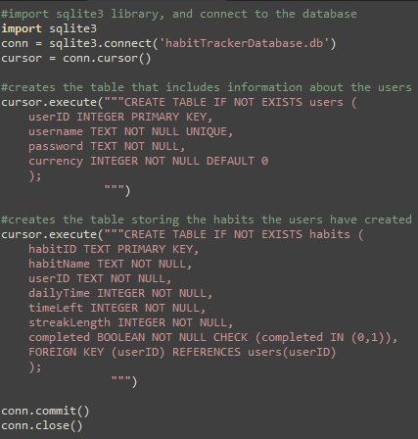

Description of Sub-program:
Before I can begin writing functions, I will need to create an initial structure for the database, as described in my design section. As my first subroutines, (the sign up and log in function) will need to query the database. This code will only ever need to run once, because once the table has been created it will be stored, the purpose of this is only to create the initial and empty database.
While I have used SQL before, I have never used the pysqlite3 library, so to learn to do this, I used the geeksforgeeks and w3schools pysqlite3 tutorials to figure out how to create a new table, I found this helpful, not only for creating new tables but querying the database.
Testing:
In order to test that this works as intended, I will open the database file in notepad and check that it has saved the relevant attributes that are written in the code, if I see that there are some fields mentioned in the source code are shown in the notepad file, it has been created successfully, what I found in there is shown in the image below, this will prove that the database has been made successfully.
User feedback (if applicable and if not a justification):
This program will not be run in the main program; it was only ever run once to initialise the database so user feedback on this was unnecessary as they would never see it
Errors and actions taken:
The only minor errors I encountered were simple syntax errors where I would spell one of the fields incorrectly, or not include the data type in capital letters, these were fixed quite simply, as the syntax error messages helped me search for this.
I only encountered a few minor errors, mainly that some data types of fields weren’t in capitals which would cause an error, In the error message it would say exactly where the error occurred and what the error was, these were fixed and I deleted the old empty database, so that it would make a new database, because of the “CREATE TABLE IF NOT EXISTS”, I tested in exactly the same way and the results below were shown.

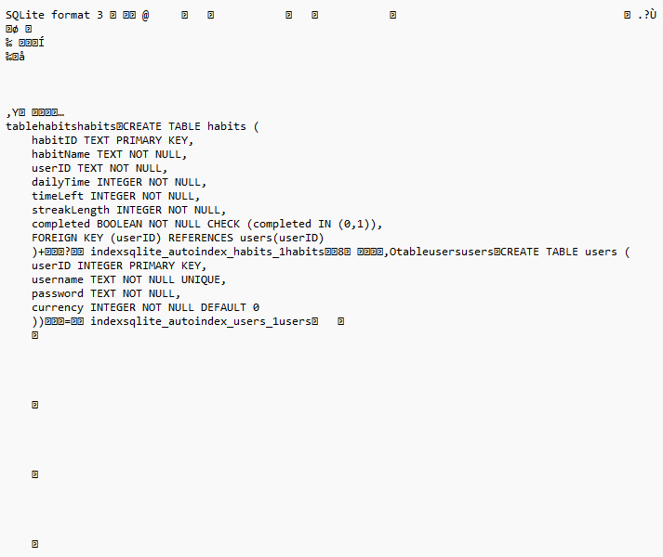

Sign Up Prototype 1:
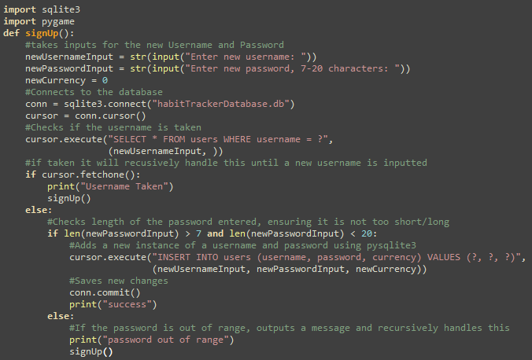
Description of Sub-program:
To start this algorithm, I want to ensure that the bare algorithms functioned as intended, before building on it with a GUI and other visual elements, I am beginning with a simple text based program, where the user inputs their new info, and it initialises other fields required, before adding this record to the database. After I had a working database query, I built on this with some essential validation, checking that the username inputted is not already an existing username, before checking that the password is between the allowed bounds, in terms of characters, if anything is incorrect with the username and password, it will be solved recursively, asking again for a re-entered username and password with an appropriate message. I approached it this way as it meant that it wouldn’t need to be changes significantly to implement a GUI.
Testing:
To ensure this works I would execute the function, then enter a sample username and password from the iterative test data above, then I would open the .db file in notepad and refresh the page, if the username and password appeared in the database file it worked successfully (screenshot of the database result below)
When I tried the boundary test data it functioned as intended, rejecting it and calling itself recursively so no additions were needed
However, when I did the erroneous test data, I would enter a username that already exists in the database to see what it would do, this is handled recursively and worked as intended, prompting the user to enter info that is not already taken
User feedback (if applicable and if not a justification):
Generally, user feedback is that a text-based approach is not usable enough, this was anticipated. Because this was the first prototype it was my intention to expand this further to a GUI instead, this prototype’s role was simply to ensure that the SQL statements worked as intended, I will work on this in later prototypes, but for now as long as I could perform database operations, this prototype has served its purpose.
Errors and actions taken:
There were a few minor syntax errors, but as there is no GUI for this prototype the implementation was relatively simple

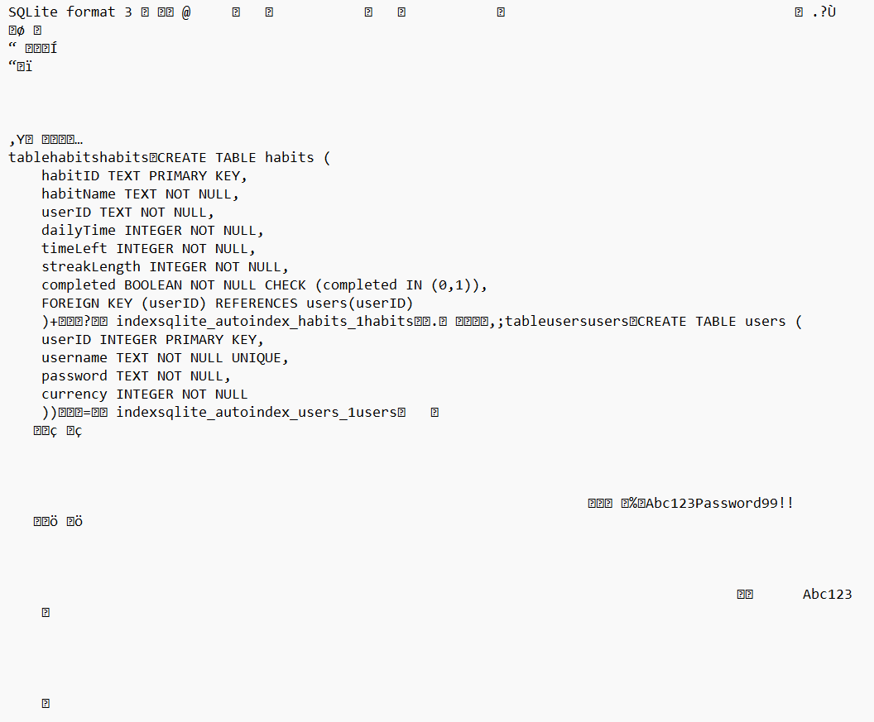

Log in prototype 1:

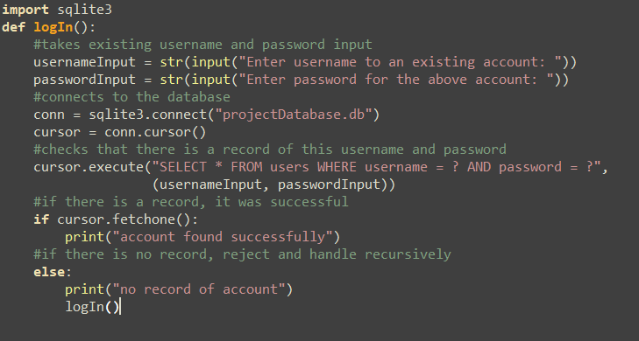
Description of Sub-program:
The purpose of the Log In page was to allow the user to enter the username and password to an existing account, this can only be done after the Sign Up program, as there need to be existing accounts in order to test it works. Again, as this is the first prototype, I only wanted it to be text based so I can ensure the database queries function as intended. I can then build on this later with a GUI and other elements. I also added in validation, ensuring that if the account wasn’t found, it can be handled accordingly
Testing:
When I tried the normal test data, (same as password normal data), It worked as intended, it found the account information successfully and gave the correct output
When the boundary was attempted, it also returned successfully, because when the sign up was done, the empty username was saved successfully, additionally with the same password meant it worked as intended
When the erroneous data was used, it recursively handled this, as the account had not been made, so it should recursively call the function again
User feedback (if applicable and if not a justification):
Similarly to the Sign-Up prototype, feedback is that a text-based approach is less usable than a GUI, this was expected. And because this is my first prototype I was always going to expand on this with a GUI. It was simply to check that I could use the SQL statements effectively, I will work on a GUI in later prototypes, but for now as long as I could perform queries it works
Errors and actions taken:
A few minor syntax errors from misspelling or other errors, they were resolved relatively quickly and retested in the same way

Start Page Prototype 1:
The intention of the Start Page was to let the user decide which option they want between logging in and signing up, A simplified pseudocode version, this shows the general program flow but does not show any coordinates or Pygame methods needed, that in addition to test data is shown below
from logInFunction import logIn
from signUpFunction import signUp
procedure startPage():
logInButton.initialise()
signUpButton.initialise()
if mouseClicked == True
if mouseCoordinates == logInButton.coordinates then
logIn()
elif mouseCoordinates == signUpButton.coordinates then
signUp()
else:
pass

Type of test data | Data | Explanation | Justification
Typical | Clicking on the log in button | Should call the log in function | Checks that the buttons function when clicked
Boundary | N/A | No boundary data as it is unrealistic to click between individual pixels | N/A
Erroneous | Clicking elsewhere on the screen | Nothing should happen as no buttons were pressed | Checks that it isn’t just executing a function whenever mouse is clicked

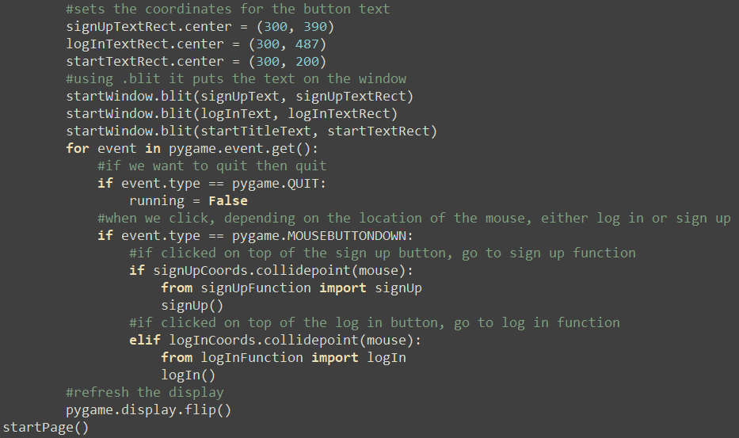
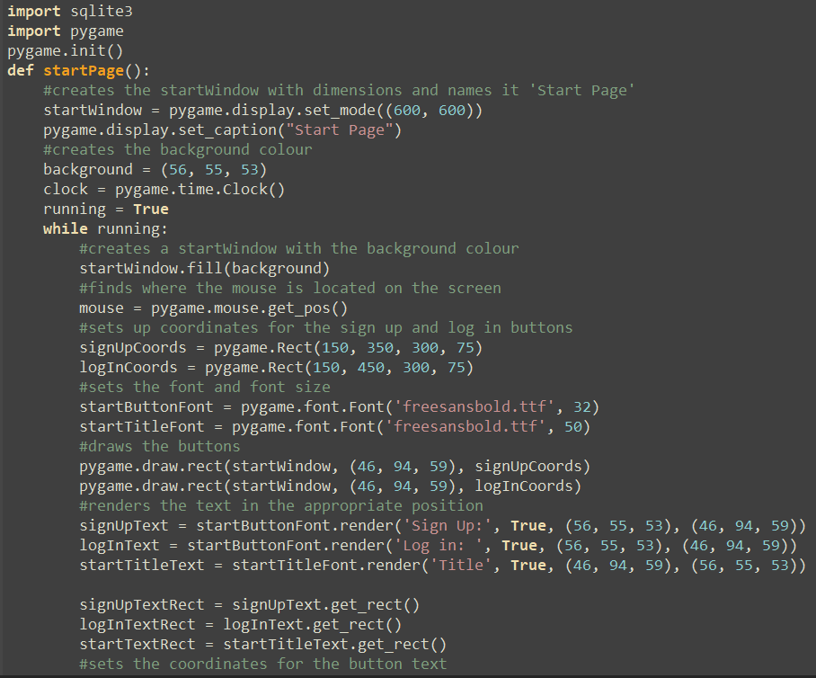

Description of Sub-program:
The start page is only responsible for prompting the user whether to log in or sign up, this is used to link together the functions, this was the first attempt at making buttons and a GUI, I then linked the sign up and log in functions, so that when the mouse was clicked in the coordinates of the button, it would execute the function.
After this I am now at a point where buttons can execute a function upon pressing
Testing:
The only inputs were the user clicking on a button or not clicking on a button, this all seemed to function as intended. The normal test data was executed successfully, when clicked in the coordinates, both functions successfully executed. Erroneous data, when clicking elsewhere on the screen functioned successfully, doing nothing, no actual errors occurred apart from the calling error shown below
User feedback (if applicable and if not a justification):
General user feedback was that the screen wasn’t particularly engaging, while this was somewhat expected as the screen was quite minimal. I decided I would focus on the functionality of the project, then afterwards I would focus on the appearance, colours etc.
Errors and actions taken:
When I imported the functions to execute, (using “from filename import function”, the sign-up function would be executed without me calling it yet, however the log in function worked properly and did not execute until its calling. I checked each program and neither called themselves in the main program at all, I tried saving and rebooting however it didn’t work. I came back to this the next day (on a different machine) and it started functioning as intended, I never encountered this error again, but I went through the retesting process as normal.

Rectangle Button Prototype 1:

This was not detailed in my design so I had to make psedocode and a test table for the button
import pygame
class rectButton:
initialise(window, coordinates, buttonColour, textColour, text, textSize, buttonFunction)
def draw():
pygame.draw.rect(window, buttonColour, coordinates)
rect = text.rect
window.blit(buttonText, rect)
def click():
if event == pygame.MOUSEBUTTONDOWN
if event.coordinates == coordinates
buttonFunction()

Type of test data | Data | Explanation | Justification
Typical | Click the button | Checks that the button can execute functions upon being clicked | Ensures the functionality of the button
Boundary | N/A | It is unrealistic to click inbetween the buttons pixels so boundary data isn’t applicable | N/A
Erroneous | Click elsewhere | Ensures that it wont execute from just pressing the mouse | Makes sure it only executes the function if the mouse button is clicked while on top of the buttons coordinates

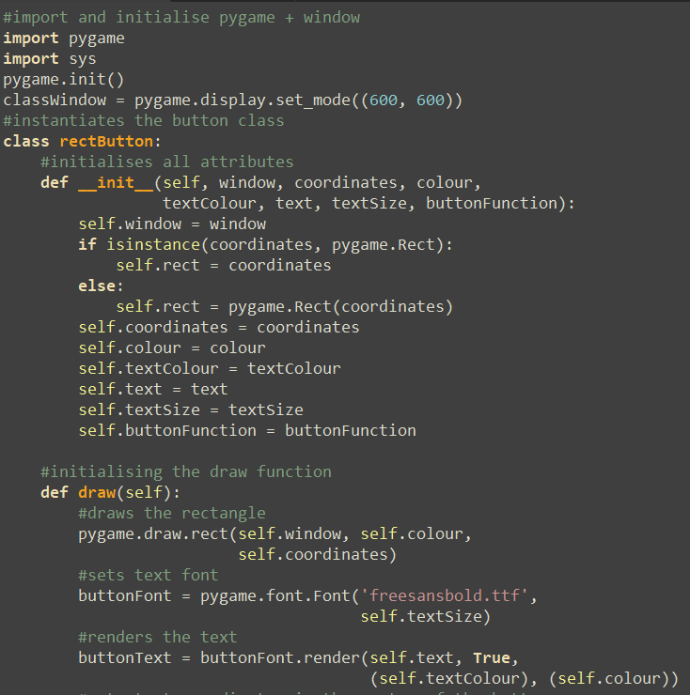

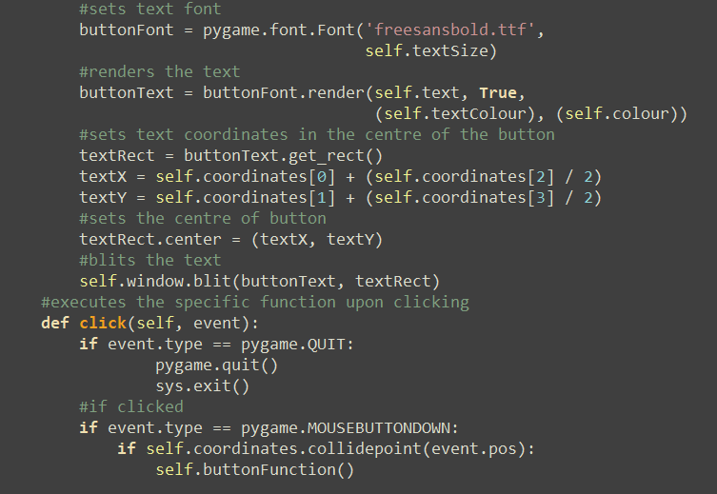

Description of Sub-program:
This Class defines the blueprint that makes all rectangular buttons with text, it has attributes for all relevant coordinates colours and text, and methods for clicking and drawing the button, this made the development process more efficient, as I realised the sheer number of buttons I would be making, it would be inefficient to rewrite the same code every time, so instead I made a class to make the development more efficient
Testing:
Normal Test data functioned as expected, executing the function when pressed and drawing the button correctly, the Erroneous data also functioned as expected.
User feedback (if applicable and if not a justification):
User Feedback wasn’t necessary because this was not a feature that users would interact with directly, it served as a tool for development to be more efficient
Errors and actions taken:
Few errors were encountered, other than few minor misspellings of keywords, but otherwise this process was relatively straightforward

Log in prototype 2:
Initially I only made test data for the entering of information, however there also needs to be one to check whether the active/passive modes worked, so this was included below.
Type of test data | Data | Explanation | Justification
Typical | Clicking on the text box | Should change colour and be able to type into it | Checks that the active/passive modes function
Boundary | N/A | No boundary data as it is unrealistic to click between individual pixels | N/A
Erroneous | Clicking elsewhere on the screen | Nothing should happen, or it should turn passive colour and not change | Checks that it will turn back when clicked anywhere else
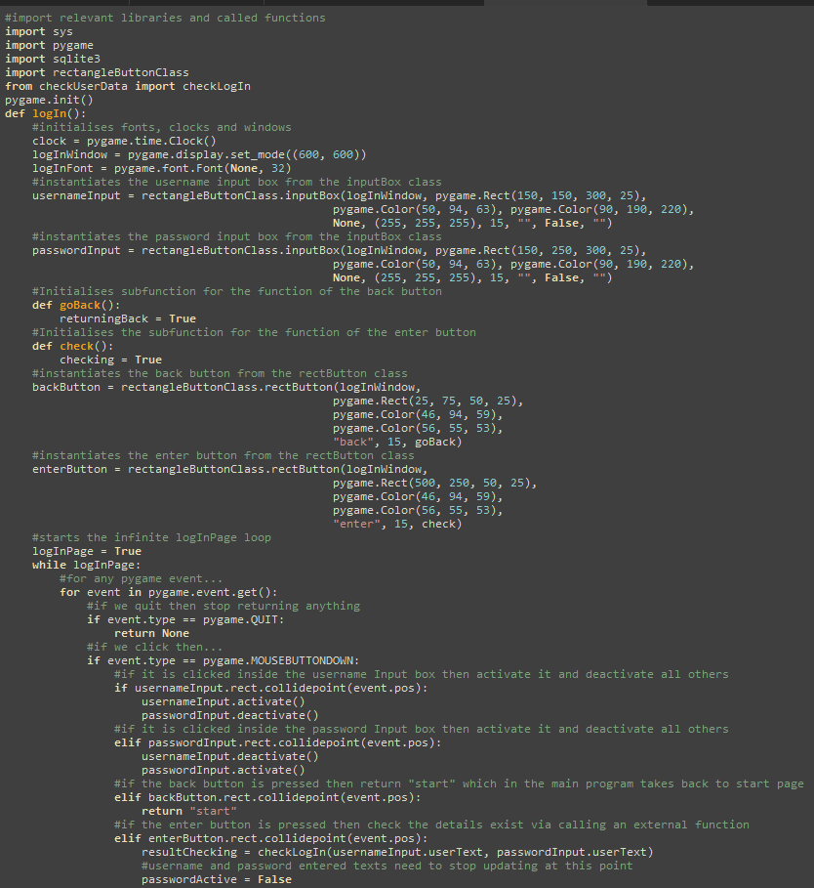

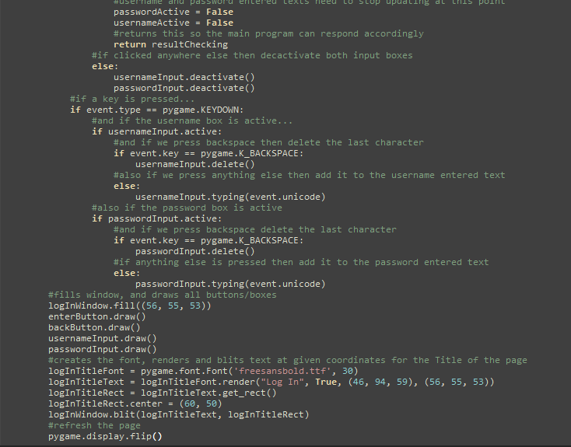

Description of Sub-program:
Once I had made the Start Page a GUI, I refined the initial logIn prototype to make it a GUI, this was so a user could log in to an existing account. But with a GUI, this function caused me to realise that the way I was coding wasn’t efficient and sustainable, this was the function that took the longest because I needed to make many different classes and change the structure of the program to avoid certain errors and make it more efficient. Input boxes were made partially from a geeksforgeeks tutorial, this page would feature two input boxes, an enter button and a back button.
Testing:
When attempting the normal test data, there was an error where the wrong text box was added to, a minor syntax error where the wrong variable name is used, I retested after and this functioned as intended with two boxes. Boundary test data also functioned as intended, whenever anywhere else on the screen was clicked, the box would turn passive or do nothing as it was already passive.
User feedback (if applicable and if not a justification):
Users said that the screen was quite hard to read as it was not high contrast enough, I would work on this in later iterations
Errors and actions taken:
When initially making the box, there was an error where I could not make the input box any bigger, because the input box needs to change dynamically with the size of the input to show it on the screen, this was because the maximum size set was smaller than the default size, so it would turn smaller, so I increased the maximum size.
When I added a second input box, and typed in the password box, it would add to the username box, this was a simple error due to the fact I wrote the wrong variable name in.
Also the second box would flicker on the screen whenever it was ran, I looked through the class code and everything functioned as intended, however in the code written to draw it, I used pygame.display.flip, this was also included later on, meaning every clock cycle I was drawing the box, clearing it and redrawing it again, causing the flickering, I removed the first flip and this seemed to function as intended, I retested with the same test data and this functioned properly.
Once I had reached this point I realised it was inefficient to make a new text box each time it was needed, I decided to make a class for this so input boxes could be more easily instantiated.

Input Box class Prototype 1 (Done between the login 2nd prototype):
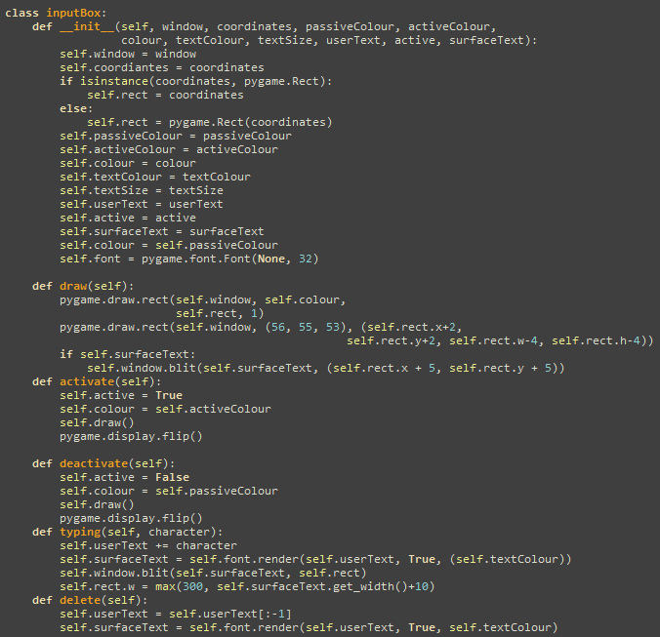

Description of Sub-program:
While making the log in second prototype, I realised how inefficient it was to write the same code for each box, it was more time efficient in the long run to make a class for the input box so they could be more easily instantiated, it worked by taking all attributes in the calling statement, and having a different method to draw, activate, deactivate and type/delete text,
Testing:
When testing the class, I made an example window with an example box. The test data for this would be the same as the test data for the test data mentioned above in the log in prototype. Normal test data functioned as intended, however when I tried to delete it the text wouldn’t clear. After using copilot to help identify the error,
User feedback (if applicable and if not a justification):
User feedback wasn’t necessary because this was not part of the program the user would see, simply to create a blueprint for the input boxes
Errors and actions taken:
When developing the delete method, there was a logic error where text wouldn’t clear when deleted, when re-entering their info, the new text is written on top of the old text, as the old text wasn’t clearing, but the position of the text would still change. I had to use AI (copilot) to find these errors, it was not used to write any code, just show the origin of the errors. I am now at a point where I can add this class to my other programs.

Returning to Log In Prototype 2 (after input box class development):
Description of Sub-program:
This was the same as the other log in prototype, allowing the user to enter information to an existing account, building on prototype 1 by adding a GUI. However it had to be reworked because after realising the sheer number of input boxes I needed to make, it would be more efficient to make a class, after making classes to speed up development, the program needed to be changed to call a class rather than make all methods itself. This was the process of me implementing this with the classes rather than regularly.
I also created more usability features making the program easier to use, I created a back button to go back to the start page.
Testing:
When using the same test data as prototype 1, the normal test data, it worked as intended, it found the account information successfully and gave the correct output
When I used the boundary data, it also returned successfully, because of the previous testing we had completed, with the same password meant it worked as intended
When the erroneous data was used, it recursively handled this, as the account had not been made, so it should recursively call the function again, which did occur successfully.

During development of the back button, I had to import the start page function to the log in function to go back to the start page, however due to the way the start page was structured, it also called the log in function, this meant the start page called the log in function which called the start page which in turn called the log in page again etc. This is a circular import error, and I had to change the structure of my program to accommodate this, by making one master program that calls all other functions, but is never called itself.
User feedback (if applicable and if not a justification):
User feedback was good, it was clear to use and access, however some users had errors with the colours chosen, as I had chosen two quite dark colours, the contrast was quite hard to see, I worked on this later with other prototypes, to make it more readable
Errors and actions taken (if applicable):
A few minor spelling errors were encountered during debugging; this was due to the American spelling that pygame uses, e.g. pygame.color() instead of pygame.colour().

CheckLogIn prototype 1:

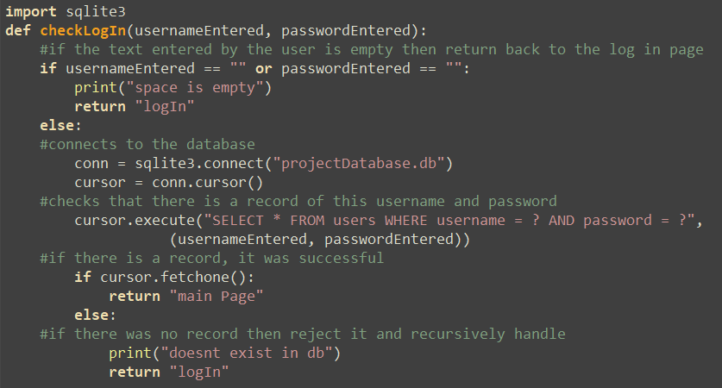
Description of Sub-program:
At this point the log in prototype was looking very long and hard to understand, to simplify this I decided to move the checking algorithm to its own program so that it was more readable, this was mostly the same apart from I had to change it to pass the parameters
Testing:
Testing was the same as the original log in function testing, everything worked as intended as this code was near identical to the previous version, just in a different place
User feedback (if applicable and if not a justification):
User feedback wasn’t necessary because this was not something users would interact with, it is only interacted with through the login function, there is no UI or any user involvement, it simply checks the details entered
Errors and actions taken:
This was duplicated code from an already functioning program, this meant errors were minimal

Main Program Prototype 1(between login prototype 2):
I did not expect I would need this to develop, so I had to make a pseudocode algorithm and test data for it shown below
running = True
while running
currentScreen = “startPage”
if currentScreen == “startPage” then
result = startPage()
elif currentScreen == “logIn” then
result = logIn()
elif currentScreen = “signUp” then
result = signUp()

if result == “logIn” then
currentScreen = “logIn”
elif result == “signUp” then
currentScreen = “signUp”
elif result == “startPage” then
currentScreen = “startPage”
else then
running = False
endwhile

Type of test data | Data | Explanation | Justification
Typical | Click on log In | Checks that it can register when the screen changes | Ensures that the basic function of the program is working
Boundary | N/A | It is not realistic to click inbetween individual pixels | N/A
Erroneous | Click anywhere else on the screen | Checks that the screen isn’t just changing whenever clicked, but on the specific coordinates | Ensures that the buttons themselves work

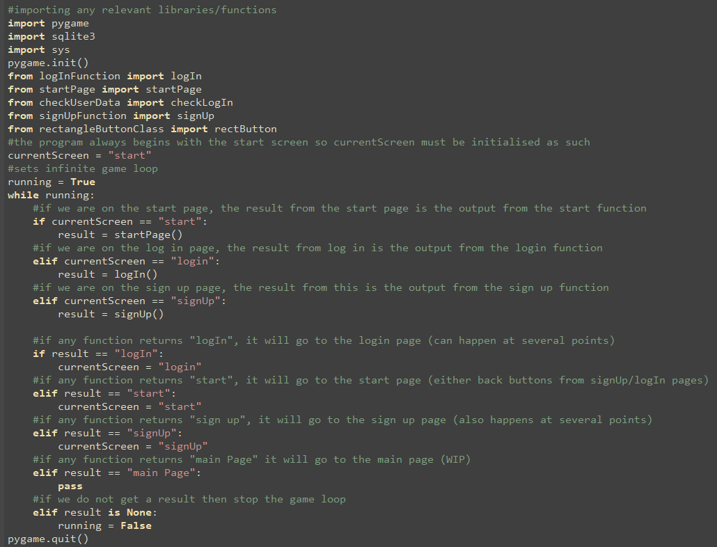
Description of Sub-program:
This program calls all other functions, but in turn is never called by another function, this avoided the circular import error we encountered earlier during the log in prototype, allowing moving between pages more seamlessly than earlier, making the structure of the program easier to understand and improving functionality.
It works by keeping track of the current screen the user is on, depending on the current screen, a different function will be executed and depending on what is returned from each function, a different screen will be entered.
Testing:
It was not anticipated I would need this, due to changes I had to make new test data for this function shown above. Normal Test data functioned as intended, updating the current screen and showing this on the screen. The Erroneous also functioned with little error as I had made the buttons before, all that was needed was for them to return the apt statement to change the current screen.
User feedback (if applicable and if not a justification):
User feedback wasn’t necessary because this feature is only used for calling functions. It is not a feature that the user will interact with at all, due to this, feedback is unneccesary
Errors and actions taken (if applicable):
This function relied on all functions returning a value, which was okay to implement; some of the functions had sub-functions that returned the correct values instead, which made it difficult to return back to the main program, so these had to be restructured to accommodate for this. I had to change this so it was returned in the main function rather than the sub-function rather than returning the same value twice

Returning Log In prototype 2 again (after making the main program):

function entered()
enterButton = rectButton(logInWindow, pygame.Rect(500, 250, 50, 25), pygame.Color(46, 94, 59), pygame.Color(56, 55, 53), "enter", 15)
running = True
while running
for event in pygame.event.get()
if event.coordinates == enterButton.rect.coordinates then
checkLogIn()
else then
pass
endfor
endwhile

Type of test data | Data | Explanation | Justification
Typical | Clicking inside the Button coordinates | Checks whether it registers that it was pressed and that it was at the correct coordinates | Ensures basic button functions
Boundary | N/A | Its unrealistic to click inbetween the pixels | N/A
Erroneous | Clicking outside the Button coordinates | Checks that nothing will happen if the screen is pressed anywhere else | Ensures that it is checking the coordinates and not just always executing the button whenever the mouse is pressed

Description of Sub-program:
After This I created an enter button to enter the information, this was also not detailed in my design so pseudocode and test data is shown above. Also I moved the checking algorithm to a separate function, as with this in the same program the code was lengthy and difficult to understand. I could do this easily with the class used earlier
Testing:
When testing I had to combine this with the log in test data and the enter button test data, surprisingly the login test data caused more problems, the original button class was made assuming no parameters would ever need to be passed, which was an oversight because this function would require username and password inputs
User feedback (if applicable and if not a justification):
User feedback was generally positive, it isn’t a major feature, simply to check the log in info so it wasn’t a crucial aspect of the project
Errors and actions taken:
To resolve the parameters issue, I had to research on stack overflow, the *args feature in python allowed a smany parameters to be passed as needed, or none at all, so this was implemented into the button class an updated version of the button class is shown below with the arguments.
There was another minor error where when I made my username and password input boxes after the input box class development, both boxes would only append the username text, minor syntax error as I accidently wrote usernameUserText instead of passwordUserText, so it appended the username.
The Final error encountered was that the checking function would always return that the user had submitted empty information, this was because it was recording what the user had inputted straight at runtime (which was of course nothing as the program had just started running), I had to change this so the variables were defined at the time of calling rather than runtime.

Sign Up Prototype 2: 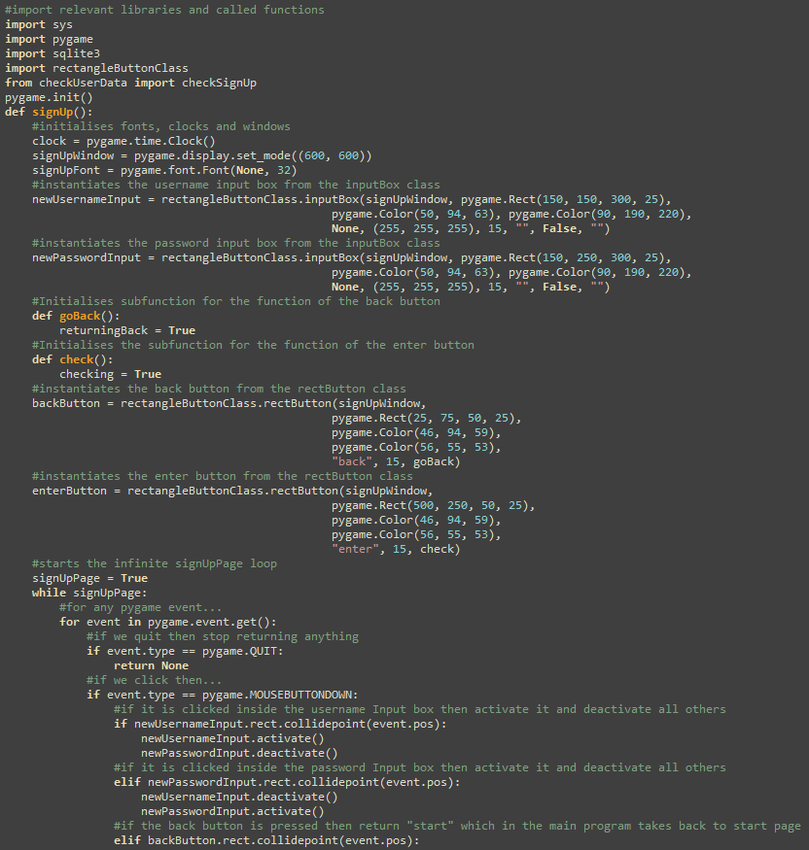
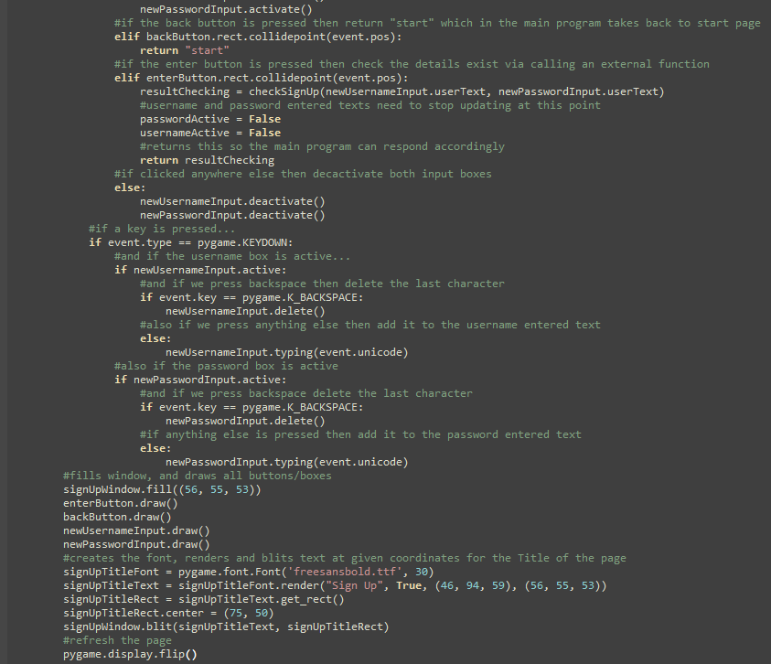
Other than the checking algorithm this would be near identical to the Log in function prototype, I simply pasted over the code with altered variable identifiers. This allows for faster development and testing, as the code was already functional.

CheckSignUp Prototype 1:

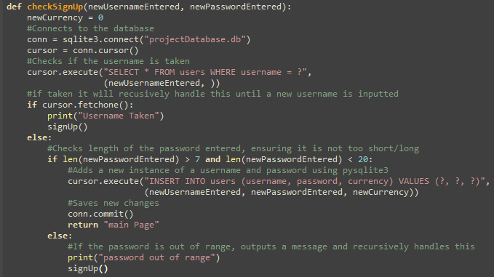
Description of Sub-program:
This was almost identical to the process taken earlier with the log in function, to move the checking algorithm to a separate function, this was simply a case of duplicating the code and substituting in my parameters
Testing:
Test data was identical to the original sign up prototype data. It all functioned as intended as this algorithm was already tested previously in sign up prototype 1, it was simply a matter of moving it. Then checking that inputs were stored in the database
User feedback (if applicable and if not a justification):
This is only interacted with via the sign up function, it has no UI or user inputs, so user feedback was not necessary, as it only needed to check their data
Errors and actions taken:
No errors were encountered because this was copied and moved from the main function, parameters were passed in the same way as the CheckLogIn function

Home Page Prototype 1:

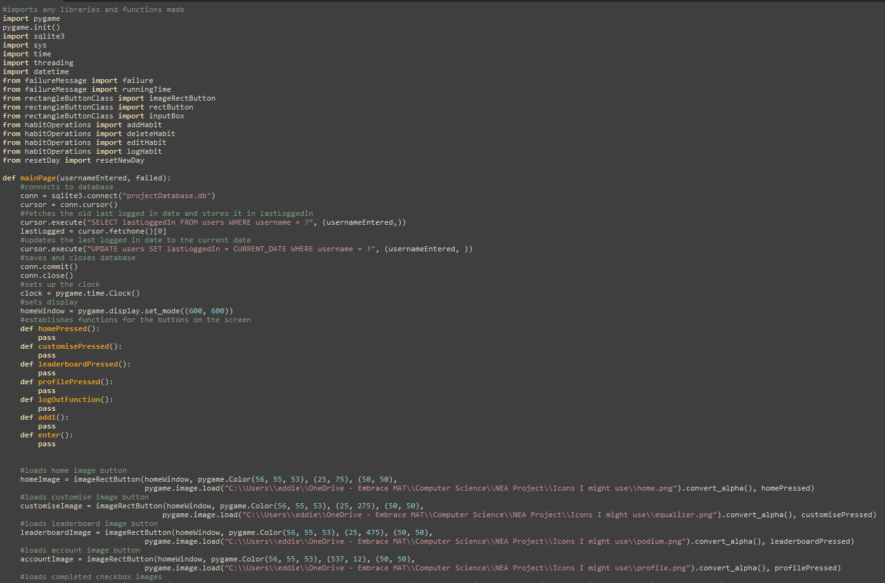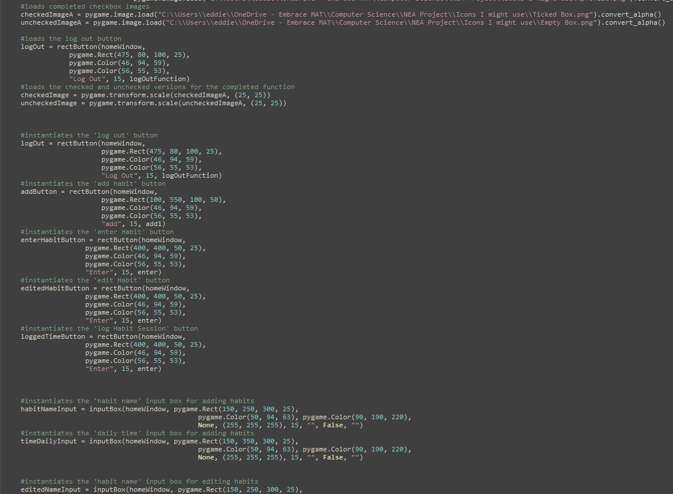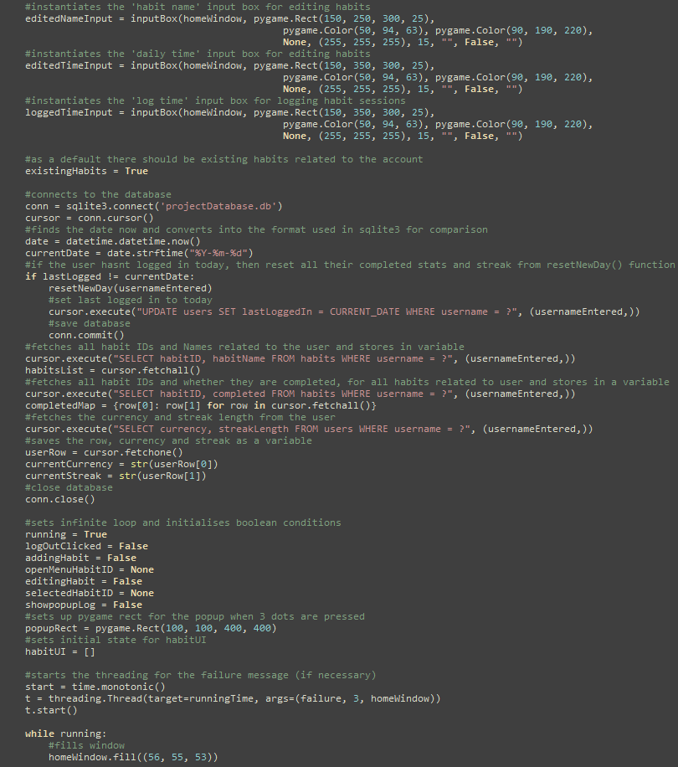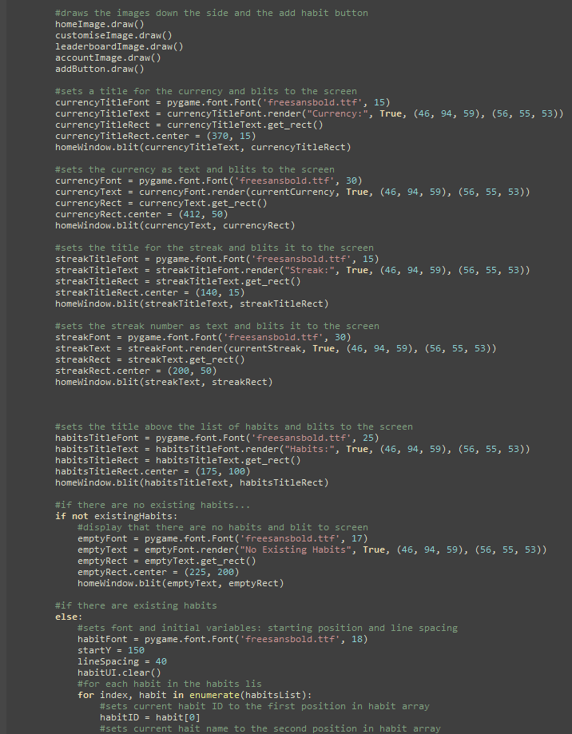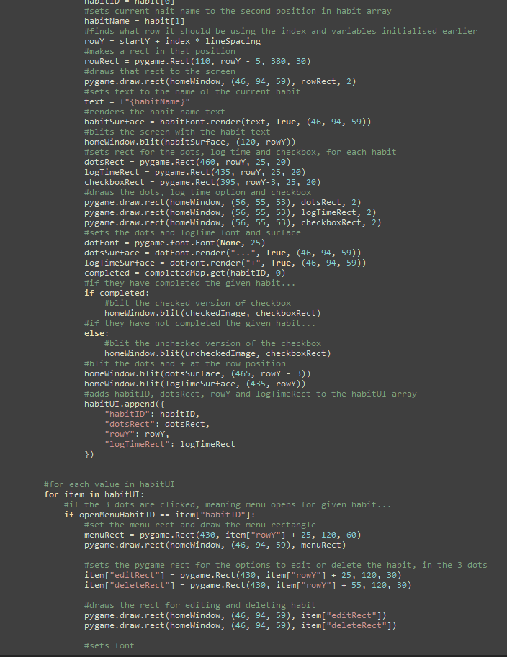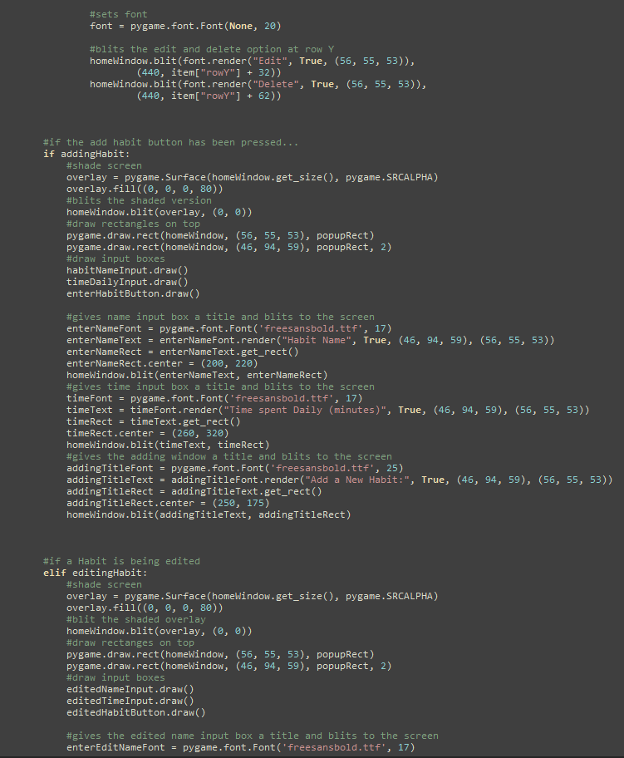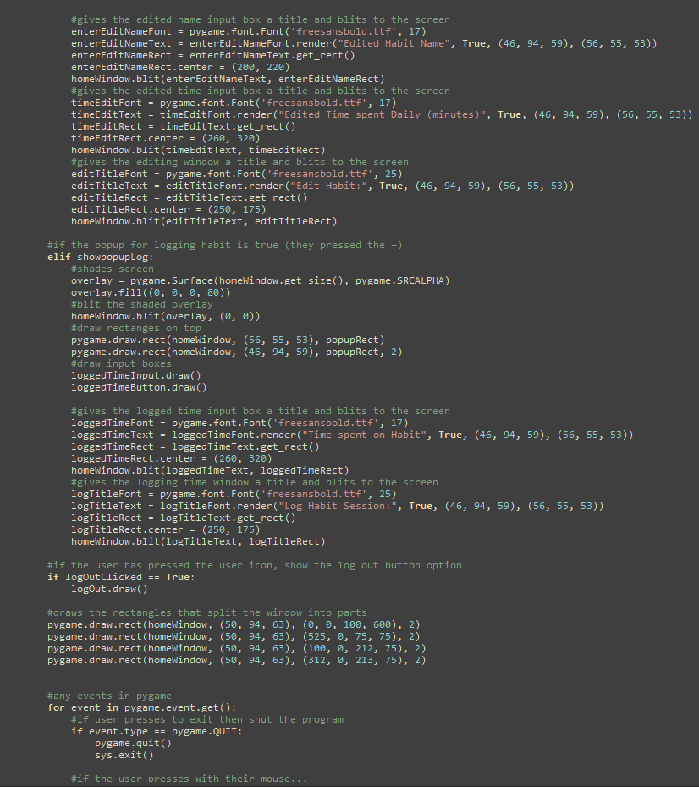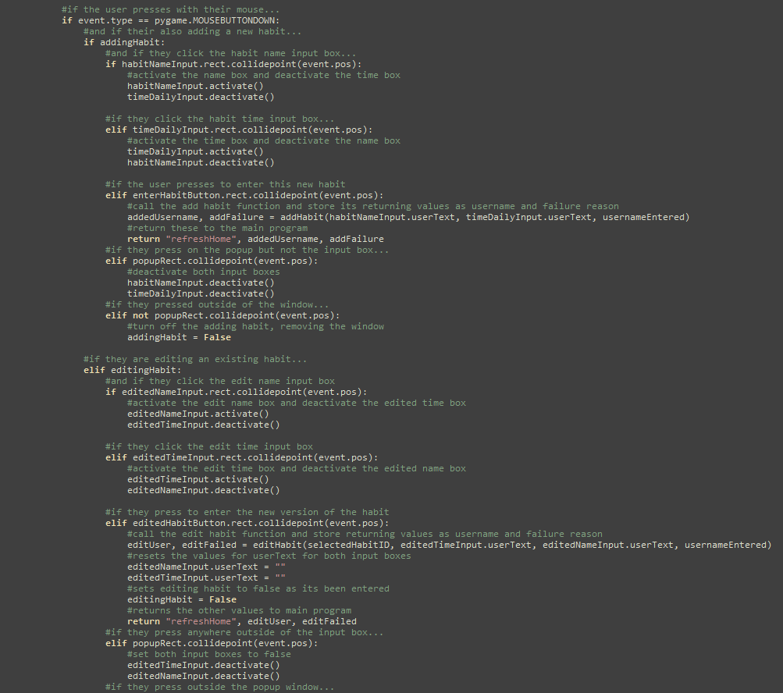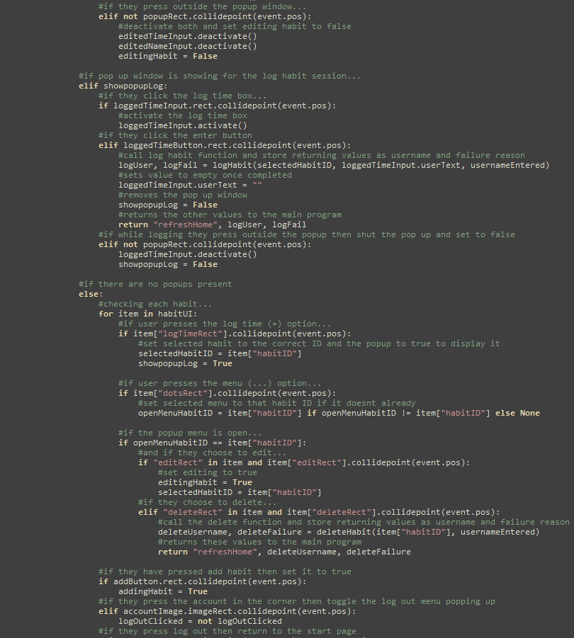
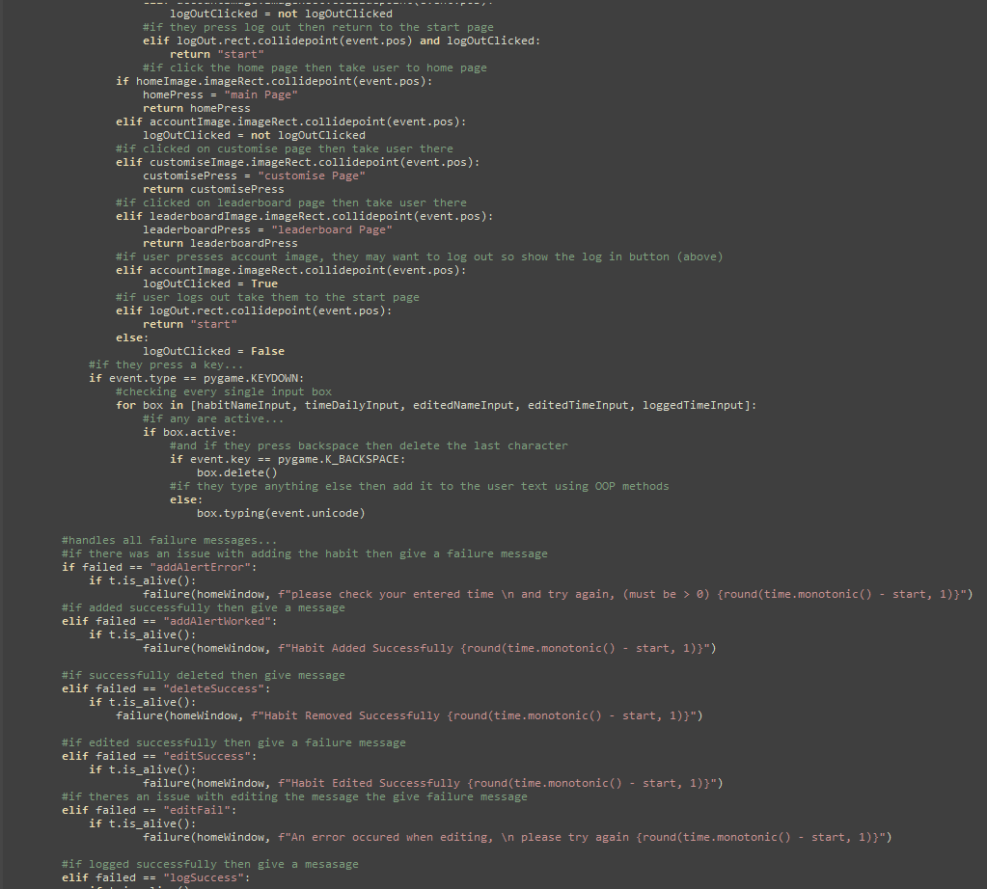
Description of Sub-program:
This was the main page that is displayed as default when signed up or logged in, giving summary views of the users stats like currency, streaks and a list of habits.
It works by loading all buttons and input boxes, then generates a list of the current habits associated with the user stored in the database, each is given its own space in the list (a new line)`
It also manages all the habit operations, to add, delete, edit or log a habit session will all be accessed via this page.
Testing:
The testing of the page as a whole was structured in modules. But general testing went well, at this point I was quite experienced with making buttons and input boxes, and linking pages to the main program so it was less problematic than other testing processes.
User feedback (if applicable and if not a justification):
Generally user feedback was positive, they felt that having the bar of buttons down the side and along the top made it much more usable, also when I gave users the opportunity to test, they instantly understood the function of each button, when asked to log out, everyone instinctively navigated to the account button and pressed it. So in my opinion I have made this usable and also functional
Errors and actions taken:
When developing, I had an issue where the images being loaded wouldn’t be found if I was developing at school. As the username on my laptop was eddie, but at school it was EddieHazeldine, so it couldn’t function as intended. I had to edit this before working on development every time I switched between them.
When working on this screen, I wanted to display the amount of currency the user had, there was an error with the database queries, stating “Programming error: Incorrect Number of bindings supplied”, this was because in pysqlite3, all values given in queries must be provided as a tuple even if theres only one data value, I made it a tuple format by adding a comma after the value, I did use stack overflow to diagnose this issue.

ImageRectButton Class Prototype 1 (midway through home page):

Type of test data | Data | Explanation | Justification
Typical | Click the button | Checks that the button can execute functions upon being clicked | Ensures the functionality of the button
Boundary | N/A | It is unrealistic to click inbetween the buttons pixels so boundary data isn’t applicable | N/A
Erroneous | Click elsewhere | Ensures that it wont execute from just pressing the mouse | Makes sure it only executes the function if the mouse button is clicked while on top of the buttons coordinates

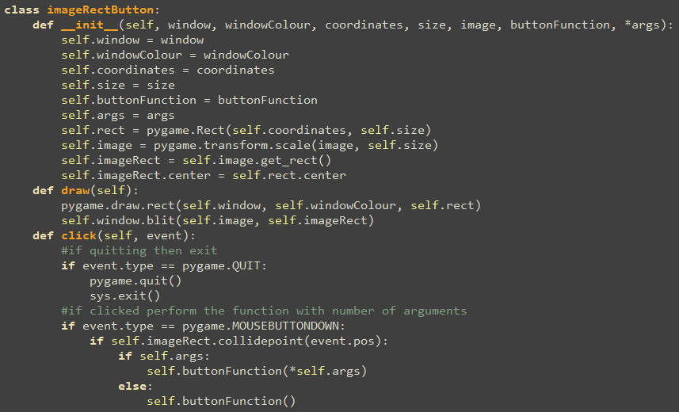
Description of Sub-program:
While creating the Home page, I realised due to the large number of buttons with images needing to be displayed, a class would be more efficient to display these many images.
Testing:
Testing for this was the same as the testing process for the other button class, I have written it above for reference, but it is identical to the rectangle button.
Both Normal and Erroneous test data functioned as expected, because the draw and click functions were near identical to the text button, blitting an image rather than text, so majority of this was already tested and functional.
User feedback (if applicable and if not a justification):
This class is included in the UI, generally the usability depends on the image used, but generally users felt the minimal design was clear and easy to read/use
Errors and actions taken:
One Error was encountered with the images I was using, they had a transparent background, and they didn’t load as intended. They all showed a black box on the button, I researched this and found that apparently it is an issue with when they are stored on OneDrive, however this can be fixed by using conver_alpha() rather than convert().

Add Habit:
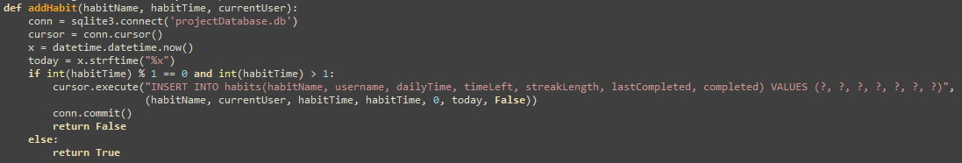

Description of Sub-program:
This program is used to add a new habit to the list of habits a user has, it takes the name, time and the user that is currently logged in as parameters and inserts this into the database, on the assumption validation is correct.
Testing:
Normal Test data functions as expected, Boundary and Erroneous also functioned due to the validation, no major errors were found other than some mispelling
User feedback (if applicable and if not a justification):
This function has no user interface, there is no medium for users to interact with this, no feedback is necessary.
Errors and actions taken:
The main syntax was near identical to the pseudocode in the algorithm because I wrote the sqlite3 operations according to its actual syntax rather than a pseudocode version, so the actual database query functioned as intended. It was also a relatively short and simple algorithm

Delete Habit:
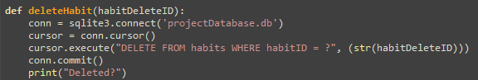

Description of Sub-program:
This function takes the ID of the habit to be deleted and removes it from the database
Testing:
Normal data functioned as intended, removing it from the list successfully. The parameter is not written by the user, so there is no chance of error.
User feedback (if applicable and if not a justification):
There is no user interface here so the user doesn’t interact with this, no need for any feedback
Errors and actions taken:
No severe errors, there was an issue with connecting to the database but this was a relatively simple fix

Edit Habit:
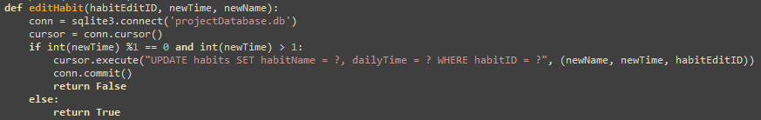
Description of Sub-program:
This function takes the habit ID, and the new stats that it will have, then connects to the database and validates users’ input is a positive integer, if it is successful then update the record, however if unsuccessful then don’t update
Testing:
Normal test data worked fine, by now I had done many SQLite queries, so I was more familiar with its syntax, making any later queries much simpler. Additionally, I had already made other buttons before so I could use these as a blueprint to help with the clicking. When I tried the other test data for the user inputs, they also functioned as intended, the name and input seemed to function exactly as intended.
User feedback (if applicable and if not a justification):
Features no user interface, it is simply the medium for the user to interact with the database, so no feedback is required.
Errors and actions taken:
The only errors encountered related to the validation not functioning, this was because I forgot to include it, once I realised the erroneous data wasn’t being rejected, I looked back and edited the validation and it begain working as intended

Log Habit Session
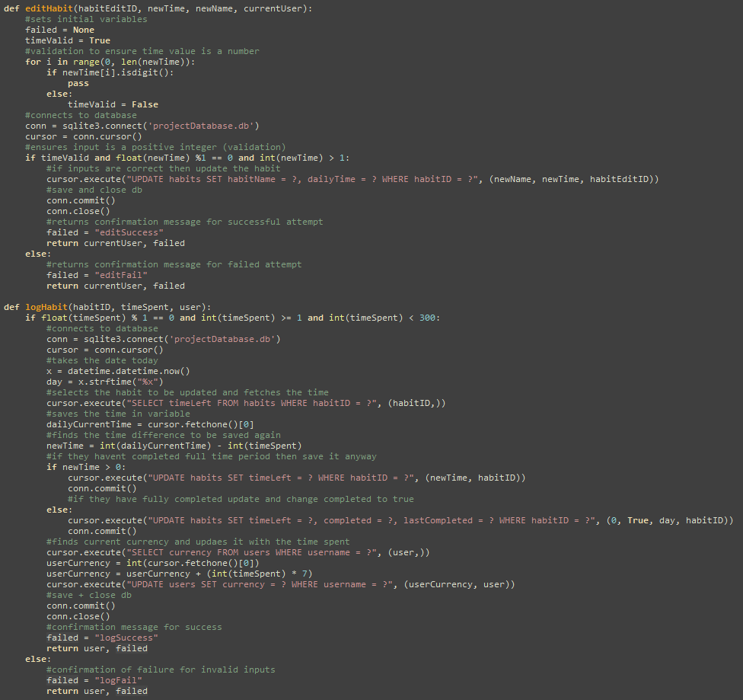
Description of Sub-program:
This allows users to log a session that they have completed, by taking the time spent and time left, and using it to find the new time left, if this is less than zero (they had completed their daily goal) and this will be updated in the database, it will also increase their currency according to the time spent. Then returning whether it was a success or a failure.
Validation is carried out to ensure the time is a positive integer that is less than 5 hours, to avoid users exploiting these features
Testing:
Normal test data did log successfully, however if I tried to complete it in two separate sessions, it would not update the completed variable, the erroneous data however did function as expected
User feedback (if applicable and if not a justification):
This feature does not have a user interaface, it is a medium for users to interact with the database. This is why the users do not need to give feedback on this, they only need to feedback on the input boxes and buttons used to execute this function
Errors and actions taken:
When I encountered the logic error of the completed value not changing when the logged times were across two sessions, I looked through the code and I found the time left was set back to the daily time whenever it wasn’t fully completed in one session, so it can only ever be completed in one session, however I moved this outside the loop so that it is only reset at the start rather than every single time. This meant a habit could be completed in any number of different sessions rather than just 1

Reset New Day
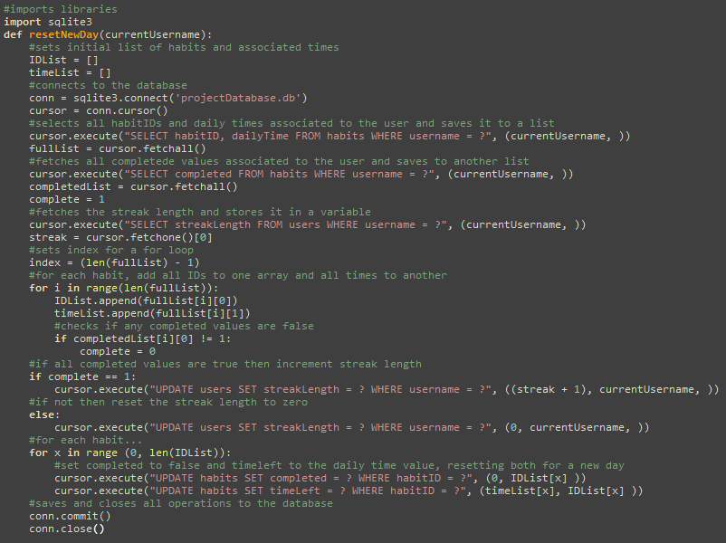
Description of Sub-program:
This program is called by the main page if the user hasn’t logged on today. If the last logged in date in the database is different from the date today, then it will be called to reset all values to their defaults. It begins by checking whether all habits were completed the day before, if the were then increment the streak and if not then reset it to zero. It then sets completed to false and the time left to be the daily time for all habits associated to the user.
Testing:
This doesn’t have any test data because the only data used will be the current date and the last logged in date. When the last logged in date was today it would not be executed, however if it was different, i.e. the user hasn’t logged in today, then everything is reset to what it would be at the start of the day.
The only real testing was executing it on a day where all habits were completed yesterday and one where not all habits were completed yesterday. These all seemed to work as intended.
User feedback (if applicable and if not a justification):
Users do not see or interact with this program as there is no user interface, it is more of a validation algorithm than anything else, so user feedback wasn’t necessary
Errors and actions taken:
There was one issue, where even on a new day, the function wasn’t being executed, this was because the format of the date in sqlite3 and datetime is different so they cannot be compared directly, sqlite sets it as YYYY-MM-DD, however datetime sets it as DD/MM/YYYY, so I had to compromise the formats of both to have consistent formats so that predictions can be made accurately

Leaderboard Page

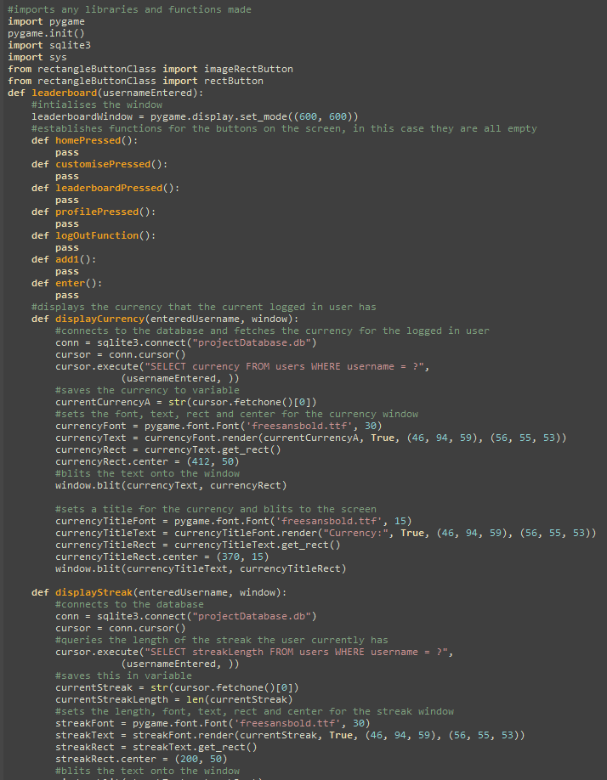
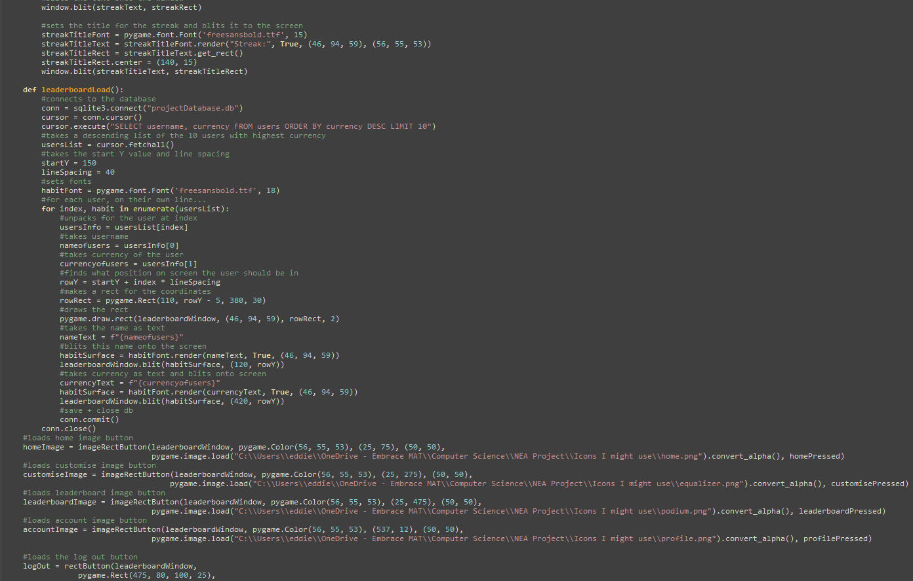
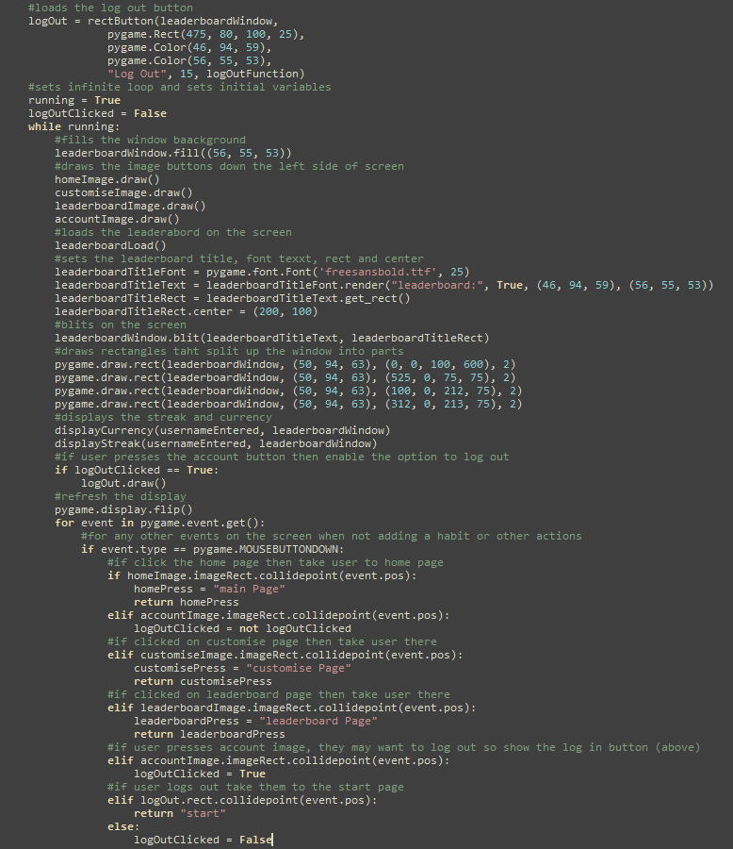
Description of Sub-program:
This program has the same left hand bar and top bar as the home page, to allow for consistency in the navigation between the pages. This page also features a leaderboard, featuring the top 10 highest scoring users in descending order and what their respective currencies are. This is done in a similar way to the habits list, as a vertical list downwards of the names and habits from highest to lowest.
Testing:
I tested by accessing the leaderboard page and ensuring the data was accurate to that in the database, but I also wanted to check that it could respond accordingly to if there were <10 users, it also handled this well, simply not showing any more spaces, as there were less than 10 instances of users to be put in the list, so it could not be any longer. This meant it was robust to if the database was wiped, which during development can be very common
User feedback (if applicable and if not a justification):
General user feedback was very good, everyone felt it was easy to read and understand the purpose, I did not include number labels to show each persons position, as I felt because users could see the descreasing currency, they can intuitively figure out the purpose, it was also given a title so it was clear
Errors and actions taken:
No major errors were encountered, but I had to use trial and error to find which line spacing was the optimal for this size screen.

Customise Page

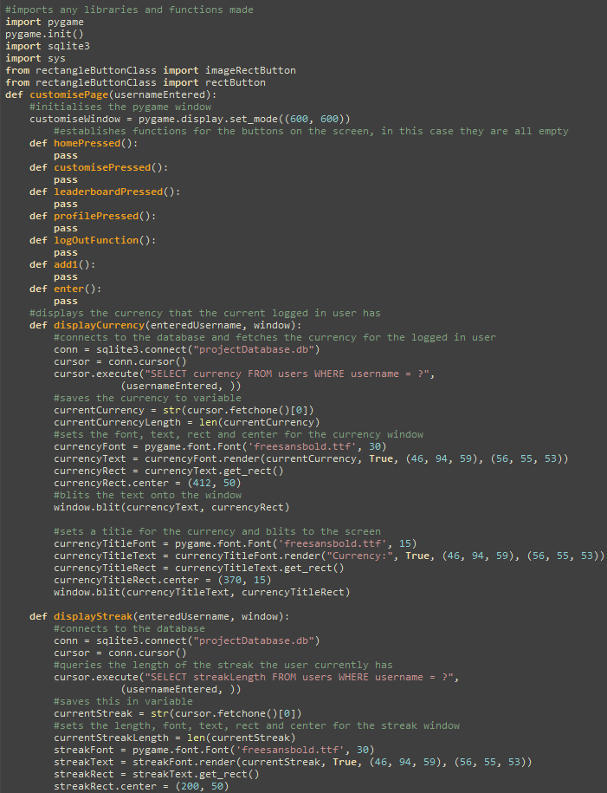
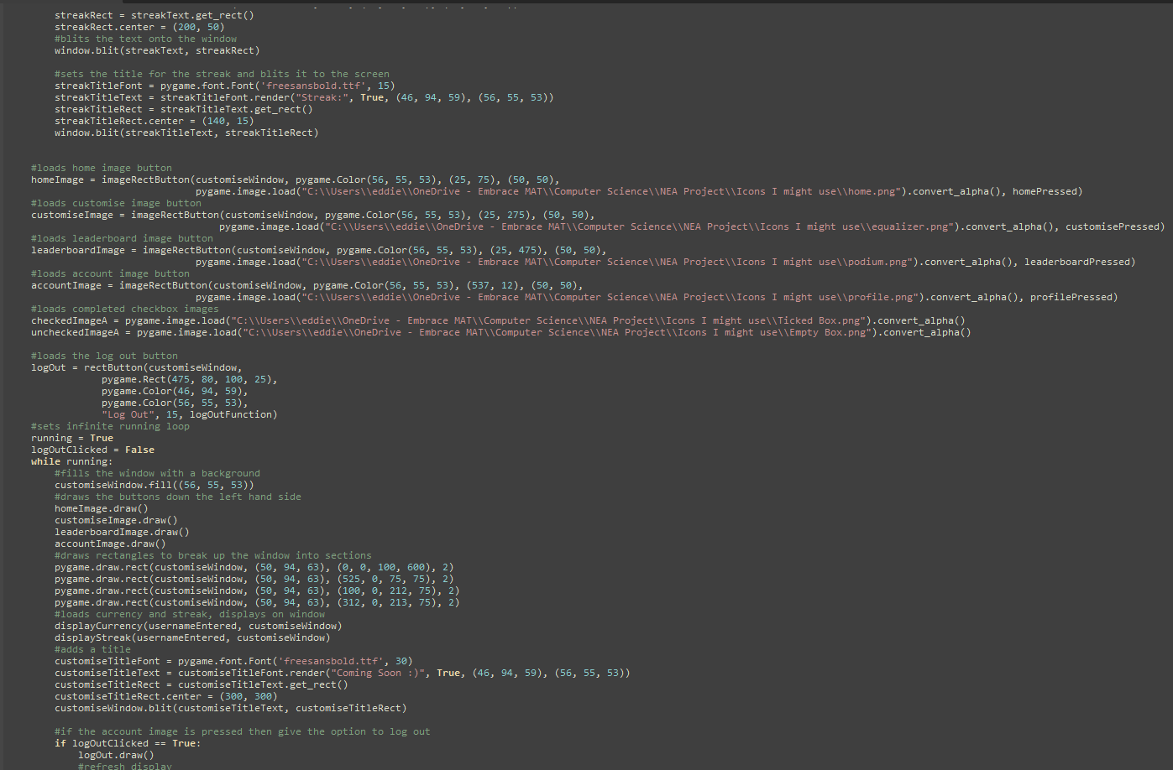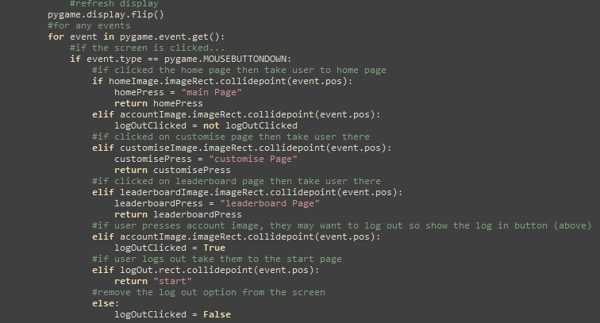
Description of Sub-program:
This page was unfortunately not finished due to time constraints and other deadlines, however I did begin to develop it and link it to the rest of the project. Currently it has all the same function as the left bar and top bar of the home page, and a message saying that I intend to work further on this in the future. The bar down the left gave the user buttons to navigate between pages. The bar across the top showed the streak length, currency and the option to log out. None of the customisation features were actually finished
Testing:
Testing was generally successful, because for now the program is very similar to the home page, this was intentional for the buttons between pages and the streak/currency, this enabled an improved usability, with more consistency between the navigation of pages. Also, because the code was so similar, no errors were encountered
User feedback (if applicable and if not a justification):
Users felt it was clear that the page was unfinished and that I intended on coming back to it in the future, however a few did mention that if it was unfinished I could have omitted the entire page in general. This was a valid point as the page didn’t currently have any real function. However, I wanted to keep it in the program to show that I would finish this in the future.
Errors and actions taken:
No major errors were encountered due to the similarity of previous code

Failure Message
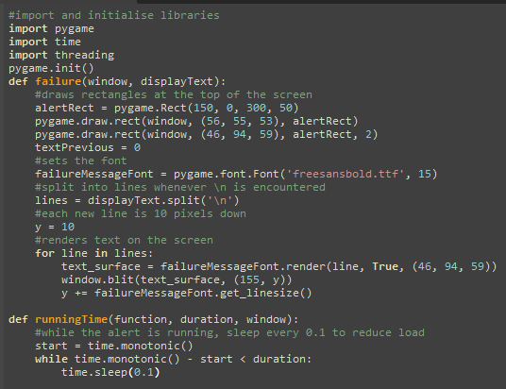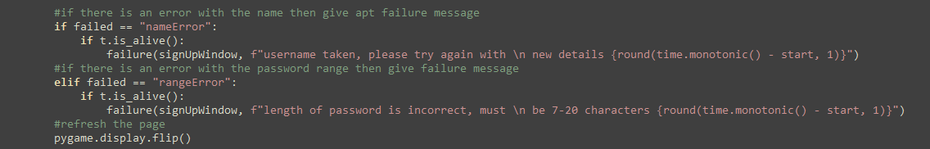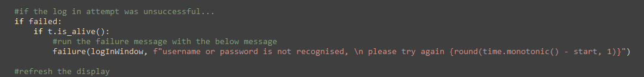
Description of Sub-program:
This sub-program notifies the user whenever they have carried out an operation that requires notifying in some way, e.g. deleting a habit, but also for failures, if password was too short or too long.
This sub-program has two functions, one drawing the actual message, and the other keeping track of the amount of time left on the notification. The first draws the shape of the message over the window and sets fonts and lines correctly, then for each line blits it to the screen. The second gets the start time and keeps it on the screen until its been a given amount of time (I used 3 seconds), also above is how this was implemented into the sign up and log in functions
Testing:
Testing worked successfully, there is no user input here, so there is no validation necessary, this message is done as a result of the validation being carried out. Testing was simply to make sure it executed properly so no actual test data was needed.
User feedback (if applicable and if not a justification):
Users generally said it was good, a mix of responses, some said it was on the screen too long, others saying it wasn’t on the screen long enough.
Errors and actions taken:
When completing this, I noticed my program got very slow when executing the failure message, After research into this using stack, I added in a time.sleep() to reduce the load on the CPU, because it doesn’t need to update the message 60 times a second, just when the displayed timer changes

Adding in Failure Messages to Home, Log In and Sign Up pages
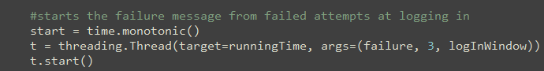
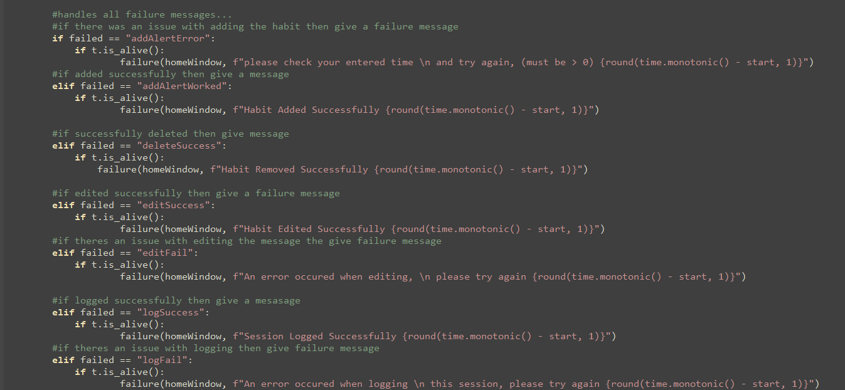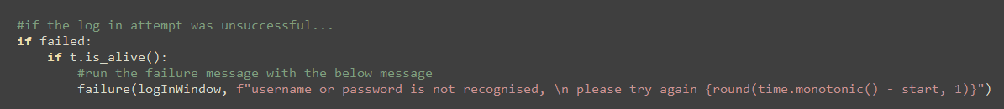
Description of Sub-program:
This simply shows how the failure message functions were implemented into my actual functions beyond the use of the functions. One part is done at the beginning of the function, setting up the initial time, and the other is done in the game loop, calling the failure function, this is nearly identical for all the pages its used in, other than changing the message and the window its being displayed to.
Testing:
There was no real test data for this as there is no direct input to this, but I did test to ensure the functionality of the code, I intentionally entered an existing username into the sign up page and looked at its results, it functioned as expected, blitting the pop up to the page, users are also still able to interact with the rest of the page while the popup is active. Once the timer is up it will disappear. But no actual errors were encountered here.
User feedback (if applicable and if not a justification):
This specific part of the code has no user interface, it is simply the method for calling the failure function, feedback on the failure message is available in its own section.
Errors and actions taken:
No real errors encountered

Initialise Databse Prototype 2
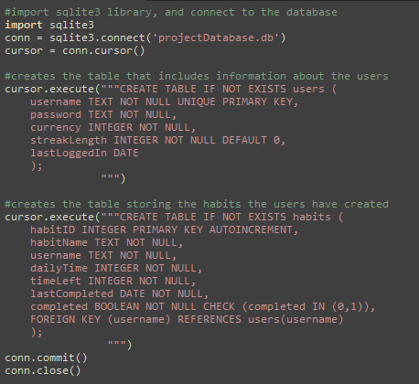
Description of Sub-program:
The changes in this prototype are quite minimal, I added the columns streakLength and lastLoggedIn to the users table, named conventionally. These were made to allow for other features to be added, as the initial prototype was only used for the essential features.
I also added lastCompleted and removed streak length from the habits table, I needed to track the last completed dates to implement the streak feature, I also decided to change the streak from habit specific to user specific, as it is more usable and allows for a more readable page
Testing:
The testing was also near identical to the initial prototype, I checked the database file in a text editor and checked that each attribute was stored in the table. This was found and achieved successfully.
User feedback (if applicable and if not a justification):
There is no user feedback necessary as there is no user interface, this isn’t actually part of the main solution, it simply sets the initial (empty) state of the database, it was only to be used during development rather than it is use.
Errors and actions taken:
No errors were encountered

Main Program Prototype 2

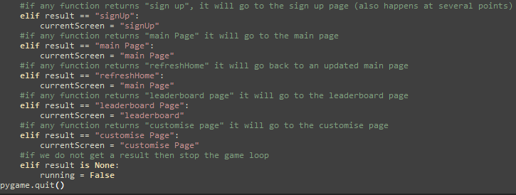
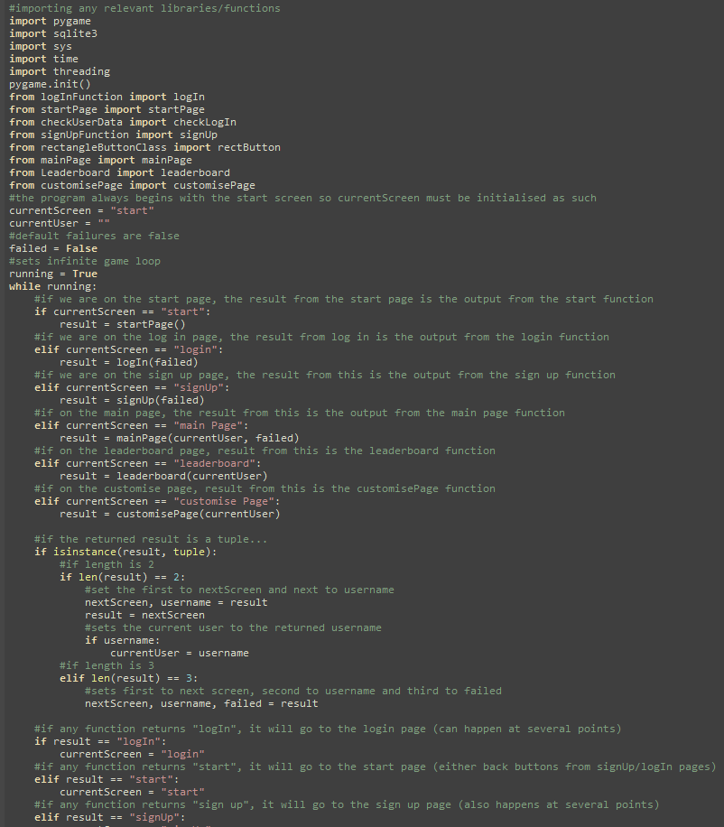
Description of Sub-program:
Not much has changed since prototype 1, essentially just that more features have been implemented, so more conditions need to be made in this function. The following pages were linked to this program in its final prototype: Main Page, Leaderboard Page and the Customisation page.
Also some functions needed to return a tuple, so the program was tweaked to allow for these to function, as seen in the image, tuples of length 2 or 3 are in the same format.
Testing:
Testing was quite simple because I had already practised with the log in, sign up and start pages, that the process was near identical to program a solution for the other pages. This meant no major issues were encountered in this process. Other than the length of the tuples varying but this was handled by unpacking the values into set variables.
User feedback (if applicable and if not a justification):
This has no user interface and acts as a master function that calls all the other functions, there is no interaction with this other than to run the program. So user feedback wasn’t necessary on this aspect as they did not interact with it.
Errors and actions taken:
The errors were mainly that some pages and functions needed to return more than one value, that is why I implemented the isinstance(result, tuple) function to ensure that multiple values could be returned and unpacked unproblematically.

Testing: Evaluative

Final Testing Evidence

What is being tested | How will this be tested | What is the expected result | What was the actual result | What actions need to be taken as a result of this
Start Page: Do the buttons function | Click each button, log in and sign up | Taken to the log in or sign up page | As expected
The Start page shows the two buttons, these navigate to the log in or sign up page depending on what is pressed, the two latter photos show the result of pressing the relevant button
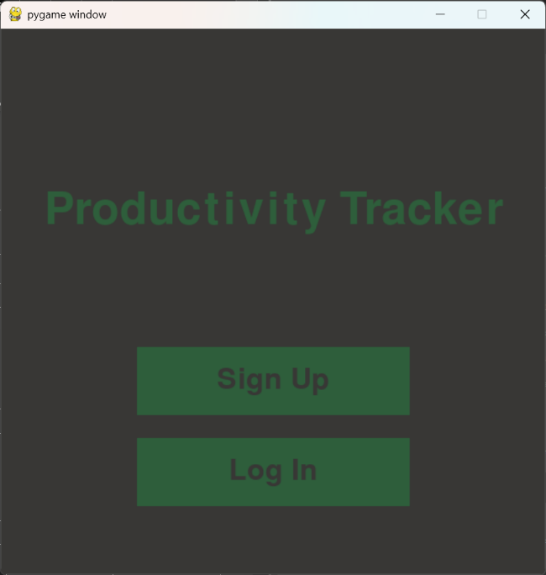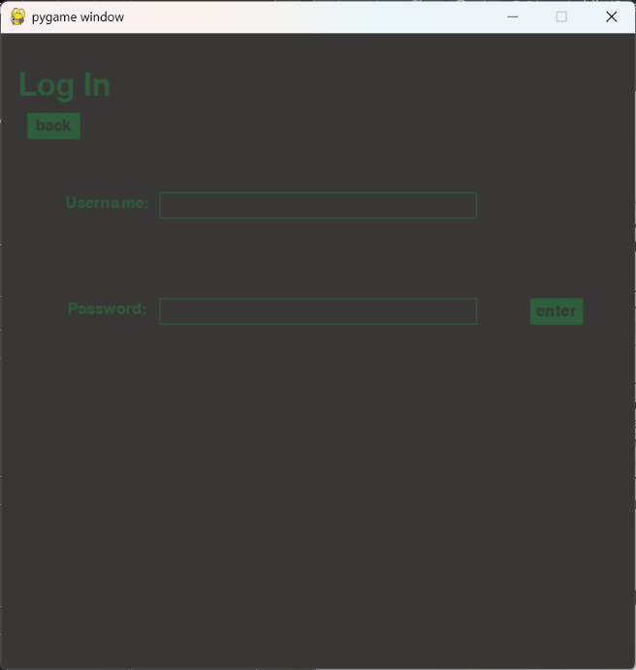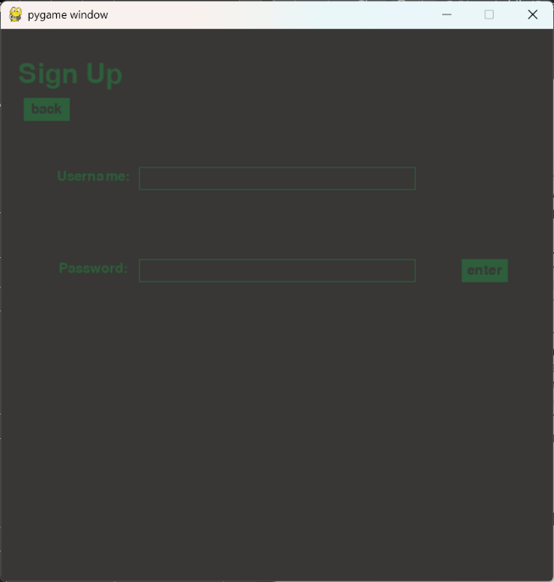

General: Do input boxes activate | Click each input box and click off it, changing between each field. | Colour should change whenever clicked on/off, if one is on and the other is clicked, the activation should switch to the other | As expected
Whenever a box was pressed, it would activate, and whenever it was pressed off it would deactivate, also if the first box was active and the second is pressed, the first would deactivate and the second would activate, this ensures that they cant be written in both, below are screenshots showing the testing I carried out.
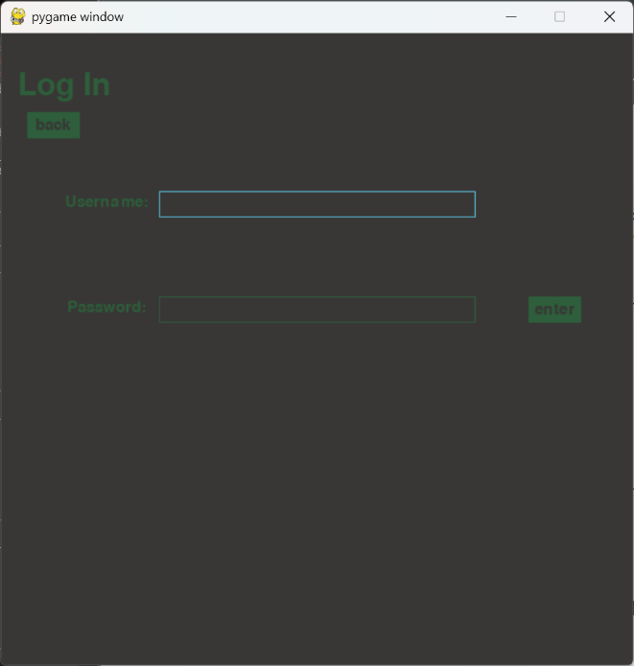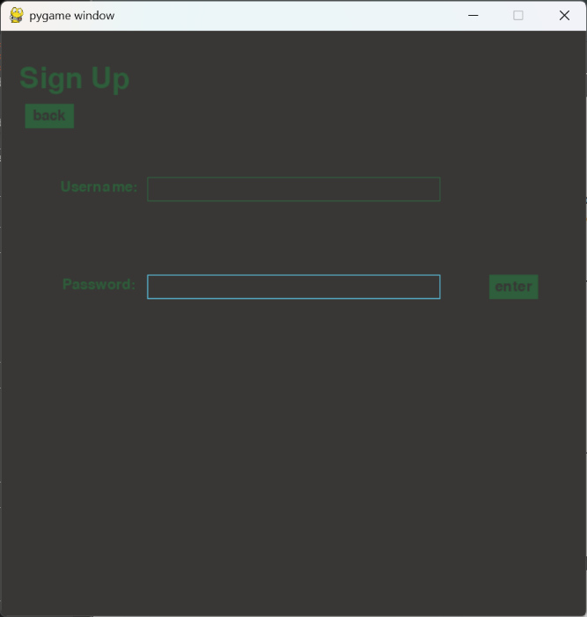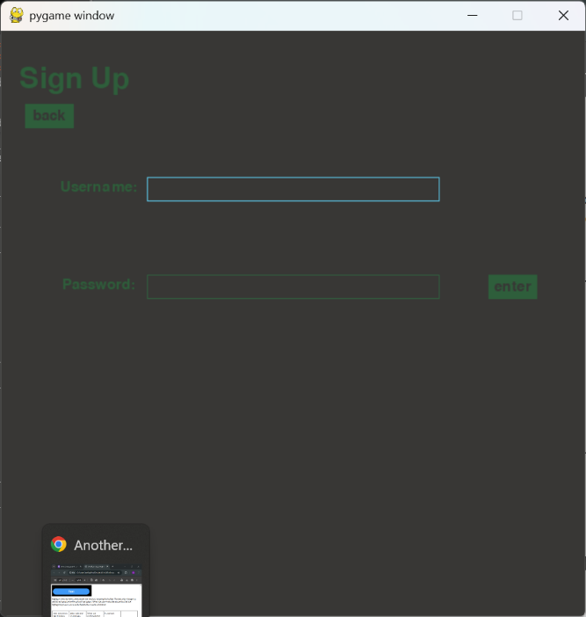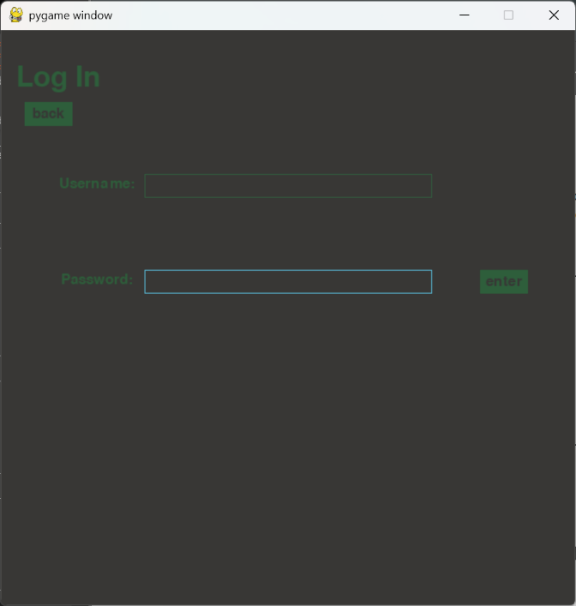
Sign Up/Log In: Do Input boxes record the inputted characters | Click on each input box and type characters, then backspace is pressed | All characters are displayed in the text box, when backspace, should remove the last character | As expected
When a box is highlighted (active), and any characters are pressed, it will display the character in the input space using the event.unicode function, this will appear in the input box, also if the backspace is pressed then it will remove the last character from the string and from the screen.
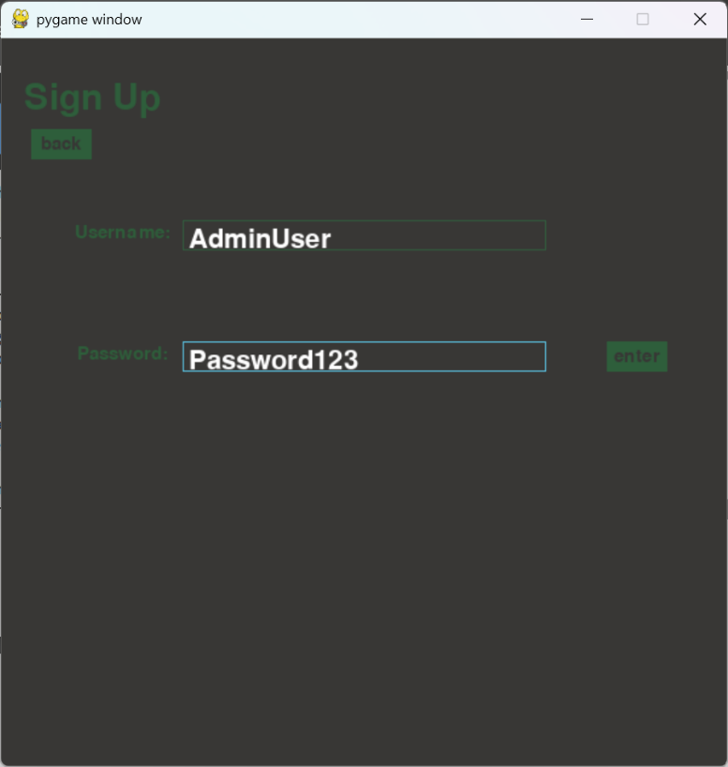
Sign Up: Are invalid inputs rejected | Enter the details to an existing account, then enter a too-short password | Should be rejected and sent back to the sign up page with an explanation of the failure. | As expected
Below shows the output from when I input a password that’s under 7 characters and a username that is taken, this is detected and a failure message is given at the top, detailing why this has occurred, the user is sent to a refreshed, empty sign up page and told to try again.
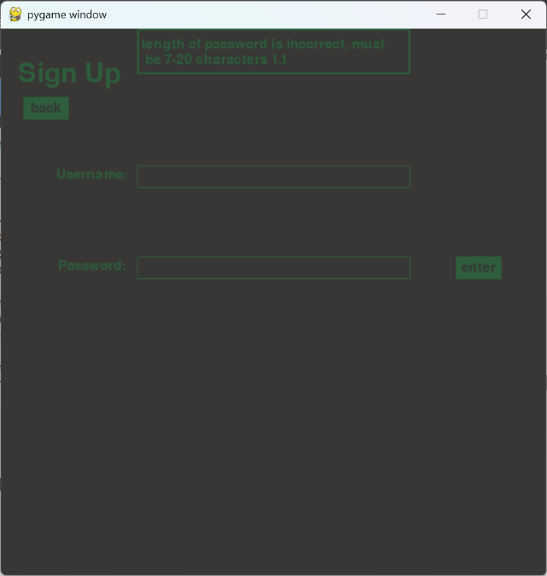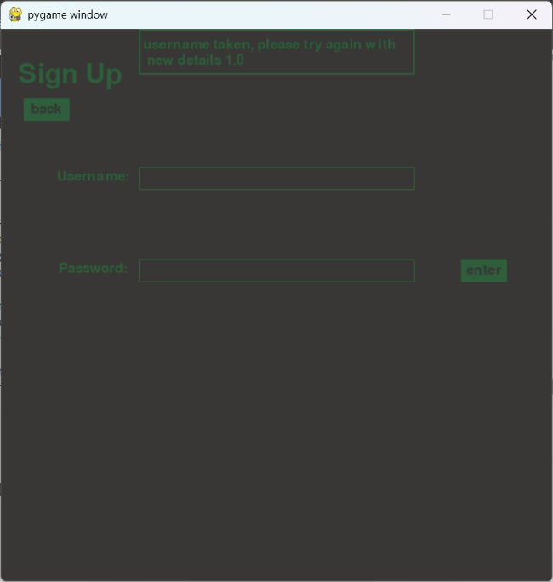
Sign Up: Are you sent to main page and is the data saved | Press the enter button and open the database | When entered, the screen should go to the home page, and the database should update with the relevant details inputted | As expected
As the user signs up, the details (on the assumption they were correct) should be saved in the database, below is a screenshot after the user signs in, in the red box is the user details that were inputted, they were saved in the database with the date they logged in.
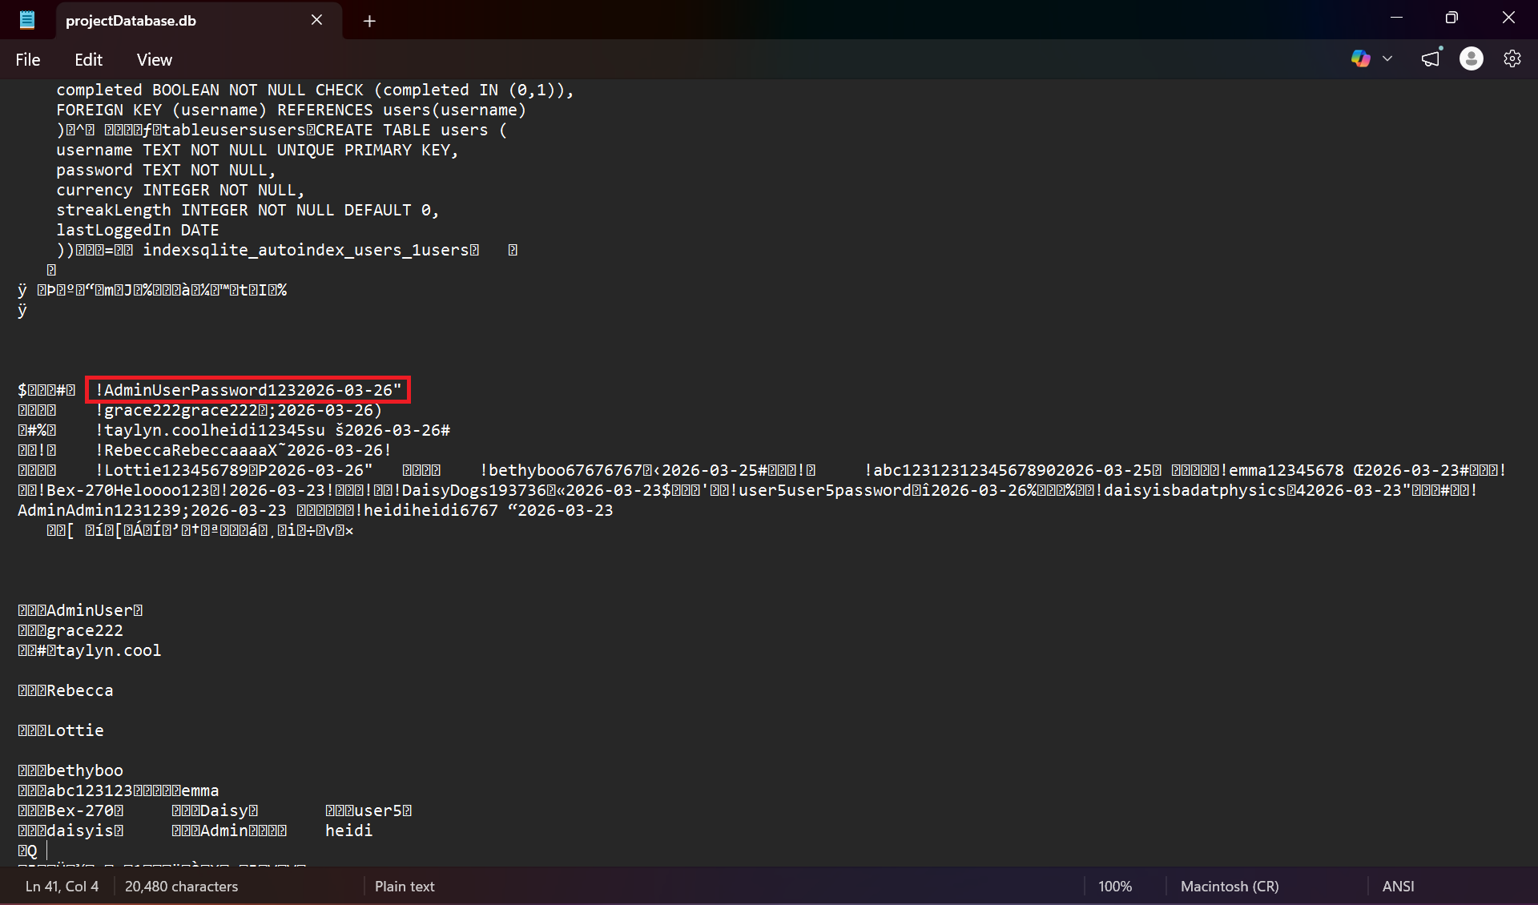
Home/Customise/ Leaderboard: Does the account button function | Press the account button in the top left corner | A pop up button should appear with the text ‘Log Out’ | The account button doesn’t function on the home page only | Add in the same code from the other pages to allow this to function
While testing, the account icon didn’t seem to do anything when clicked, this was odd because the code was near identical for the account button on each page, this was a minor logic error, where during my commenting of code, I initialised the Boolean function in the infinite game loop rather than before it, this means that it is always set to false at the beginning of each iteration, so I moved it outside the loop and this seemed to be fixed.

Home/Customise/ Leaderboard: Does the Log Out button work | Once the account button is pressed, press the pop up button | Should send the user back to the start page. | As expected
Once I had moved the initialisation to outside the loop, they did function correctly for all, below is a screenshot for an example of one of the pages with the account button clicked, it now displays the option to log out.
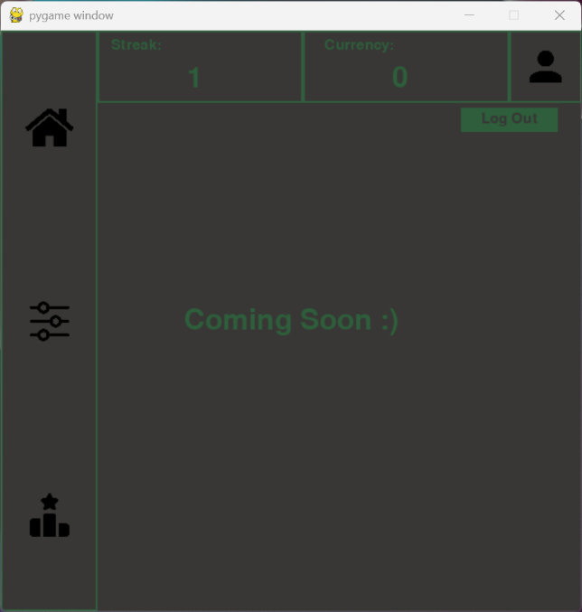
Home/Customise/ Leaderboard: Is Currency Correct | On the main page check currency, then open database and check currency | Should be identical in both | As expected
Screenshot is shown below under the streak section, the red box shows the currency, it should be zero as they have not done anything yet, also this is what was stored in the database.
Home/Customise/ Leaderboard: Is Streak Correct | On the main page check the streak length, then open the database and check it for the logged in user | They should both be identical | As expected
Screenshot in the red box shows the streak length, this is default 0 because the account has only just been created, I revisited this the next day, shown as incremented because all habits are completed, this is checked when the user logs on and updates in the database.
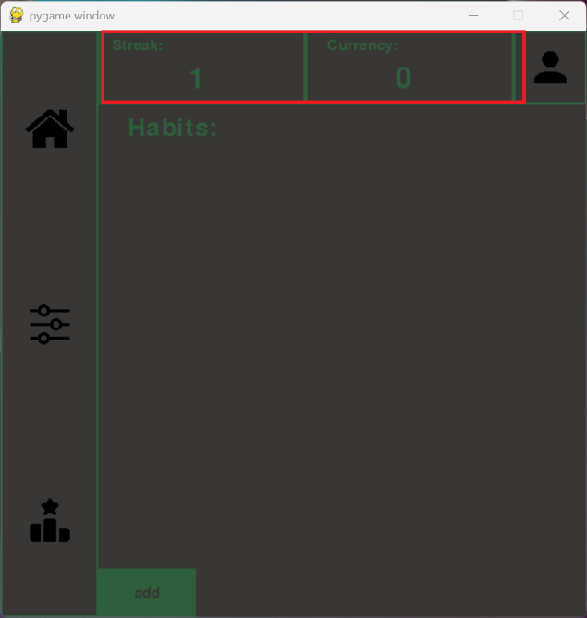
Home/Customise/ Leaderboard: Do Buttons down the left side work | On the main page, press the customise page, then on customise page press on the leaderboard page, on the leaderboard page press customise, and on customise press the home page | Should take users from home -> Customise -> Leaderboard -> Customise -> Home, this allows all possible paths to be tested, and that all the icons do function as buttons | As expected
When I tested this, it worked for all possible pathways, I didn’t include a screenshot as the transition between pages cannot be indicated by an image, the only evidence provided was in my video

Home Page: Can you access the add habit button | Press the add button at the bottom | A popup appears prompting the user to enter new info | As expected
When the add button at the bottom of the screen is pressed, the popup should appear, below its shown what happens when this is pressed, the popup does successfully show, and text can be entered to the input boxes, using the same class as before
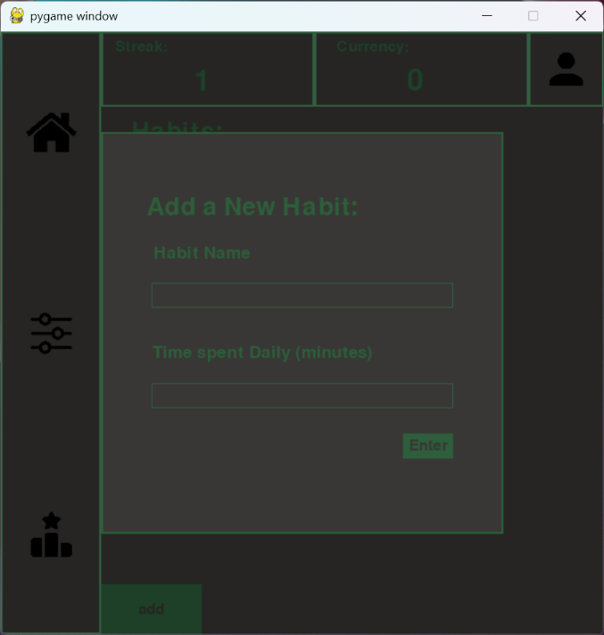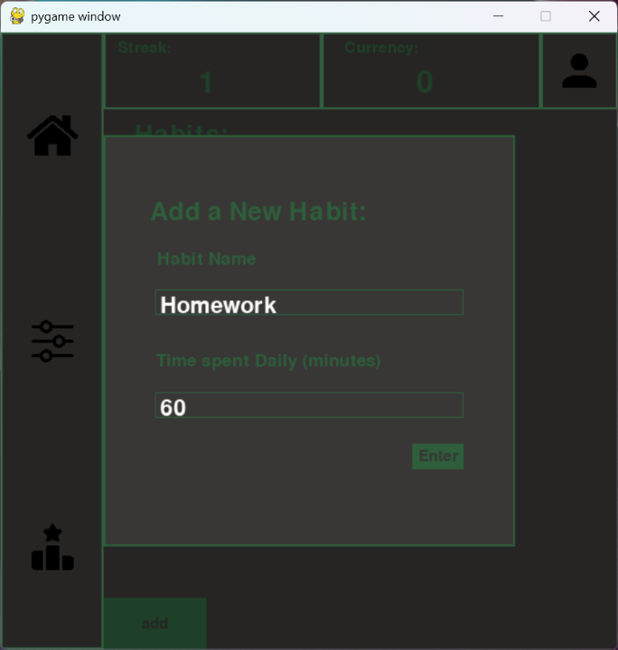
Add Habit: Does the add habit save | Enter relevant info for the habit and press the enter button | It should display it on the screen as the habit list and update the database with a new record | As expected
When the enter button is pressed (seen in the pop up), it will submit the entered values to be checked, then it will be saved to the database, when valid details are inputted a message will appear at the top and the new habit will appear on a new, refreshed version of the screen.
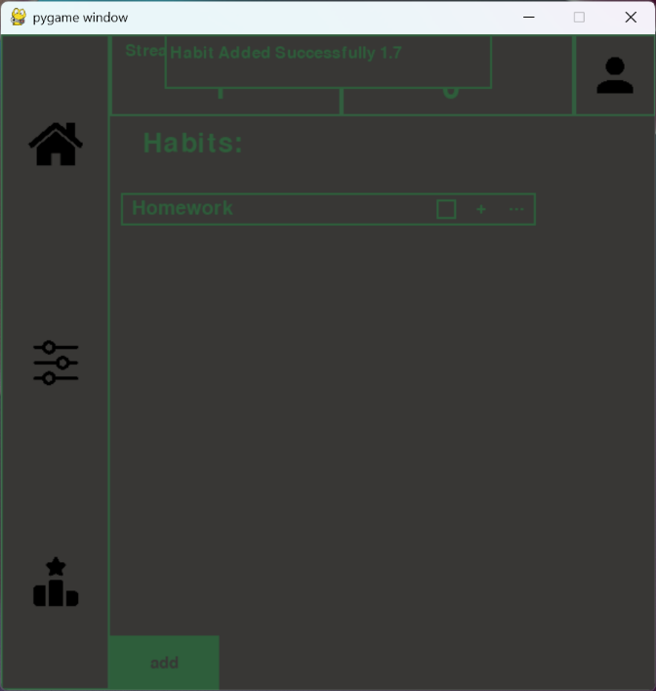
Add Habit: Is there validation for the Add Habit option | Enter incorrect info, e.g. a very large time and a time that has letters e.g. time = ‘1x5s’ | Use of letters should be rejected, also very large times > 500 should be rejected. | As expected
This shows a very large time being inputted to see if the validation would function, here any very large times are rejected. This is successfully rejected, the user is shown a message explaining why, and it is not saved to the database, and therefore not shown on the screen.
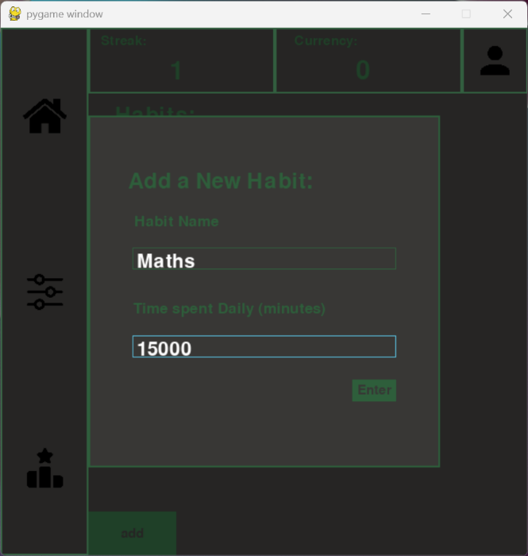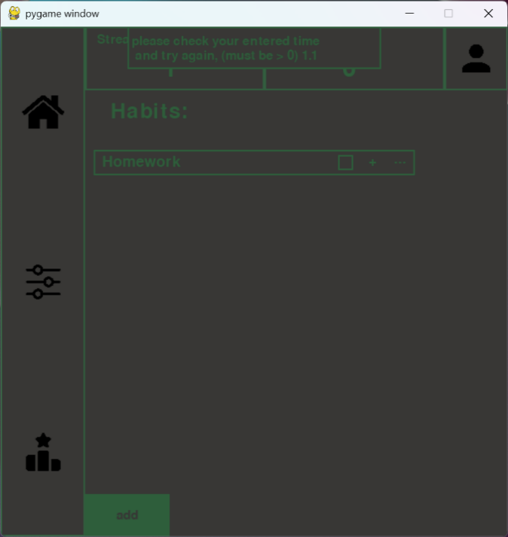
Home Page: Does the log habit button function | Presses the log habit button | A pop up should appear, prompting the user to enter the details of their session | As expected
The log habit button should appear when the user pressed the + button next to a habit, this would log the session for whichever + button is pressed, when pressed the popup should appear and the background should be shaded. Text should be able to be inputted in the boxes, as shown below
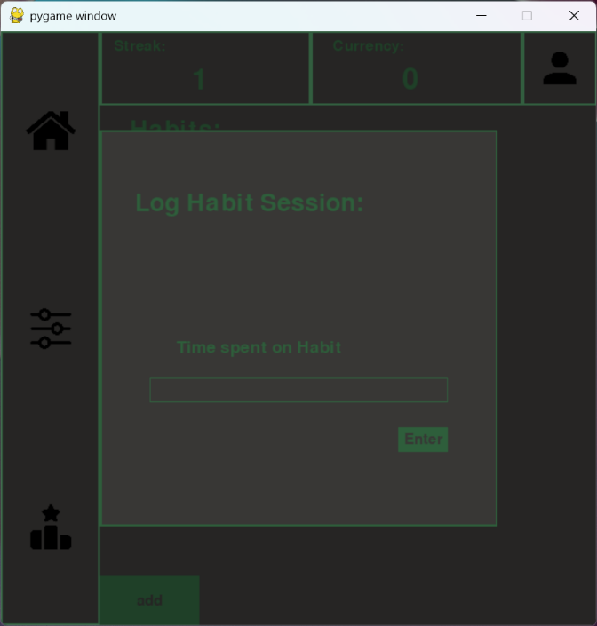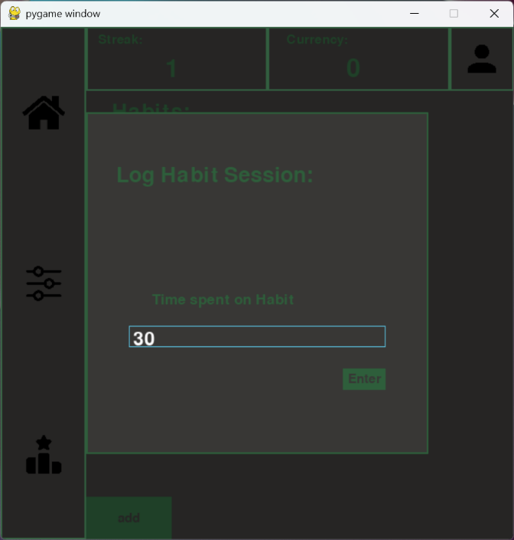

Log Habit: Does the log Habit work | Enters time, less than the daily time, and presses enter, then does this again with more time, so the sum is more than the daily time | After the first, the database should change, to store the amount of time left for the day, after the second then the completed checkbox should be true | As expected
This image shows when a habit is logged successfully, if the total time spent that day is more than the daily time set then it will be ticked, showing its complete. This will reset on a new day, I also tested for negative and fractional numbers, these display a failure message when executed, informing the user why it was unsuccessful and what they need to do to make it valid. The Checkbox does change on a new day and the database updates when this occurs.
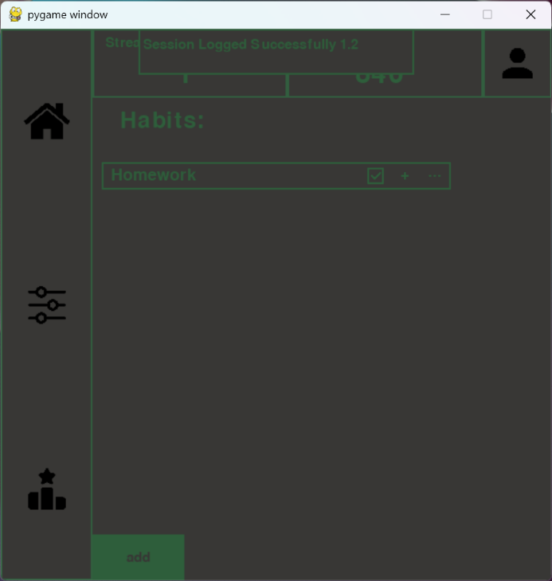
Home Page: Does the 3 dots function | Presses the 3 dots | A pop up button should appear, with further options to either edit or delete the selected habit | As expected
When the dots were pressed, the popup appeared, giving the users the option to interact further with the selected habit, either editing its name/time daily or deleting it. Below shows the popup that appears when clicked, the popup will also deactivate if the 3 dots are pressed a second time, in case the user needs to backtrack. Any other clicks will not be recognised while the popup is active.
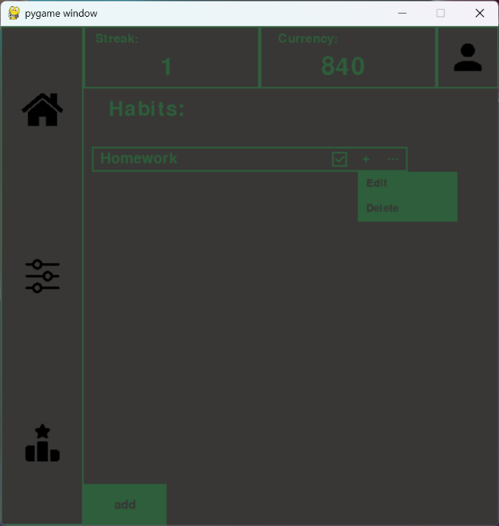
3 Dots Popup: Does the Edit Habit Button work | Presses the edit option on the pop up menu | Another pop up should appear showing options to change the name of the habit or the time spent daily of the habit | As expected
The edit feature is accessed by the 3 dots as it is specific to the habit. When pressed if comes up with a popup similar to the add habit feature, allowing users to edit the name or time of the habit with input boxes.
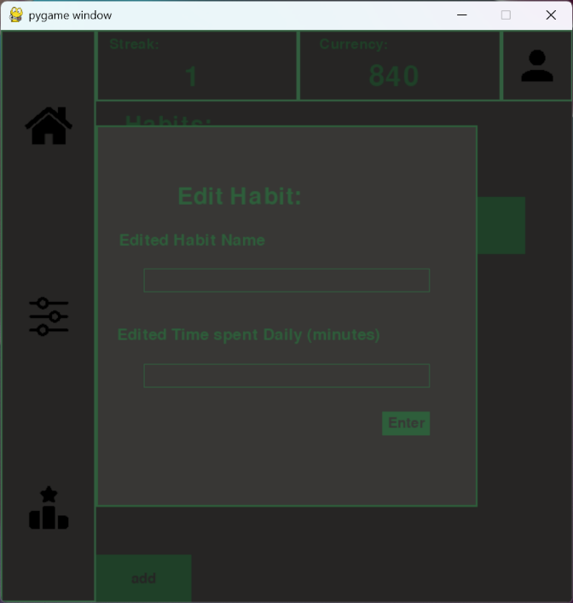
Edit habit: Does the edit habit work | Presses the enter button on the popup to save the new updated info | The edited version of the habit should appear on the screen, and the database should be updated | As expected
Input boxes functioned as expected. It also successfully changed the name and time, as seen below, the updated name and time are saved and the page is refreshed to show this with a message informing users as to what has happened
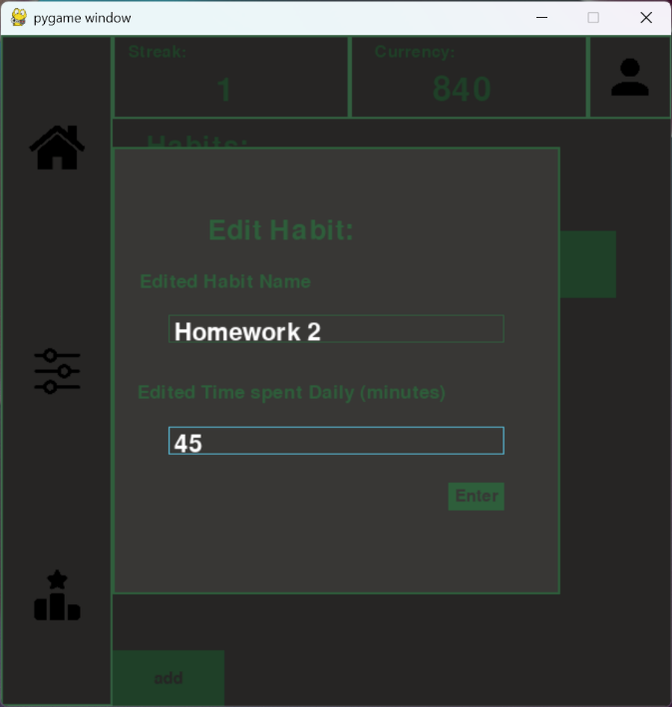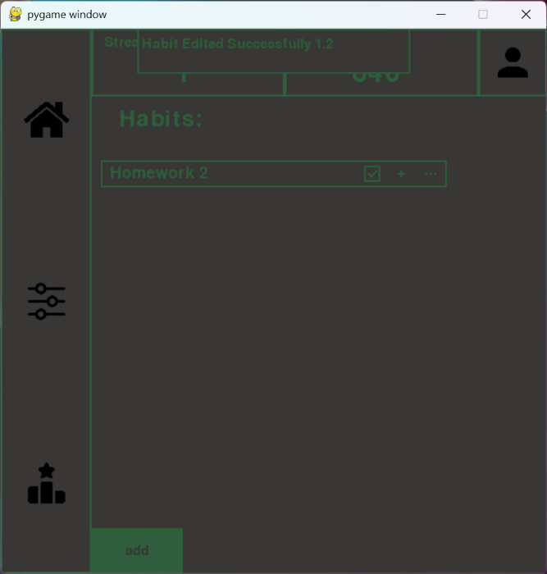
3 Dots Popup: Does the Delete Habit Button work | Presses the delete option on the pop up menu | The Habit should be removed from the list and the screen, also the database should be altered | As expected
On the pop up menu, there is an option to delete the specific habit, when pressed it is removed from the database, then the screen is refreshed and the user is informed what they have done.
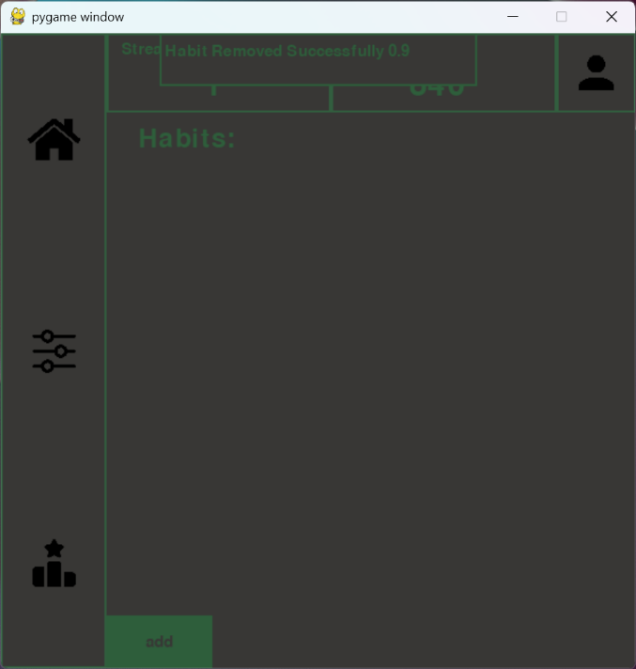
Customise Page: Does it function | Clicks on the customise page | There should be a smaller window with the users current avatar, below a list of options of items to equip | This was unfinished | Page was added but left blank with a message
When the customise page button is pressed, It should appear with a UI allowing the user to change their character. This was unfeasible in the time, so it was left, however I began to make the page but I did not have the time to finish this. In the future I would include this, or expand on it further. So it was partially achieved as the page itself functions, however not fully and not as intended.
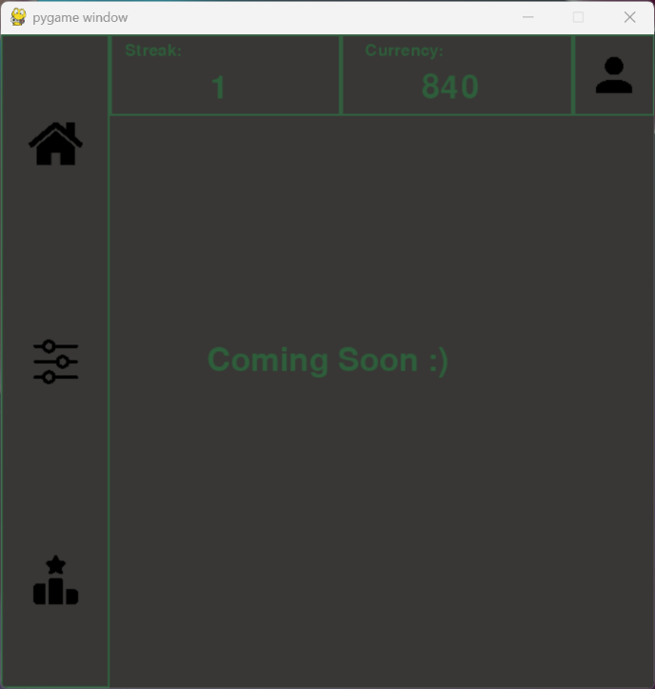
Customise Page: Can you buy and equip | Purchase an item with your currency by clicking on it and accessing the pop up menu, | The item should appear as purchased and equipped by appearing on the avatar, currency should decrease. | This was unfinished | Page was added but left blank with a message
No this was not achieved because the page was unfinished, given more time I would have implemented this, however it was unfeasible in the time I had left. Deadlines from other subjects e.g. EPQ overlapped with this, making it harder to fully dedicate myself to the project.

Customise Page: can you dequip | Take a purchased item and click it to access the pop up menu and dequip it | The item should disappear from the avatar | This was unfinished | Page was added but left blank with a message
Not achieved because the previous features weren’t implemented. A message was left on the page to show users I would intend on adding this in a future version.

Leaderboard Page: Does the leaderboard function | Clicks on the leaderboard page | A leaderboard of the 10 highest scoring users should be displayed with their respective currency in descending order | As expected
This was achieved, it shows the 10 highest scoring users and their currency. Below is a result of my post-user testing, showing correctly and updated to the most current version.
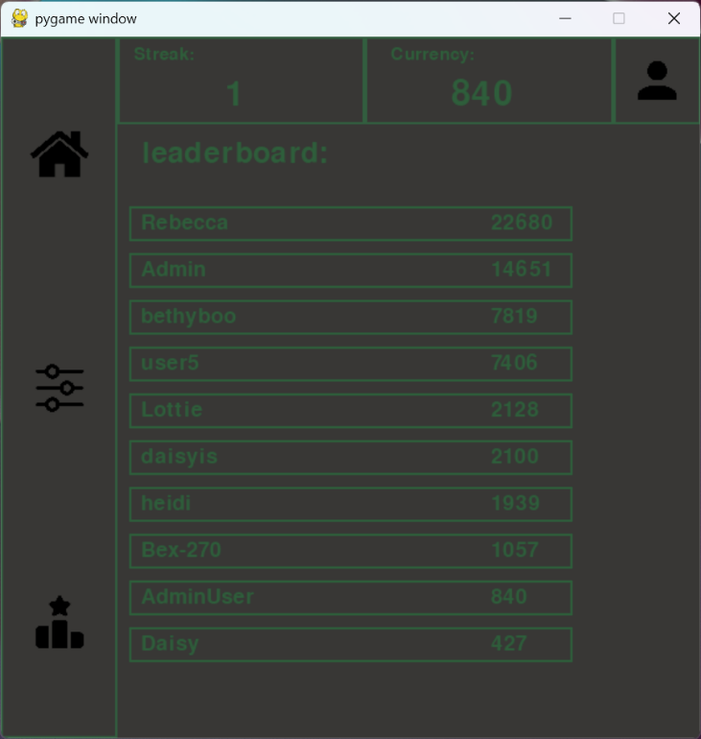

Usability Testing
I asked my stakeholders to attempt to use my project. Once they had completed this I gave a survey so they could score aspects of the project
Question | General Feedback from stakeholders | Score (I/A)
Was the Start Page usable? | Generally positive, it was a simple screen with a title and two buttons, intentionally so users understood its purpose. Scored quite high so this was achieved in terms of usability, there were one or two lower scores (nothing under 6/10) but no elaboration was provided. | Avg/10: 8.7
Did the Sign Up page work as intended? | Simple yes or no, more for functionality than usability, but everyone found it to work as intended | 100%
Did you get a failure message on the Sign Up page, were you prompted to correct this? | A few received failure messages for the following reasons: Password was too short, password was too long. Everyone that experienced this said they were prompted by a failure message. However the very large number of people that experienced their password being too short has made me consider allowing passwords to be slightly shorter, as a few were just below the cutoff (6 characters) where the range was 7-20 | N/A
Was it clear how to Log Out? | Positive feedback on this one generally. Majority found it clear that clicking on the account button allowed them to log out. Lowest score was a 7, but the average pulled it up quite significantly with 5/7 survey takers giving it 10/10 usability | Avg/10: 9.4
Did the Log In page work as intended? | Also a yes or no, everyone said yes, so functionality is good, usability generally seemed good as people understood you had to click on the box in order to add to it. A few tested the back space, and encountered some resistance, as when pressed and held down, it only removes one character, so I may later add the ability to delete many characters at once via holding the backspace | 100%
If the Log In page gave a failure message, why and were you prompted to correct? | Only one person encountered an alert, as they misspelt their password, however they were prompted to correct this and let through the second time. Everyone else entered the correct info | N/A
Did you find it easy to create a new habit? | Feedback was positive, lowest score was an 8, so everyone found it very accessible and usable. | Avg/10: 9.4
Was the create habit button functional? | Yes or no question, everyone found it to work easily and as intended, again more testing the functionality here but its good it can be understood by anyone | 100%
Was it clear how to log a habit session | Lowest score again was 8, so generally usability was good, a few people did attempt to click the checkbox button to add a session or log it as completed. But very quickly realised why and corrected. | Avg/10: 9.3
Was it clear whether you had achieved your daily goal? | Slightly lower scores, lowest was a 6, so this could be a minor area for improvement in the future, but once completed most people understood its purpose. | Avg: 8.7
Was it simple to find how to edit or delete a habit? | Yes or not, and testing that the 3 dots was a clear way of accessing the edit and delete functions | 100%
Was the edit habit window usable? | Everyone said yes that this was usable. However a few people said it would have been more usable if the old name and time were displayed in there as default, allowing them to actually edit it. This would enhance usability and could be an area for further development later. | N/A
Was it easy to delete a habit? | 100% said it was easy to do and functioned as intended, this was yes or no, so this is positive feedback | 100%
Was the leaderboard page usable? | Lowest score was a 7, generally good results, it’s a page with very little interation, so it doesn’t require extensive user testing | Avg/10: 9.3
Did the daily streak work properly? | Yes or no question, everyone found it to work as intended, a few came back the next day and saw it had either reset or incremented, so it did function | 100%
Did the currency update when a session was logged? | Yes or no, everyone found it to update, which is good as this is quite foundational for the leaderboard to work | 100%
Was it clear the customisation page was unfinished? | Yes or no, everyone found it clear, ideally I would have added it fully, however time limitations were quite significant, but a message was displayed to say why and that I intend to work on this later | 100%
Were titles and text easy to read? | Generally okay results, everyone found it usable somewhat. However I was aware the colour scheme was less readable for some. This was good feedback nonetheless | Avg/10: 8.6
Were buttons easy to interact with? | Okay results, people generally found them usable, however it could have been more clear what was an interactive button and what was plain text like a title. | Avg/10: 8.7
Were the list of habits easy to see? | Results were okay, a very large spread of results here, lowest score was a 6, so generally okay but definitely an area for improvement, possibly with higher contrast fonts and colours | Avg/10: 8.7
Was the leaderboard easy to read? | Good results, it was clear who was who and in what position, scores had a very low spread with everyone between 8 and 10 | Avg/10: 9.4
Any other feedback? | Some felt the failure messages didn’t stay on the screen long enough, originally it was 3 seconds, but this is something that could be improved on.  Quite a few felt the colour scheme made it harder to read, so this is a point that could be worked on in later iterations.  Another point is that the editing habit should as default display what the old habit name and time was, so the user didn’t have to change it if they only wanted to change the time and not the name. | N/A
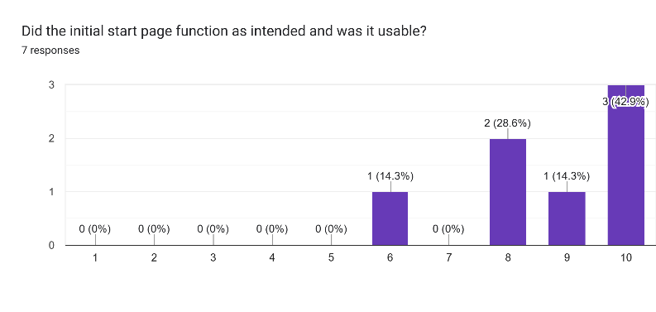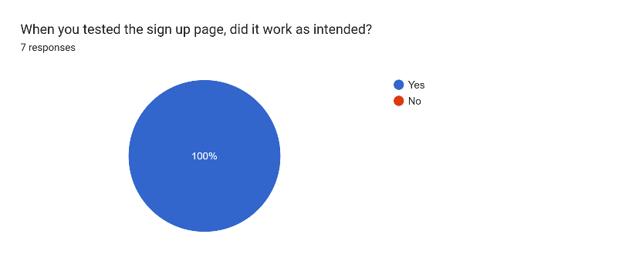
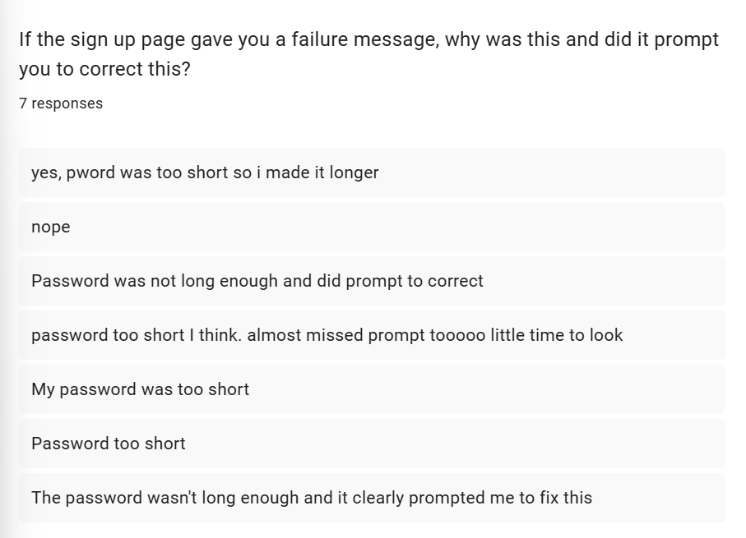
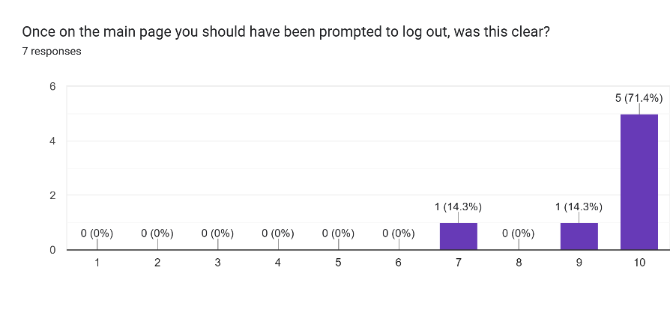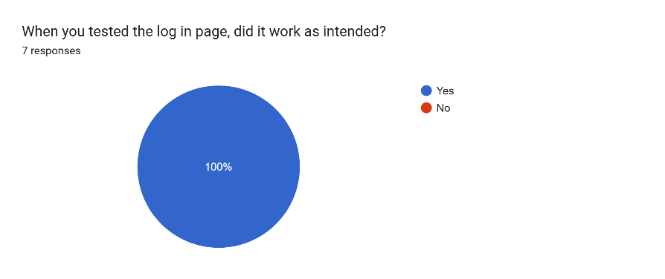
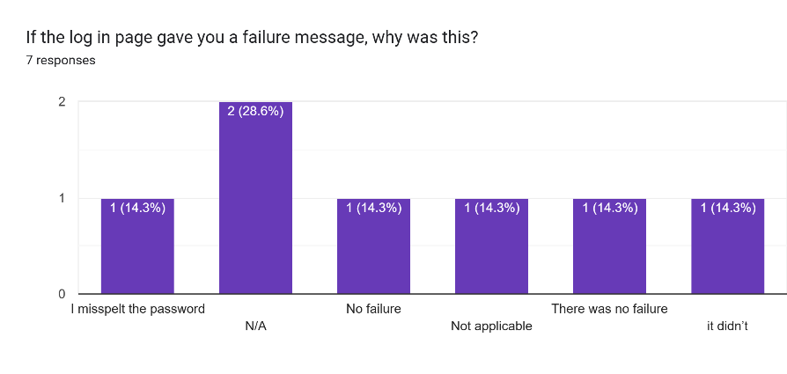
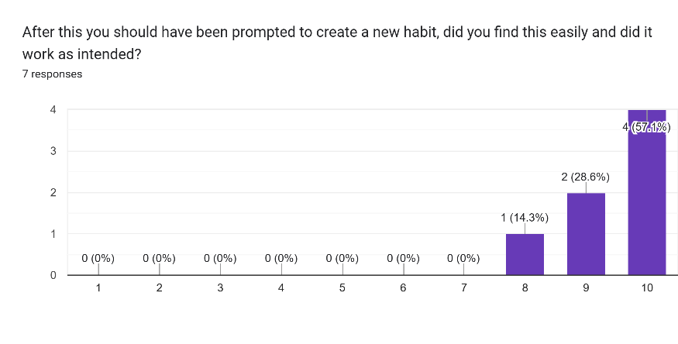
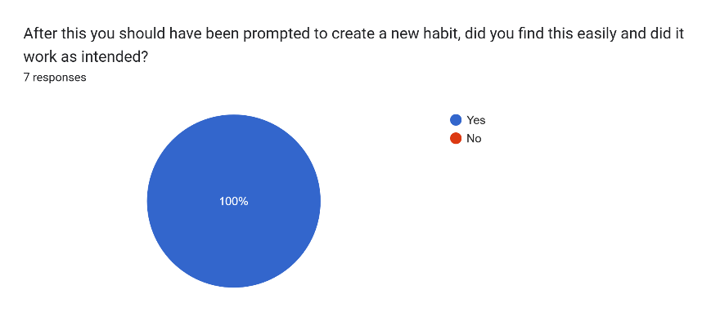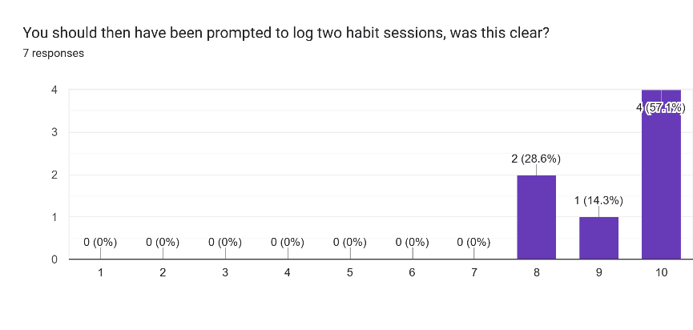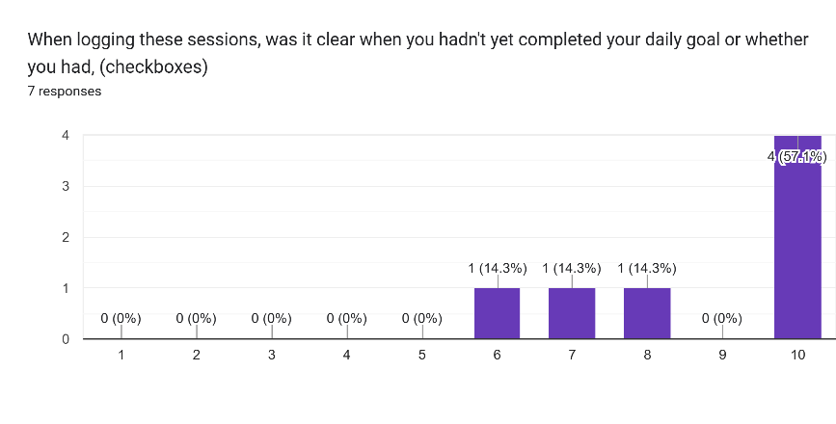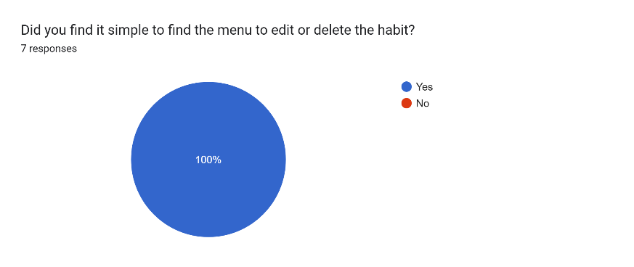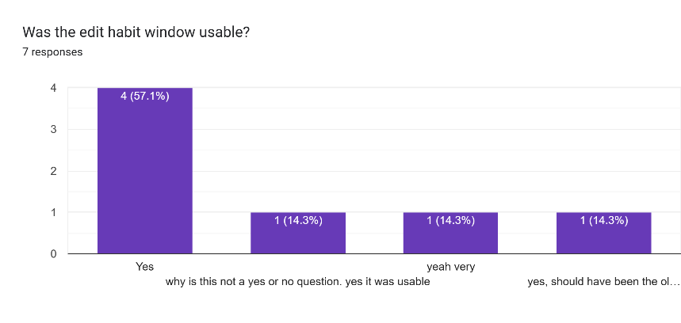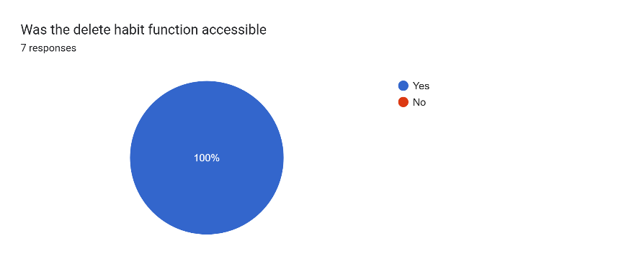
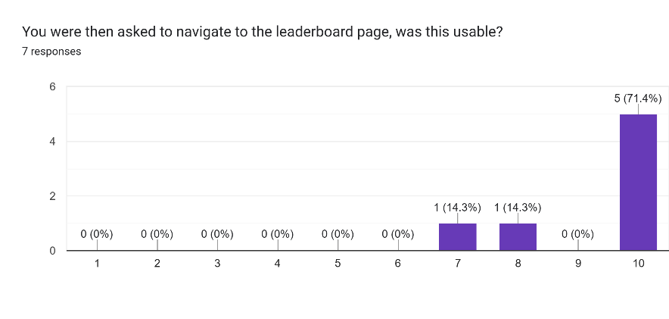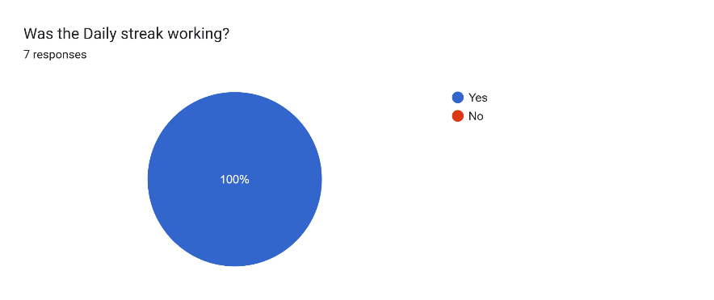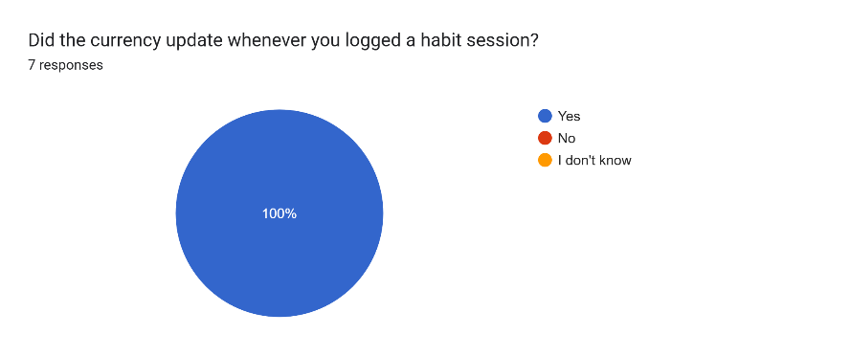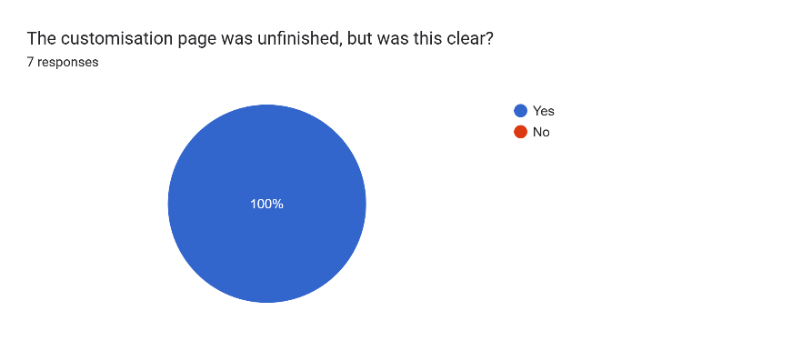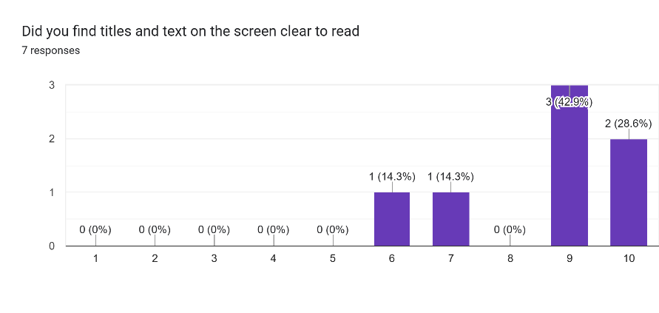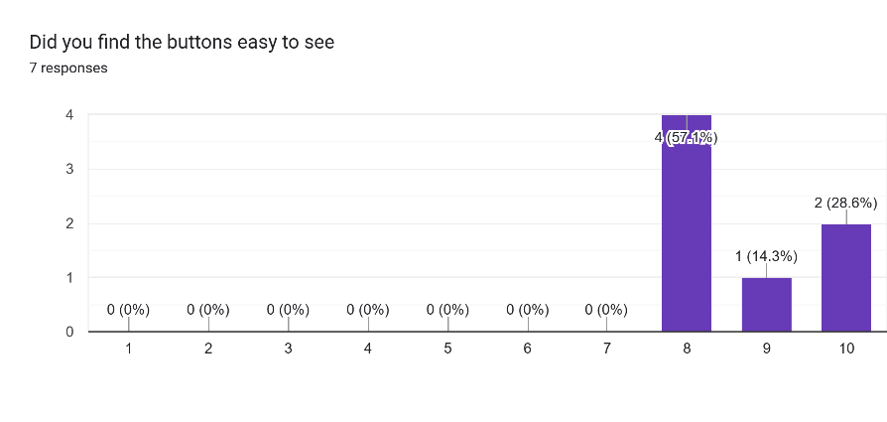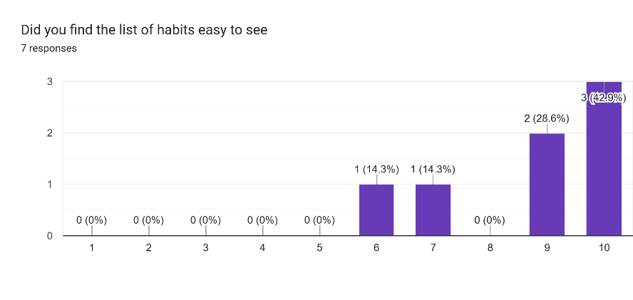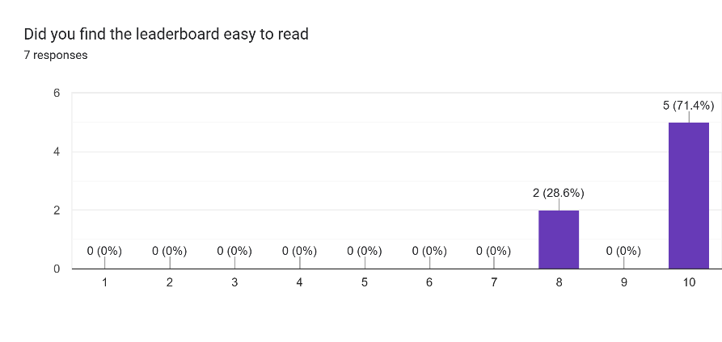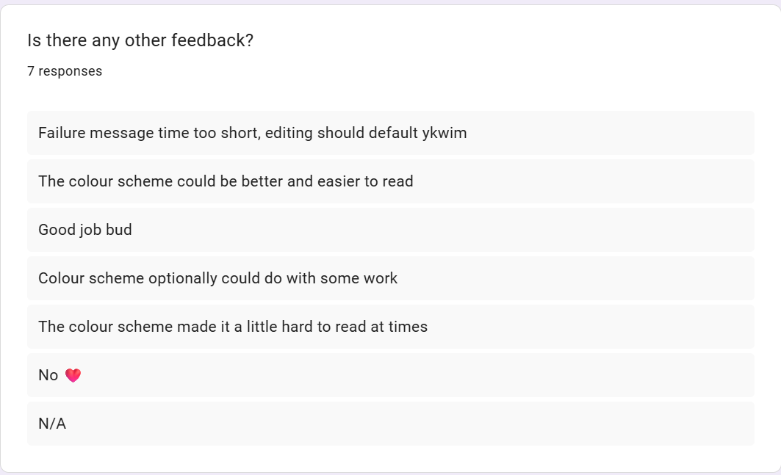

Evaluation

Evaluate Success Criteria

Achieved Fully
Achieved Partially
Not achieved
Primary:
Criteria | Measurement of success | Result and Justification
Start Page | This is needed so users can navigate to the log in and sign up pages, It needs to be clear which page is which, and also be purpose of the page. The start page will be relatively simple, it is likely it will only contain 2 buttons, so the bare functionality will revolve around this, however I need to ensure that it is clear what this page is for, and that users instantly recognise what they need to do. Beyond my testing of its functionality, I will include a question in my survey, asking whether people found the function of this page instantly obvious, and also if they found it simple to navigate, this will likely be a linear scale, if it scores 8/10 or above on average, I have achieved this. Its fine to just test the functionality but I found its just as important that users can understand the functionality, hence the question in the survey. | I feel I did achieve this, meeting the standard that I set in my criteria, this was one of the first programs to be made, so it was important that it functioned as the rest of the program built off its functionality. So this aspect was successful. There were no aspects of this that went unmet, so it was a general success.  The page displayed a title and two options to log in or sign up, in the form of buttons, these were all included in my final product, I tried to keep this quite simple, as I wanted to focus the majority of my effort to be on the actual program. This page was to allow the user to choose via buttons, and I felt this was achieved fully, the buttons do take the user to a different page, by returning keywords to the main program, if they press the sign up button they are taken to the sign up page and vice versa with the log in page. The buttons functionality was all this page demanded, so its functionality was firmly met.  Improvements made would me more on the aesthetic side, possibly including using an image as a background, or a more readable font, I would do this by having an image set and blitting it at the beginning of the game loop, or having a more interactive page, possibly with a tutorial option as well, as this may improve usability, I would include this as a third option, and it would be essentially a slide show of all the different features and how the user can access them. These would mean the users are more aware of the features on offer and they see more frequent use.
Log In | This is essential, because users need an account in order to interact with the database and use the software.  I will measure this success by whether the user can log in to an existing account, but also whether it accounts for invalid inputs: If there is no record of the account, these must be handled accordingly, and the user must be informed that their action was successful or unsuccessful. I will send out a survey to my post development test users, asking how efficient they found the process of navigating the log in page. If they give an 8/10 or above, this was successful. A survey is the only real method for measuring the success of the usability, as it is not a simple binary: ‘it does work or it doesn’t work’. As long as this works as intended, considers invalid inputs and informs users of any failures, this has been successful | I did achieve this; I met the standard in my success criteria, and there were no omissions from this. Users can navigate this page, finding the boxes to enter a username and password for an existing account, and they can find the option to enter this and check the details, it features validation, any non-existent accounts and other invalid inputs being considered. This was achieved fully because database queries and updates functioned as intended, this can be tracked because refreshing the database file will show any changes, this is proven because when logged in, and the database refreshed, the new last logged in date will change to todays date, proving its functionality. Its usability is also proven by the survey, supporting these claims further.  Hypothetically, I could have hidden the password for enhanced security: It could have shown up as a series of asterisks, and had the option to toggle showing the password, this means the if someone watches users entering their password, it is not immediately obvious what the password is, I would do this by having a Boolean isPasswordHidden variable, and a button to toggle this, the userText attribute for the input box class would need to be altered for this, as the userText is what is displayed. This would improve the security and usability of the program. A hashing algorithm could also be implemented to go further, hashing the password and comparing it to the hash stored in the database would improve security, as the actual password wouldn’t be stored anywhere and only known by the user.
Sign Up | This feature is also essential, as users need to create accounts in order to use the log in function, but also to complete any other actions, an account is necessary. I will measure this by ensuring users can enter a new username and password and checking that its not taken, and handling accordingly, also the user must be told why it hasn’t worked, e.g. the username was taken or password length was out of range. This will also have its own question in the survey, asking how usable they felt the sign up page was, if this was 8/10 or above for the majority of stakeholders then this was successful. Again as with the log in page, there is no measure of success outside of ‘does it update in the database and send you to the home page?’ | This feature was successful, I fully achieved this, because the user can create accounts successfully, including validation to ensure the new username for the account isn’t taken, and that the password is the correct length, also should these occur, the user is prompted that their inputs were incorrect, and told the reason why, this allows for them to adjust their inputs, keeping it usable.  This was achieved, because whenever a new account was made, I could refresh the database and see a new record had been inserted in the users table, this can also be tested by the ability to be able to log into the account that was just made, If they were capable of logging in, this was successful, if an error appeared saying the username doesn’t exist then I knew it doesn’t work.  To improve further, I could have allowed users to sign up with an email, I could have emailed a code and allowed users to verify this email, it means passwords can be reset without fear of malicious use, and there would be less risk of losing accounts. I would implement this by adding another text box to enter an email, validation to check it’s a valid email, then sending an email with a random verification code. Then checking that the users email is correct, now its possible to email them about forgotten passwords, allowing more secure access to accounts. This can also go further with one-time login codes, where the user enters a code emailed to them to access it, eliminating the need to remember a password while maintaining the same security.
Create a Habit | Again this is essential as the project wouldn’t be functional without this feature, success is more of a binary yes or no, the only measurable way of looking at its successes would be to whether it is functional and whether it is usable. For the functionality this will be achieved through testing, however for the usability the only way of assessing this is through a survey, this will contain a question along the lines of ‘On a scale 1-10 how easy did you find it to make the habit?’, if the average rating is 9 or above then this is successful, but there is no way of measuring success purely from testing, so a survey was the best option to test its usability.. | I did achieve this successfully, the user can create a habit by clicking the button and entering the relevant information. This included validation to ensure the time was a reasonable length, the names do not have to be unique, as habits are identified off their ID in the database rather than their name, so multiple users can have a habit ‘maths homework’ because its not the name that’s being queried by. If any invalid inputs were provided the users are informed via a message at the top of the window.  I could see whenever a new habit was made that the habits table in the database was added to, proving that it is successfully being added to the database, as well whenever its added the home page is refreshed and its possible to see the new changes to the habits, it is automatically refreshed after any add, log, delete or edit of the habit.  To work on this further, I would add further validation of the habit name, because at the moment it can be any length or format, so in the future I would check the length of the name, and if its greater than 70 characters, then reject it, this is because it can interact with the buttons at the end of each habit box. I would add a length check and also a presence check, to ensure they can’t enter an empty string as the name, the time spent already had these validations but the name did not.
Delete a Habit | This is not absolutely essential, however it would not be very usable without it so I included it in primary success criteria. Success would be measured by whether the habit is successfully removed, but also whether the method for finding the delete button is easy enough to access, this will also be mentioned in the final survey, asking, ‘how easy was it to delete a habit you had made?’ if the score was greater than 8/10 on average then this was successful. | I did successfully achieve this, users can successfully delete a habit by pressing the 3 dots and then the delete button for the given habit. This removes it from the database and refreshes the screen so its removed from the list of habits on the page.  I can tell this works because the record is removed from the habits table of the database, and because it removed from the screen. Users are informed that the operation was successful, but if anything goes wrong and it isn’t removed, then it gives a messages saying something went wrong.  Developing further, I probably should have added a confirmation message, currently after you press delete it will just remove it permanently, however to work on usability I could have added an ‘are you sure’ pop up, to ensure the user doesn’t accidentally remove a habit. I would do this by simply saying, if deleteHabit: popupDelete = True, then later saying if popupDelete = True, draw confirmation window where they confirm a second time that they do want to delete.
Log Habit Completion | Other secondary features cannot exist without this to track the users data, so its essential for the program, success is measured by whether the user is able to figure out how to log the data, and also that the logged data is stored in the external database. This project must also feature this, as data cannot be tracked without the user logging their data. Validation is also a crucial part of this, users must be unable to have their invalid inputs rejected. This will also have a question on the survey, asking whether they found it simple to complete this. If it scored 8/10 or above on average then it was successful. | I did achieve this primary feature, I think I did because the user can successfully press the ‘+’ button in order to log the time, the popup does appear and they have the option to log time, this can be types into and when the enter button is clicked, it will take the current time left from the database and find what timeLeft – enteredTime is, then save that to the database, then if the new timeLeft is negative, then write completed = True to the database. And then if completed = True then draw the complete checkbox rather than the incomplete one.  I can verify this is happening by looking at the database logs, if when I check before its different to what it is after, by the amount that was entered, then its successful. And if the completed checkbox appears on the screen then that successfully functions as well.  To work further, I could have saved the consistency of each habit over the last month or so, this would mean I could conduct more in depth analysis on the users consistency, allowing for more tracking and information to be kept. I would implement this by having an complex data type in the database, and appending to it whenever a new day passes, checking the last value stored when theres a new day.

Secondary:
Criteria | Measurement of success | Result and Justification
Leaderboard with Friends | The project doesn’t need to feature this, as it is not essential for the use of the software. Success would be measured by how effectively it represents the leaderboard and how often it updates  Not essential, as no other features build off it and the program would function without it. However, I think it would have enhanced usability and would motivate people to stay consistent. I will test this to ensure it displays in the correct order and the correct users, usability is less important as this wont have any interactive features, but there will still be a question in the survey to ensure its readable | I did partially achieve this, Instead of a leaderboard with friends I made a global leaderboard. I did not implement a ‘friend’ feature for this, so I could not have made a leaderboard for friends, but I did make a leaderboard that finds the 10 highest achieving users globally and prints this.  I can verify this is right by checking the currency associated with each user by opening the database in a text file, if this is correct and the order is correct on the screen, then the leaderboard works, this did occur and it does function as expected.  To complete this, I would make a friend finder, where people can search for a username and it will give them a list of similar usernames, then the leaderboard will select all usernames and currencies where they are friends with the user in question, ordered by currency, descending and make this the users leaderboard instead, it allows for more competition with friends and it will push users to do more, for the sake of beating their friends score.
Daily Streak | Also non-essential, no other features build off it, however it gives the user a reason to be consistent beyond completing tasks, enhancing the motivation to actually complete their habits. I would track success by its functionality, by testing that it does increase if the user is consistent for a day, and also that it resets when the user stops their consistency. Usability isn’t completely necessary as there is no user interaction beyond reading it, but its important they understand what it means and can read it clearly. | I did achieve this and it can be seen on the main, customise and leaderboard pages. The Daily streak will increase if it’s a new day and on the previous day, the user did complete all their habits, however if it’s a new day and they didn’t, it will reset to zero.  I can check it works by looking in the database and checking that it is the same, also if I come back on a new day and check that it increases or resets to zero. Upon doing this, I did verify that this was successfully achieved.  I would improve on this by having a more sophisticated way of tracking the streak, potentially also tracking the last 7 days of consistency just so the user can see which the have been consistent for. This would allow for more insights into their productivity. I would use a queue to implement this , where if it’s a new day, dequeue and enqueue the last day and the status of today, so it shifts back each time. This would refresh daily to ensure its correct.
In-game currency | Again unnecessary for the bare functionality of the project, but it would be nice to include if time permits. It allows for greater elements of gamification, motivating the user to be more consistent and productive. This will be increased by the user's logging habit sessions. This will be tested by looking to see if it changes when they log a habit session, and its usability will also be tested in the survey, ensuring users knew what it meant. If they say it is over 8/10 usable then this has been achieved. | I did achieve this fully and successfully, the user does have the currency in the corner of the screen on most of the pages, and it is changed whenever a habit is logged. I also checked the database and it displays the correct amount on there to.  To improve on this I would give it a more sophisticated formula for giving currency, something dependent on the streak length: I would take the streak length and include it as a bonus on top of the amount earned for completing the habit, this would reward consistency of users and promote them being productive
Customisation | Non-essential feature that builds off the currency, where users can use currency to customise an avatar or their page. This will allow them to have more tangible goals, which will be tested by ensuring that the users can access this and that when they buy things, they are equipped and the users currency decreases. In the survey, if they say it is over 8/10 usability-wise, this was successful in its usability. And also its functionality | I did not achieve this. I did not have the time to finish the customise page, however I did include a message at the bottom to tell users I intended on working on this more at a later date. If I had implemented this I would have checked the database to ensure the information regarding which items were purchased was consistent, then buying, equipping and dequipping an item. These would have been shown on the users avatar. However they were not.

Evaluate Usability Features

Below are the designs for each page, and also the final product, I have changed a bit in terms of button placement and the layout for the leaderboard page, but in general they have stayed quite similar.
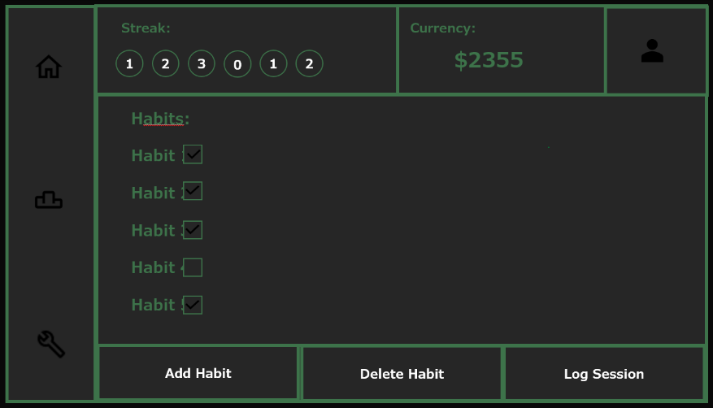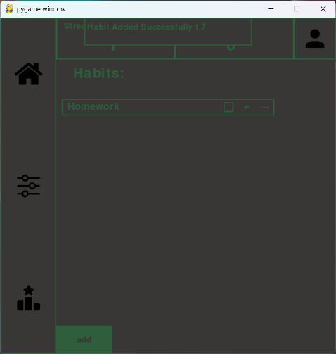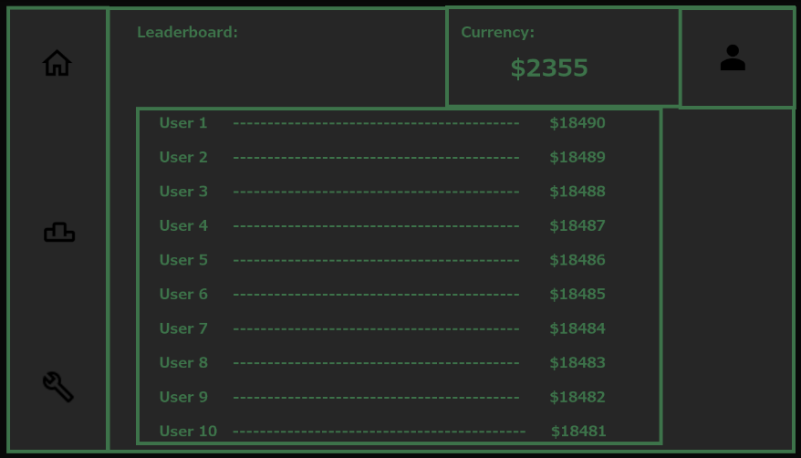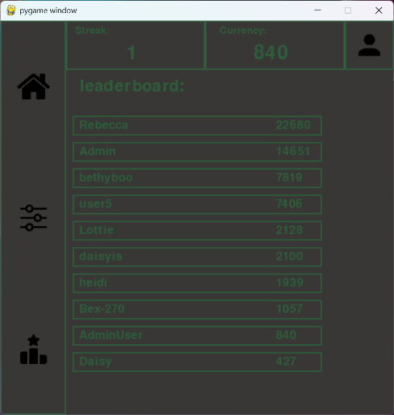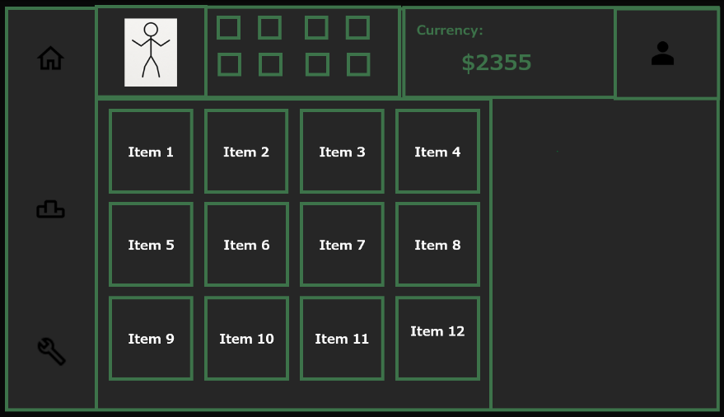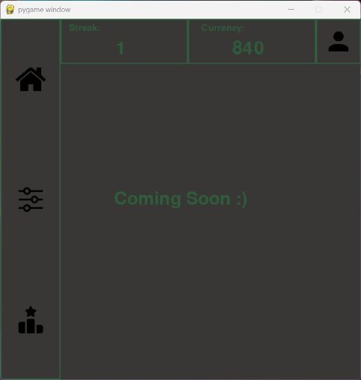

Feature | Explanation from design | Did I achieve this? + Justification | Improvements to be made
Colour | I will use a dark theme, the main background will be a dark grey, my intention is for any other colours to be a pale, dark green. This contrast draws attention to any buttons or icons. I wanted to keep a minimal design that was simple yet effective.  Alternatively, I could have used many different colours depending on the page being used, in my opinion this would have made programming unnecessarily complex, it would, in addition to taking longer, also be more difficult to learn to use, as people would find the changes in colours too confusing. | I partially achieve this, as I did stick to the colour scheme, however I used a lighter grey and a paler green which made it lower contrast and harder to read. Therefore I did achieve it in part but also some parts were omitted. | I should have used a darker grey like the colour in the designs, it makes the screen more readable for the green text, also using a more green colour allows for more contrast than the more neutral green that I ended up using. I would improve this in the future by using higher contrast colours.
Layout | I intend on including a menu bar down the side of the screen, this will feature buttons that will send the user to the designated page.  Alternatively, I could have used a menu that would vary depending on the page. The way I have designed this takes advantage of reusable program components, making testing and development easier. This menu design would have taken longer with real improvement in the quality of the program. | I did achieve this, I included the bar down the side with buttons and kept this consistent on every major page once the user was logged in to an account. This consistency helped with navigation and usability, so I did achieve this fully | I could have used icons that are higher contrast, dark grey and black aren’t particularly high contrast and may be hard to see, so I could have used an icon the same green as the rest of the page, making the layout easier to read.
Icons | On the menu bar, and other buttons, I intend on using icons to represent each page in the menu bar, which will be consistent throughout the program, it makes the UI simpler and more minimal, this will also be the same for altering habit lists: to add, remove or edit the habit list. Icons will show the user the function of the button, without describing it.  Alternatively, I could have used a hotkey, e.g. if the user presses Shift+H then go to the home page, or if user presses Shift+L then go to the leaderboard page. This would allow for easier programming but will be less user-friendly. | I did achieve this, use of icons on buttons meant the user didn’t have to read the text to find out the use of the button, as the icons told them. I found this to be a more minimal way of navigating a page, and enhanced its ability to be navigated | I could have used more icons, e.g. for the log in and sign up page, or for the currency title. However I only felt I should be using these icons if its purpose is immediately obvious, and for some there are certain features that cannot be described as an icon.

Limitations & Maintenance
I tried to keep my requirements as minimal as possible, as I know students may not have access to the most advanced machines and I wanted it to be accessible to majority of people, and able to run on majority of computers.
- 2GB RAM
- 2GB of Storage
- Monitor, Keyboard and mouse
- Python IDE
- Sqlite3 and pygame installed

Limitations
One of the issues is that the window is not resizable nor adjustable, meaning it will take up the same number of pixels on each screen, older monitors with a worse resolution would display the program much larger than a newer display. This means there is an inconsistency between devices. It is possible that this could lead to issues with the readability of the program on high resolution monitors, but it should function as intended on majority of displays.
Also, the way it has been developed means only someone with access to my school OneDrive can access the database, on reflection this was not the right choice for making a project, It should Ideally be a downloadable file for anyone to access, but either way, if everyone at a school for example were to access it, they could use global leaderboard features locally with their own database, its not ideal and not how its intended to be used, but it would still function.

Maintenance
Commenting to aid future development
The Code has been commented very thoroughly, any future developer could very easily identify the purpose of any line of code in the program. This is written in a way to aid with future development, so programmers can identify where something is coming from, and understand the format and structure of the code. This allows for faster debugging.
Modular Programming
I have utilised modular programming significantly in this project, each page has at least one of its own programs. Each class, habit operation and user data check is kept in its own function. I included one master program, its job is to call all other functions for execution, and any returning values from these functions will determine the next step, for example when sign up is called, if it was successful then return such and the main program will send the user to the home page, this completely eliminates any possibility of circular imports, and is a more sophisticated way of calling functions that linearly. Instead only going through the main program whenever switching pages.
Variable Naming Conventions
I have used appropriate variable and constant names where possible, all buttons and functions are named in a way that can be instantly identified, additionally I have utilised camel caps so programmers can tell where are word ends/starts, enhancing the readability of the names.
Program Structure
I have also kept a consistent structure between functions, all functions start with initialisation of the window, then of buttons and input boxes and any other processes, then the infinite loop and window filling, then the drawing of buttons, then specific functions to the program, then the event loop checking for typing and clicking, and finally the failure messages and the page refresh. This means the programmer can Identify the structure of one program without looking at it, as long as they have seen another function structured in a similar way. Making it more understandable faster.
Future versions of Databases
If new features were to be added, many would require more attributes to be added to database tables, however now I am at the stage of a working program with actual user data, so to just delete and remake the database is no longer viable now it is functional. So to manage this safely, I could use a schema to store each version number, Each time the program is launched, the current version would be checked and bring the schema up to date without loss of actual user data. Without wiping all user records.

Appendix

References
AI I used to debug a few issues, it was not used for actually generating program code: https://copilot.microsoft.com/
Forum used for diagnosis of bugs and errors:
https://stackoverflow.com/questions
Tutorial for Pygame I used as an introduction:
https://www.geeksforgeeks.org/python/pygame-tutorial/

Code Appendix

Check User Data:

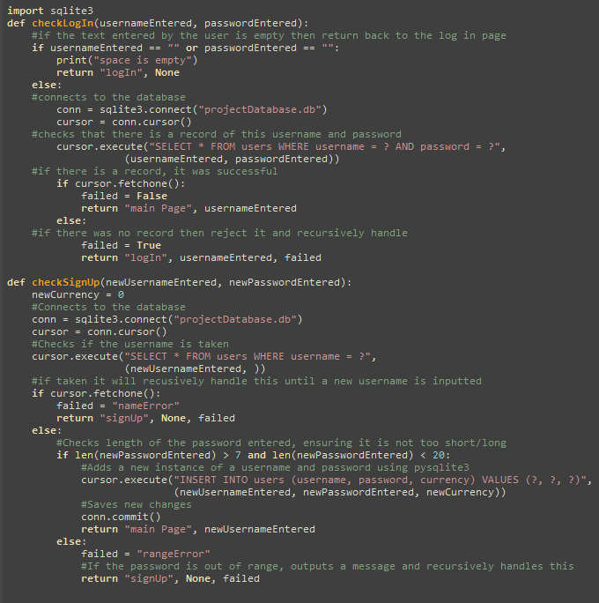

Customise Page

Failure Message

Habit Operations

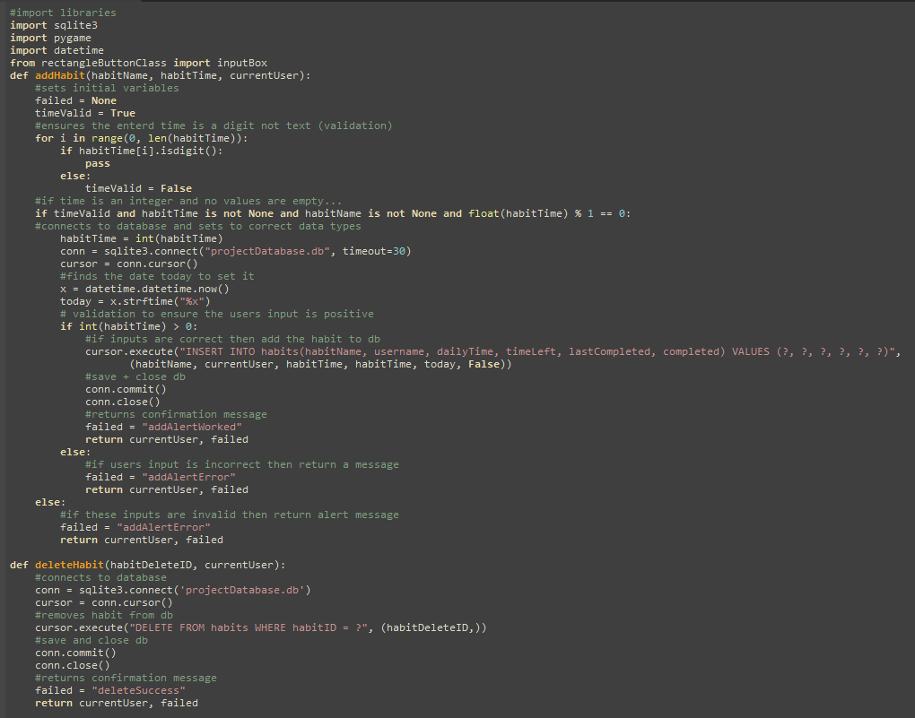

Initialise Database

Leaderboard

Log In Function

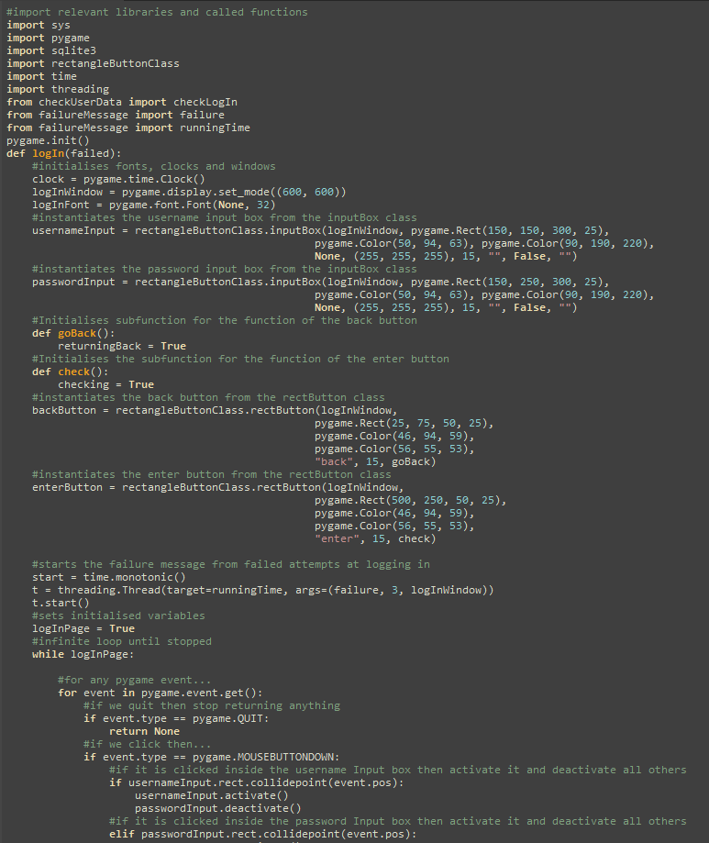

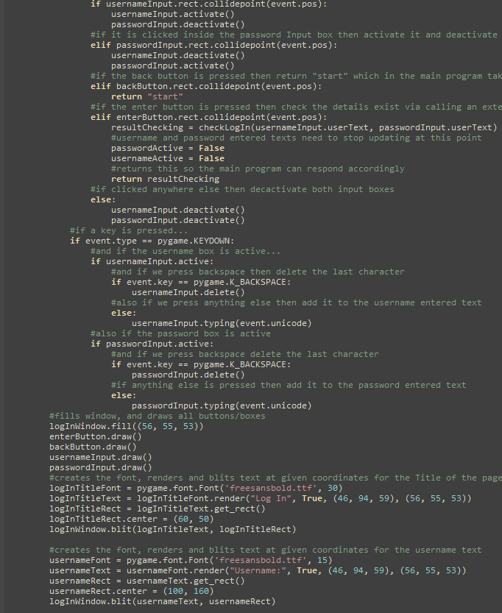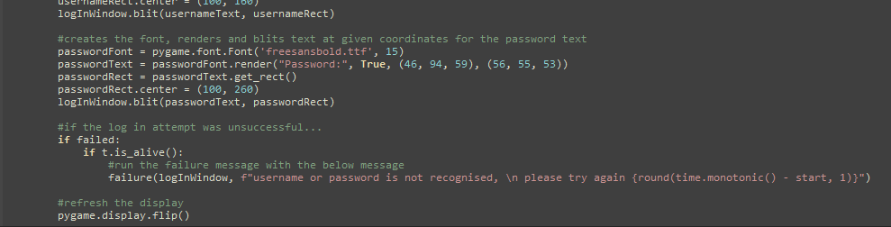

Main Page

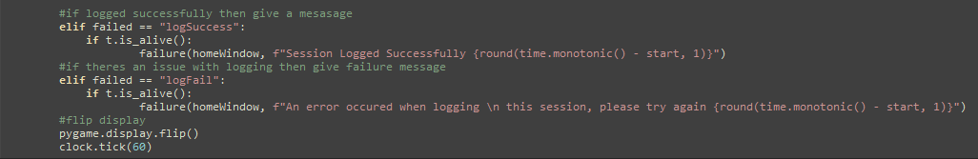

Main Program

Rectangle Button Class

Text Rectangle Button

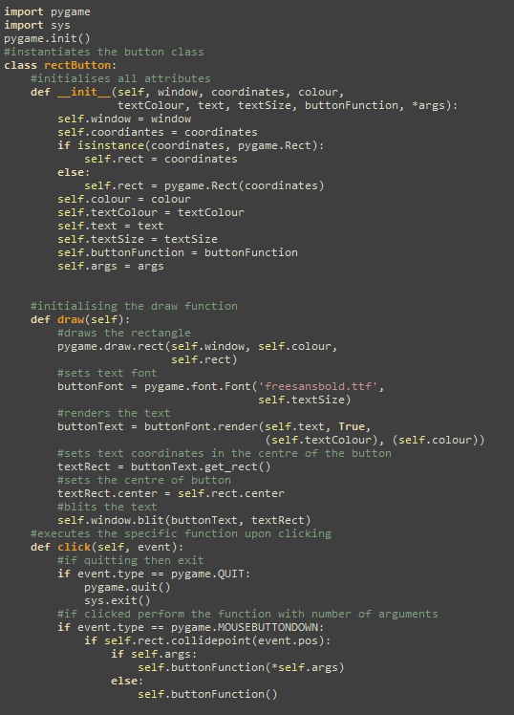

Image Rectangle Button

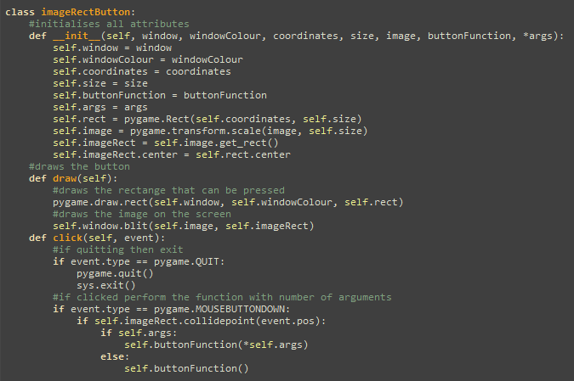

Input Box

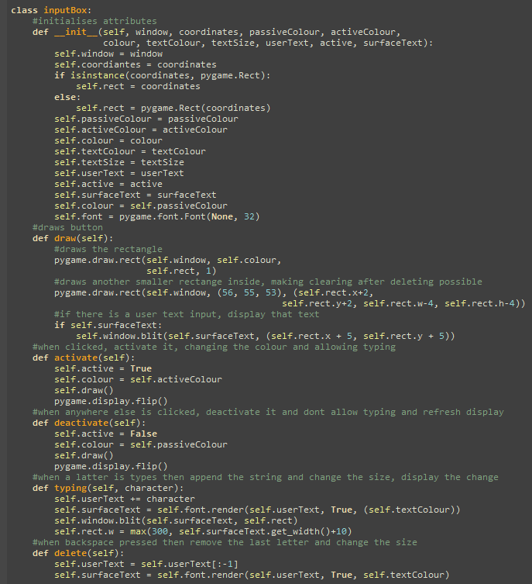

resetDay

Sign Up Function

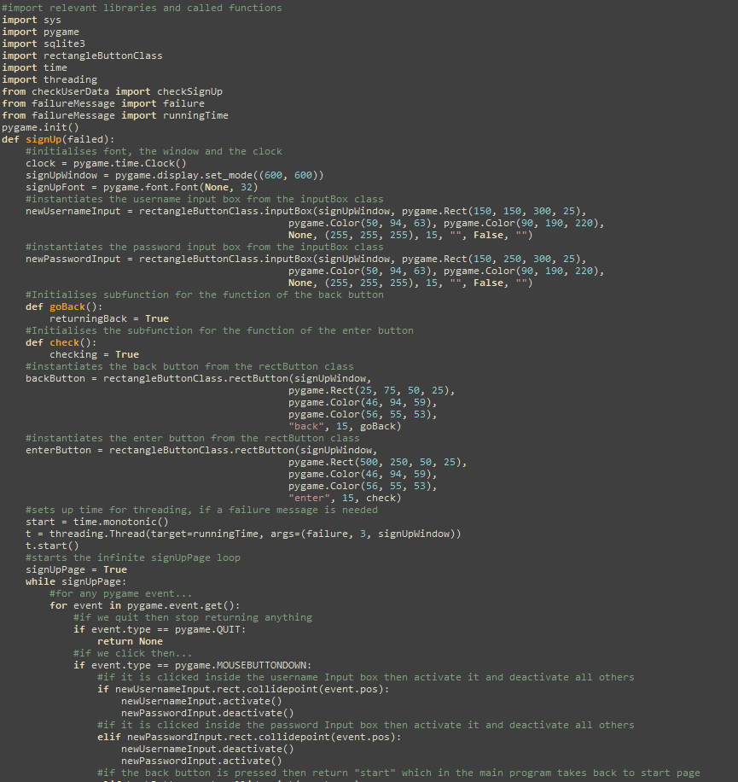

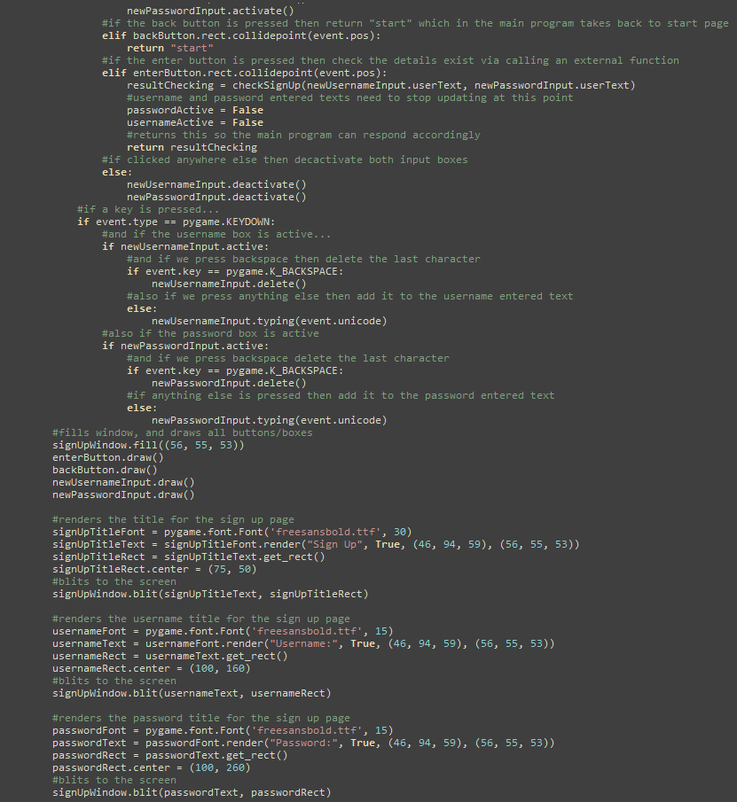
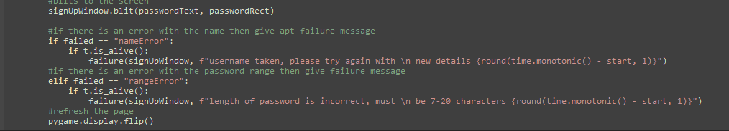

Start Page



